1st International Conference
″Computational Mechanics and Virtual Engineering ″
COMEC 2005
20 – 22 October 2005, Brasov, Romania

COMPLIANT MECHANISMS ACTUATED BY SHAPE
MEMORY ALLOY ACTUATORS

Dan Mândru¹, Simona Noveanu², Rareş Crişan³, Nicolae Lobontiu⁴
Technical University of Cluj-Napoca, ROMANIA, ¹e-mail: mandrud@yahoo.com
²e-mail: noveanu_s@yahoo.com, ³e-mail: crisanrares@yahoo.com, ⁴e-mail: nicolaelobontiu@yahoo.com

Abstract: This paper deals with the specific features of compliant mechanisms and their actuation based on shape memory alloy actuators. Compliant mechanisms have a smaller number of movable joints, resulting reduced wear, reduced need for lubrication, reduced backlash and increased precision. The most important aspects referring to compliant mechanisms are presented in the paper and some actuation methods are emphasized. Shape Memory Alloy (SMA) actuators are realized based on a property of certain materials to recover some previously defined shape or size when subjected to a heating procedure (shape memory effect). The most important issues in SMA actuators design are presented and some results regarding actuation of compliant amplifiers mechanisms are discussed.
Keywords: shape memory, actuator, compliant, mechanism

1. COMPLIANT MECHANISMS

The compliant mechanisms, representing an alternative solution to traditional rigid-link mechanisms, gain mobility by means of their flexible parts that, through bending, displace the neighboring rigid elements according to the functional role of the mechanism. They have following advantages: monolithic manufacturing, reduced weight, zero backlash, no friction loses, no need for lubrication, smooth motion, compact design and capacity of miniaturization. Their drawbacks are: low levels of rotation, the rotation is not pure, the rotation centre is not fixed and the temperature variations sensitivity, [1].
In the structure of a compliant mechanism it is at least one element that is flexible compared with other rigid link. The mobility is gained by transforming an input energy (electric, magnetic, thermal, mechanical) into output motion (Fig. 1), [2].

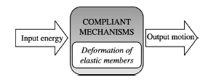
Figure 1: Schematic representation of a compliant mechanism and energy conversion

The flexible parts, called “flexure hinges” are obtained by removing material, forming thinner portions (Fig. 2a), using elastic strips (Fig. 2b) or cylinder-like thin wall parts (Fig. 2c). Other flexible connectors in the structure of the compliant mechanisms are long flexible links (Fig. 2d).
The compliant mechanisms could be divided in planar and spatial mechanisms, serial, parallel or hybrid mechanisms, with total or partial compliance. They are implemented in automotive, biomedical, spatial applications, in computer and fiber optics industries, like displacement/force amplifiers/de-amplifiers, positioning devices, manipulators, and micro-scale (microelectromechanical - MEMS) systems including sensors, accelerometers, switches or fluidic devices, [3].
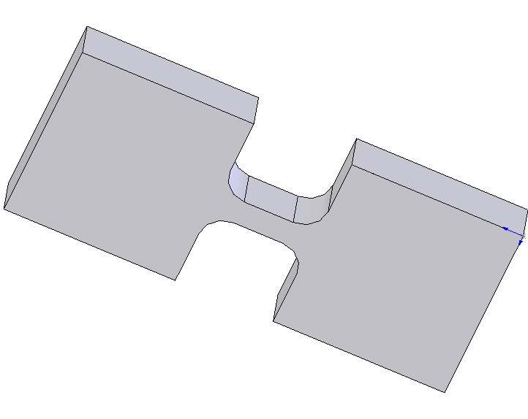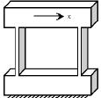

a b c d
Figure 2: Different flexure hinges (a-c) and long flexible link (d)

The previously work of the authors in the field of compliant mechanisms consists of analysis, synthesis and modeling of a large set of flexure hinges, study of the compliant mechanisms response when the external loads are applied statically or dynamically, finite-element analysis, and developing of some compliant mini-mechanisms for certain applications, [1], [3], [4], [5], [6].

2. SHAPE MEMORY ALLOY ACTUATORS

The actuation methods have a great influence on the overall performance of the compliant mechanisms. The most important elements of the actuation systems are the actuators. They convert an input energy (electrical, thermal, magnetical, chemical and optical) into controllable motion, based on the geometric characteristics of their mechanisms or on the material properties. The actuation effect is achievable by three different means: field interaction, mechanical interaction and induced strain, [7]. For both macro- and micro- scale compliant mechanisms following actuators are recommended: piezoelectric, magnetostrictive, thermal, phase change, electrostatic, electro-/magnetorheological, electromagnetic, pneumatic, electrostrictive polymer actuators, a.s.o.
Shape Memory Alloy Actuators (SMAA) belong to phase change actuators which use the dimensional changes that occur in materials as they undergo changes between phases. Shape memory effect is a property of certain materials to recover some previously shape or size when subjected to a heating procedure. The shape memory alloys could be plastically deformed at low temperature and upon exposure to higher temperature, return to their shape prior to the deformation. The basis of this effect is a crystalline transformation from austenite phase to martensite phase, [8]. The SMAs recover their original shape with substantial recovery force.Designing SMAA is an interdisciplinary approach covering the design of the actuators components (Fig. 3)

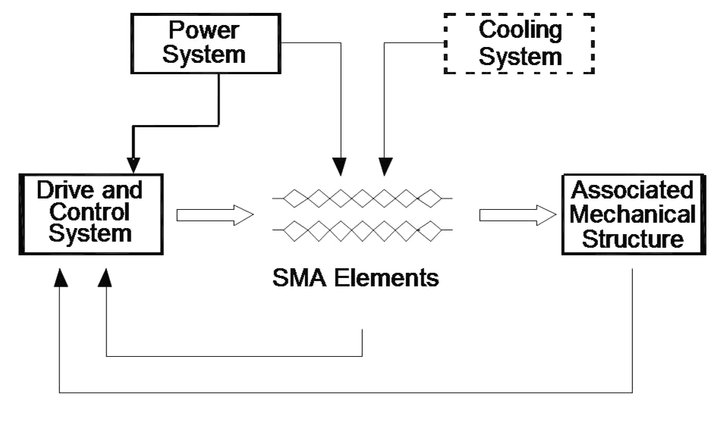
Figure 3: The structure of SMAA

The power system provides energy to heat the active elements and to operate the control and drive circuitry. The control systems provides “on” and “off” control to operate the active elements. Control circuits can range from simple to complex (manual control circuits, open-loop control circuits which automatically cycle on and off or activate the active elements based on the input signal and closed-loop circuits which use a sensor to regulate the action of the actuator). The driver system limits the power to the active elements and protects them from damage due to overheating. The driver circuits may be passive circuits (limiting the current with a fixed resistor), active current regulators (providing a constant current for any length of the active element) and PWM circuits (witch rapidly turn the current flow to regulate the power through the active elements).
The active elements provide the action. Selection of a suitable alloy is a function of transformation temperature, size of memory effect, size of memory effect, hysteresis, and number of cycles. NiTi alloy (NITINOL) is most suitable for applications requiring controllability, high wok per unit volume, high number of cycles, biocompatibility, low current for activation. The required forces and paths, the speed of transformation and the possibility of heating in available space, influence the form and size of the active elements.
The mechanical associated structure supports the active elements, permitting to act in the desired manner and protects them from overstretching, sharp bends and other forces, which could damage or degrade their performance. For the SMA components educated with one – way shape memory effect, the actuators mechanisms ensure the force that opposes the contraction force (named relaxation force). This force can be constant, an increased one (given by a bias spring) or a force of antagonist active elements.
The advantages of SMAA are: small size, light weight, high power to weight ratio, smooth and silent operation, long life, precise controllability. The slow response on cooling, the restricted energy efficiency and some nonliniear properties are the most drawbacks of SMAA.
In [7], [8] is presented the shape memory effect and detailed design methodology of the wire and helical spring active elements. In this paper, we consider SMAA based on wires to actuate compliant mechanisms. Assuming that are known: d – wire diameter, ε – size of shape memory effect, l - wire length, N – total number of wires, σ_{M} - maximum recovery stress, σ_{R} – recommended recovery stress, σ_{d} – relaxation (deformation) stress, the basic design relations are given in Table 1.

Table 1: Basic design relations of SMA wires
1 | The recovery strain | ∆l = εl,
2 | Maximum / recommendend recovery force | F_{M,R}= $σ_{M,R}\frac{{πd}^{2}}{4}$,
3 | Recommenden bias (relaxation) force | F_{d} = $σ_{d}\frac{{πd}^{2}}{4}$,
4 | The strain of an actuator with several wires parallel connected mechanically | c= ∆l
5 | The strain of an actuator with several wires serial connected mechanically | c= N∆l,
6 | The total recommenden recovery force of an actuator with several wires parallel connected mechanically | F_{t} = NF_{R}
7 | The total recommenden recovery force of an actuator with several wires serial connected mechanically | F_{t}= F_{R},

3. THE STUDIED MECHANISMS

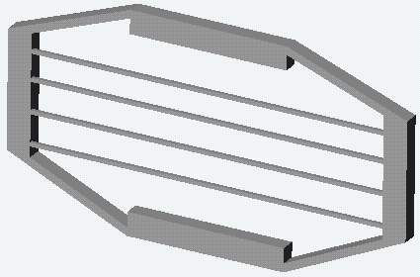
One of the great disadvantages of the SMAAs is the relative reduced linear displacement for wires, usually limited at the value of 3-5% from the total length. Due to this, for the mini-actuation systems, where other kind of classical actuators are not applicable, it is necessary for construction of motion amplification mechanisms. One of these solutions, for amplified rotational movement was presented in [9]. In this paper we proposed a number of different compliant amplifiers, which possess a very light, compact simple mechanical structure, as presented in figure 4.
1
2
3

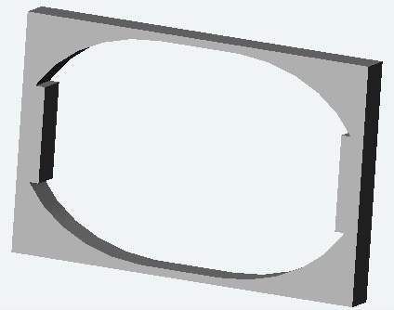
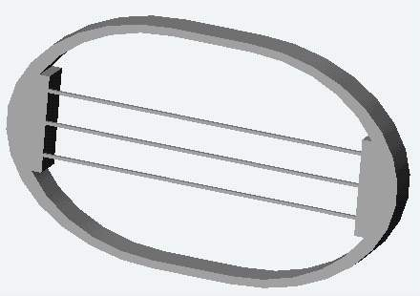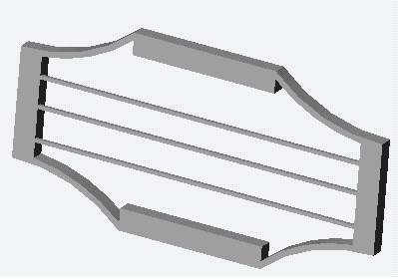
a b c d
Figure 4: Constructive solutions of the amplifier compliant mechanism

The operation principle of all these mechanisms is: application of an input force by a single SMA wire or a group of wires will generate deformation of the straight or curved flexure hinges, and the input displacement corresponding to the input force will be amplified at the output about a direction perpendicular to the input one. We note: 1- flexure hinges, 2 – rigid links, 3 – SMA wires for actuation.
4. THE FEM ANALYSIS

The finite element technique is an adequate tool for analyzing compliant mechanisms due to the speed of analysis, different analysis types (static, dynamic, thermal, mixed), and direct interaction with CAD tools.
For the compliant amplifiers given in figure 4, having same overall dimensions, same material utilized on simulation (Acrylic, E= 2,4•10³ N/mm², Yield strength = 206 MPa, Poisson ratio = 0,35), same applied forces (15 N), same frame, the results plotted by the simulation software at the same scale of deformations are presented in figure 5.

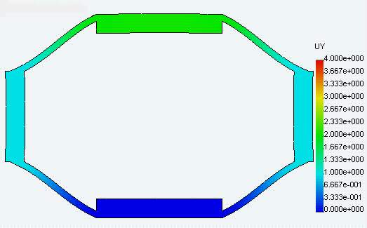 | 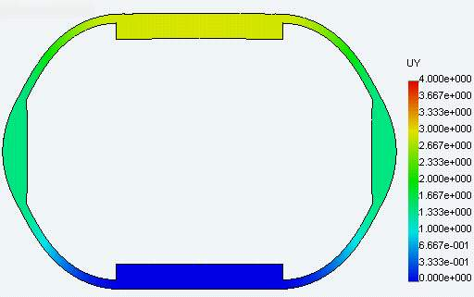
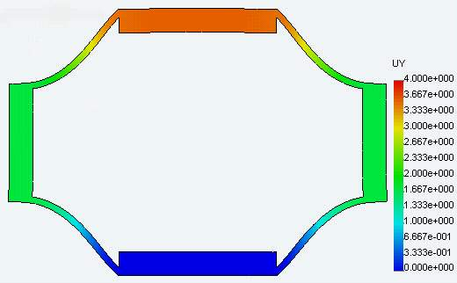 | 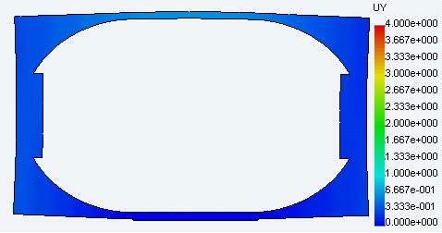
Figure 5: The deformations of the compliant mechanisms actuated by SMAA

The amplification factor is calculated based on the deformation on axis y and on axis x for each element, (a=y/2x). In figure 6 the values of the amplification factor for each model, are given.

Figure 6: The values of the amplification factor

It results that the variant with four curved flexure hinges (Fig. 4c) is characterized by the greater amplification factor, followed by the mechanism with four straight flexure hinges (Fig. 4a). The two mechanisms presented in figure 4b and 4d perform lower amplification.
For the compliant mechanisms with best amplification, a study regarding the influence of several geometric parameters was done (Fig. 9, Fig. 10 and Fig. 11). The forces developed by SMA wires depend on their diameter. For single wire of 100 µm, 150 µm and 250 µm, the developed recovery forces are 1, 47 N, 3, 23 N, respectively, 9, 11 N (considering the NiTi alloy called Flexinol™).
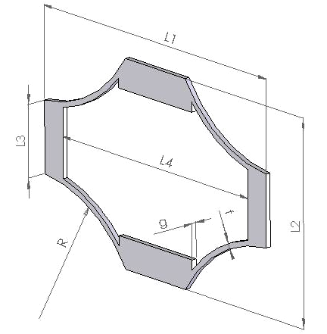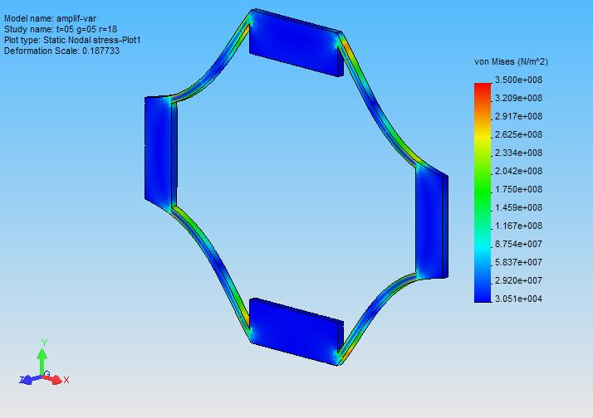
Figure 7: The geometry of the studied mechanism Figure 8: The stress plot for a certain case

Figure 9: Displacement amplification as a function of the thickness of the flexure hinge (t)

Figure 10: Displacement amplification as a function of the width of the flexure hinge (g)
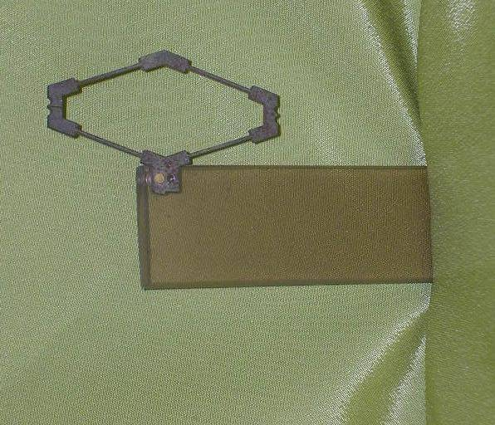
Figure 11: Displacement amplification as a function of Figure 12: The prototype of a compliant
the radius of the flexure hinge (R) amplification mechanism

Above presented diagrams are based on following data: L₁ = 30 mm; L₂ = 20 mm; L₃ = 7, L₄ = 25 mm, g, t, R – variable. The displacement amplification is not a linear function of the thickness t and radius R. Supplementary, the amplification decreases with the inputs displacements increasing. Several prototypes of compliant amplifiers mechanisms were developed, some of these are made of different alloys by electrical discharge machining or laser machining (Fig. 12).

5. CONCLUSION

The above-presented system is a compact hybrid actuator based on the interaction of shape memory material and compliant amplifiers mechanisms. It offers a high effective strain and the possibility of a more efficient usage of the actuators based on shape memory wires. The above presented mechanisms can be combined in order to improve their amplification properties. Our future work is focused on study the behavior of these SMA actuated mechanisms in interaction with external loads connected to the output link.

REFERENCES

[1] Noveanu, S., Csibi, V.: Research concerning the analysis of compliant mechanisms included in mechatronic systems, In: Proc. of the Int. Conf.“Interdisciplinarity in Engineering” Vol I, pp. 389- 394, 2003.
[2] Lobonţiu N.: Compliant mechanisms : design of flexure hinges. CRC Press, New York, 2002.
[3] Lobonţiu, N., Garcia, E.: Mechanics of Microelectromechanical Systems, Kluwer Academic Publisher, 2005
[4] Csibi, V., Mândru, D., Noveanu, S., Crişan, R.: Research concerning micromanipulation and design of microgrippers, In: Miskolcer Gesprache 2003, “Die neuesten ergebnisse auf dem gebiet fordertechnik und logistik”, pp. 175 – 181, 2003.
[5] Lobonţiu, N., Garcia, E.: Analytical model of displacement amplification and stiffness optimization for a class of flexure-based compliant mechanisms, Computers & Structures, 2003
[6] Noveanu, S., Csibi, V.: Variante constructive ale mecanismelor compliante, In: Proceedings of the 11th International Conference in Mechanical Engineering OGET 2003, pp. 169 – 173, 2003.
[7] Mândru, D., Crişan, R., Tătar, O., Noveanu, S.: Acţionări în mecanica fina si mecatronică, Editura Alma Mater, Cluj-Napoca, 2004.
[8] Mândru, D., Tătar, O., Crisan, R.: Solutii de actionare a robotilor cu actuatori pe bază de aliaje cu memoria formei, In: Revista Mecanisme si Manipulatoare, Vol.1, Nr. 2, pp. 39-44, 2002.
[9] Mândru D., Tătar, O., Crişan, R.: Aplicaţii ale actuatorilor pe bază de aliaje cu memoria formei în chirurgia minimal invaziva, In: The Romanian Review of Precision Mechanics, Optics and Mechatronics, Supplement 20a, Vol. 1-20a, pp. 385-390, 2002.
[10] Lobonţiu, N., Garcia, E.: Analytical model of displacement amplification and stiffness optimization for a class of flexure-based compliant mechanisms, Computers & Structures, 2003.

Cosmos ™ © for SolidWorks™ ©

