1st International Conference
″Computational Mechanics and Virtual Engineering ″
COMEC 2005
20 – 22 October 2005, Brasov, Romania

Computer Simulation of Tests for Vehicle Protection Structures

Mat. Petru Cardei, dr. ing. Vergil Muraru, ing. Raluca Sfiru,
INMA Bucharest, Romania, e-mail icsit@sunu.rnc.ro
Abstract
The paper presents the research results regarding the computer simulation of the resistance tests for tractor protective structures (cabs and protection frames). The simulation process takes into account the conditions of performing the tests for the protective structures recommended in the OECD standards code 4 and code 5 in March, 2000.
Even if there are aspects which the virtual test (computer simulation of the tests) cannot reach to, or whose reaching assumes a very great effort, the elaborated simulation method can be constituted by a design proceeding of the structures which could ensure the successful passing of the physical resistance tests, by using a single protection structure for that.
The performed researches show that it is possible to computer – simulate the resistance tests for the protective structures.
The method is explained by an example of virtual resistance test during the overturning, applied to a simple protective structure.

Key Words: Simulation, Vehicle, Crashworthiness, Tests

1. Introduction

The necessity of some virtual tests (test computer simulation) has naturally come out, taking into consideration that the protective structures are expensive ones and the tests recommended by standards, being also expensive, have a high risk level. The failure of a structure, when tested assumes killing another similar structure, so that the test price can raise a lot. Thus it was obviously to appear the requirement for computer – simulating these tests.
OECD has introduced the necessity to fulfill the requirements of some resistance standards for the protective structures of these machines. The European Standards which regulate the resistance tests of the protective structures can be found in [1] – [5]. The dynamic tests, described in [1], have been performed by striking the tested structure with a pendulum mass. These tests are difficult requiring complex installations and entailing phenomena, characterized by great forces and high velocity. In order to reduce the working velocities and to reach a greater accuracy, there have been adopted the static tests, described in [2]. On the other hand, the static tests are cheaper like dynamic tests.
However, even the static tests are expensive for the majority of the East-European manufacturers of agricultural machines. The perspective of destroying more protective structures in order to certify the necessary qualities in case of the equipment overturning, has increased the difficulties encountered by the manufacturers. That’s why there has appeared the suggestion of simulating these tests (either the static or the dynamic variant), namely the computer simulation of these tests or virtual tests. This situation is not appropriate to these tests, but can be found in a series of expensive types of tests, such as the stability ones during the vehicle overturning.
For the case of the static tests, the work must be conducted in the following sequence: longitudinal loading (for a wheeled tractor with at least 50 per cent of its mass on the rear axle and for track laying tractors, the longitudinal loading shall be applied from the rear, for other tractors the longitudinal loading shall be applied from the front); first crushing test (the first crushing test shall be applied at the same end of the protective structure as the longitudinal loading); loading from the side (in the case of an offset seat or non-symmetrical strength of the protective structure, the side loading shall be on the side most likely to lead to infringement of the zone of clearance); second crushing test (the second crushing test shall be applied at the end of the protective structure opposite from that receiving the first longitudinal loading – in the case of two-post designs, the second crush may be at the same points as the first crush); second longitudinal loading (these loading shall be applied to the tractors fitted with a folding - e.g. two posts – or titlable – e.g. non-two posts protective structure, only in the conditions specified in [2]).
In this paper we consider only the static tests. For this reason we describe separately the conditions of the development of these tests.

2. General regulations

[2] has imposed the following performing rules for the tests:
- the protective structure may be manufactured either by the tractor manufacturer or by an independent firm. In other case a test is only valid for the model of tractor on which is carried out. The protective structure must be retested for each model of tractor to which it is to be fitted. However, testing stations may certify that the strength tests are also valid for tractor models derived from the original model by modifications to the engine, transmission and steering and front suspension. On the other hand, more than one protective structure may be tested for any one model of tractor;
- the protective structure submitted for static test must be supplied attached in the normal manner to the tractor or tractor chassis on which it is used. The tractor chassis shall be complete including attaching brackets and other parts of the tractor that may be affected by loads imposed on the protective structure;
- where a “tandem” tractor is concerned, the mass of the standard version of that part to which the protective structure is fitted is to be used;
- a protective structure may be designed solely to protect the driver in the event of the tractor overturning. Onto this structure it may be possible to fit weather protection for the driver, of a more or less temporary nature. The driver will usually remove this in warm weather. There are protective structures however, in which the cladding is permanent and warm weather ventilation provided by windows or flaps. As the cladding may add to the strength of the structure and if removable may well be absent when an accident occurs, all parts that can be so taken away by the driver will be removed for the purpose of the test. Doors, roof hatch and windows that can be opened shall be either removed or fixed in the open position for the test, so that they do not add to the strength of the protective structure. It shall be noted whether, in this position, they would create a hazard for the driver in the event of overturning.
- A description of any temporary cladding supplied is to be included in the specifications. All glass or similar brittle material shall be removed prior to the test. Tractor and protective structure components which might sustain needless damage during the test and which do not affect the strength of the protective structure or its dimensions may be removed prior to the test if the manufacturer wishes. No repairs or adjustment may be carried out during the test;
- Any component of the tractor contributing to the strength of the protective structure such as mudguards, which has reinforced by the manufacturer, should be described and its measurements given in the test report.
Notes
1)the first observation is that [4] permits the utilization of a single protective structure for all the tests, in the event of its lasting in the very imposed sequence. Obviously, the protective structure passing through the first tests reaches the next ones, being affected by the previous tests. If the residual strains have not been too important, or have not surpassed same limits mentioned in [2], and if the structure hasn’t presented cracks or breaks, then we’ll can pass to the following test. It is certain that if the structure is subdued to a reglemented sequence of tests, this structure will resist more to any of the loading tests applied on the undistorted structure, but as for the design this can mean also on overmeasure (excess).
2)the second important observation is that [2] requires the utilization during the tests of the completely equipped chassis of the tractors whose protective structures are being tested. As for the great size tractors, this requirement imposes further costs, due to the necessity of designing and manufacturing same additional devices, which are used during the tests, in order to apply the appropriate loadings.
3)Generally, the rigid fastening of the protective structures, the chassis being absent, leads, under the reglemented loads application, to an over evaluation of strains, but guarantees a better behavior of the protective structures on the chassis. This is due to the fact that the chassis has taken over a part of the load effects. This observation has been used in the computer simulation of the resistance tests for protective structures.

3. The Performing Method of the Simulated Tests

The Main steps of the Simulation of resistance test for protective structures during the overturning are the following: S1) Construction of the pattern;S11) The building of the geometry of the pattern, the applying the loads and the boundary conditions;S12)The development of the physical properties of the pattern: elasticity modulus, density, material curve (stress-strain curve – in the case of the bilinear elastic – plastic approximation of Von Mises type, only the yield stress and the tangent modulus).S13) Load-time curve construction;S14) The selection of the analysis type (static or dynamic), the control parameter (strength or displacement), the choice of the integration parameters of the calculus algorithm, of the (fixed or variable) step, of the required outputs in the specified nodes;S2)The developing of a pattern has been done in order to obtain the fulfillment of the criteria given by OECD standards. If the stopping criterion of the test is expressed in terms of force, then we’ll run the stage until the reaching of the value calculated by the standard. If the stopping criterion of the test is expressed in terms of energy absorbed by the protective structure, then we’ll develop by probing several times, until getting an acceptable exceeding of the limit value given by the standard formulae. Another stopping criterion of the test is that of breaking or of severe damage of the structure, but the simple coming out of a little zone , in which there have been surpassed the breaking strains isn’t always a criterion of stopping the test, unless this exceeding produces unacceptable consequences according to OECD standards. Another stopping criterion of the test is given by [2]: no part shall enter the clearance zone during any part of the tests, no part may strike the seat during the tests. This phenomena are easily to observe during the virtual test, the clearance zone being very well confined. We can also obtain at every stage of the running, the values of the relative displacements, of the strains and stress. The results interpretation is performed after every successful development of the program, in accordance with the acceptance criterion given in OECD standards. It is drowning up a testing paper which could demonstrate the fulfillment of all the acceptance criteria or, which could relieve the failing of one or more criteria and, consequently the impossibility of accepting the structure (see [1] – [5]).S3) Obtaining some additional results to OECD Standards is facilitated by using the programs of structural analysis. Among these results we can enumerate: the graphical representation of the structure deforming (after every step and in the end) according to the geometry of the clearance zone (see figure 2), the highlighting of the structure critical areas, the residual deformations (strain and stress) in every area of the structure, the possibility of the calculus of the loading speed (for its control, according to OECD Standards) the estimation of the deformation speed of the structure in each of its zone.

4. Example and Interpretation of Results, for a Simple Protective Structure: Testing of protective structure on agricultural tractor MT 12 2 DM

This test was performed under running with Newton-Raphson Iterative Method with Force Control, with floating step (autostep option, maximum step 165 s). The tests must be conducted in the sequence required by OECD standards. The structural pattern used is show in the figure 1 (see the real structure in the figure 3). This pattern was inspired by the physical tests. In this figure is shown the geometry, the basic loading (strength) and the limit conditions. We consider the next material proprieties: Young modulus, E= 2.1⋅10¹¹ N/m², Poisson ratio, ν= 0.3, shear modulus, G= 8.07⋅10¹⁰ N/m², yield stress, σ_{Y}= 230 MPa, yield strain, ε_{Y}= 0.001095, tangent modulus, E_{t}= 4248666654 N/m², ultimate tensile strength, σ_{R}= 340 MPa, tensile strain, ε_{R}= 0.26. The cross section is a box section, 40 mm width, 60 mm height, and 4 mm thickness. The pattern was mashed with SHELL4T elements, with four nodes.
The times curve for force (load) appears in figure 1. The whole loading performed during 165 s can be breakdown in four distinctive parts, tacking into account the four components parts of the resistance test during the overturning, which must be applied, according to OECD directives.

4.1. Longitudinal Loading Applied from the Rear Part

The longitudinal loading applied from the rear is the first among the series of tests, which have been performed for this structure. According to the directives 86/298/CEE, 2000/19/CEE and code 7 OECD, the energy that this structure should absorbed within the longitudinal loading test from the rear is 360 j. We can observe that the structure didn’t penetrate the clearance zone. There are not areas in which can be reached the breaking limit stress (tensile strength) of the material of what is made the protective structure (340 MPa). The structure has operated in the plastic field, during the test. The residual values are determined at time t= 25 s, time at which the elastic unloading from the first test is complete.

4.2. Crushing test

The crushing test is the second from the series of tests performed for this structure. In compliance with the directives 86/298/CEE, 2000/19/CEE and code 7 OECD, the force that the structure must support without being broke or penetrating the clearance zone and without unauthorized residual strains (deformations) has the value of 18100 N. The residual values have been determined at time t= 50 s, when the elastic unloading is complete.

4.3.Loading from the side

The loading from the side test is performed controlling the energy and in compliance with the directives 86/298/CEE, 2000/19/CEE and code 7 OECD, the energy to be absorbed being of 1512 j. The conclusion is that the structure has superficially penetrated the clearance zone. This penetration couldn’t be perceived experimentally, being impossible to emphasize it for technical reasons. There are no areas where should be reached the breaking limit stress (tensile strength) of the material of which is build the protective structure (340 MPa). The structure has operated in the plastic field, during the test. The residual values are determined at time t= 110 s, time at which the elastic loading from the crushing test is complete.

4.4. Second longitudinal loading

The second longitudinal loading test, applied from the front part is performed with energy control and according to the directives 86/298/CEE, 2000/19/CEE and code 7 OECD, the energy to be absorbed being of 935 j. The main results of the second longitudinal loading test appear in figure 4. By means of the information from figure 4, a, b, c, it is calculated the energy absorbed by the structure, in this test. In this case, the reference node is node 2033 (see figure 2). In figure 4, d, e, f appear the distributions of the relative displacement fields, the strain and the stress fields (different variants) in the end of this test. From this information we can observe the maximum stress areas and if there are or not yield zone. It can be observed if the structure has or not operated in the plastic field, in the end of the test. It can be also noticed that the structure has superficially penetrated the clearance zone during the previous test, within thus one the additional penetration being inexistent. There are areas of negligible size, in which there has been surpassed the limit breaking stress of the material of which is manufactured the protective structure (340 MPa). The exceeding is very small (16 MPa) and is required only by the elemental Von Misses stress. The structure has operated in plastic field, during the test. The residual values are determined at time t= 165 s, time at which the elastic loading is complete. Following the conclusions of these tests, the protective tested structure has been accepted. The conclusion harmonizes with the conclusions obtained following the physical experiments.

5. Conclusions

The main conclusions of this paper are the following: C1) All the tests required by the OECD STANDARD, [1] – [5], can be computer simulated by either static or dynamic tests and for all protective structures of the tractors and other machines;C2) The pattern may be simple, containing only the protective structure or even more complicated including the connecting elements between the protective structure and the frame, or including the tractor frame and, eventually, the axles and the wheels;C3) For the simulation quality, it is essential to select the types of finite elements used in modeling the protection structures. The chosen finite elements should be separately tested in the even of a simple load. The structural models of the protective structures should necessarily operate in the non – linear elastic – plastic field. If they have operated only in the elastic – linear domain, they either couldn’t take the necessary energy, or, if they took the prescribed energy quantity, they should be much oversized;C4) The very complicated patterns require an appreciable modeling effort and become too expensive. So the additional results can be uninteresting or are not able to be checked up;C5)There are, also limits for the tests computer simulations. The surpassing of these limits can be made only with great efforts. For example, the welded zones of the structures, which can be modeled, but whose material proprieties microstructure arise very hard difficulties. Generally, we suppose that the welded zones have an ideal behavior;C6) The Structural Analysis programs have the capabilities to determine quantitatively and qualitatively the performances of the tested structures. Thus, we can decide if the tested structure is in compliance with the OECD STANDARD requirements, [1]-[5] .
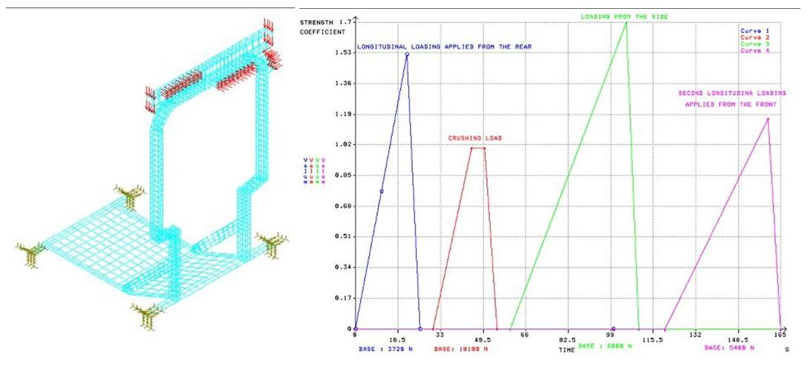
Figure 1 The structure pattern (left) and the time curve of the testing load : curve 1: time history of the strength on the longitudinal loading applied from the rear; curve 2 : time history of the strength on the crushing test; curve 3 - : time history of the strength on the loading from the side; curve 4 - : time history of the strength on the second longitudinal loading.

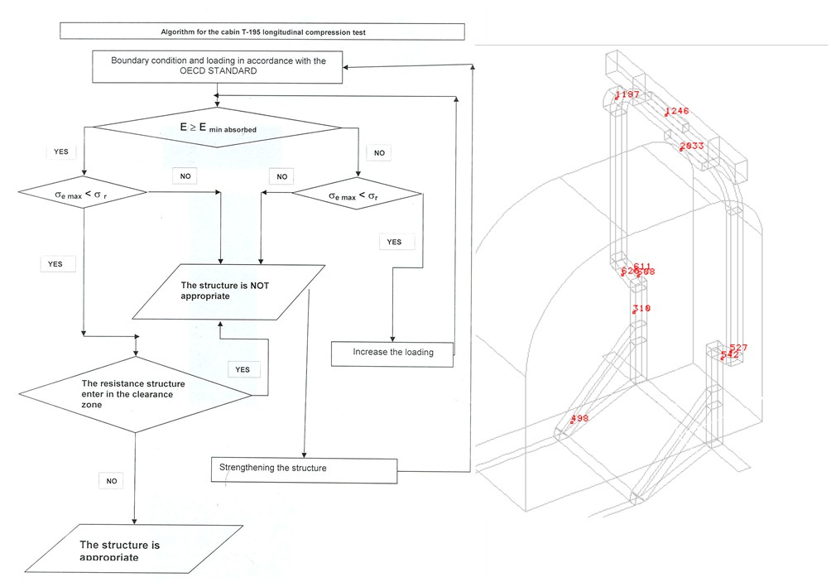
Figure 2 The algorithm of the longitudinal and side loading test (left) and the chart of the control nodes (right).

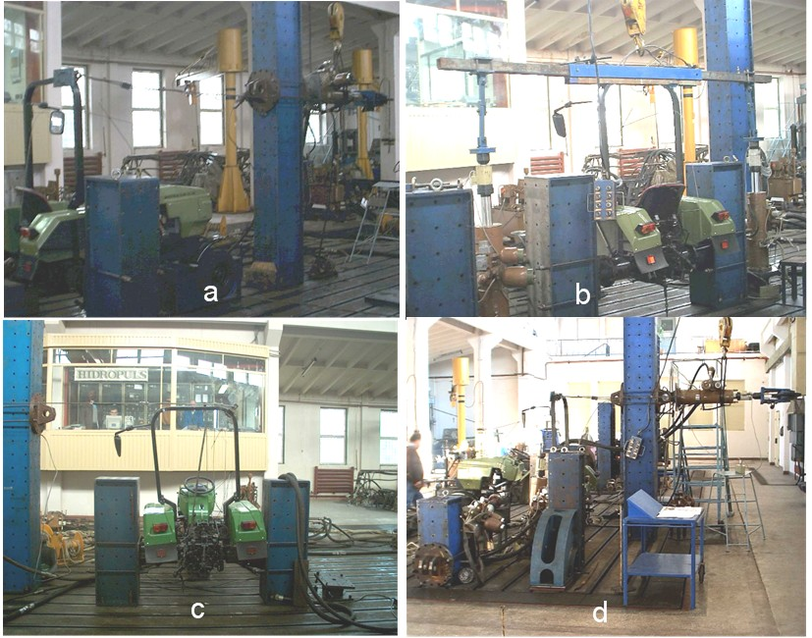
Figure 3 Images during the tests: a – longitudinal loading at the rear; b – crushing test; c- loading from the side; d - second longitudinal loading.

References

[1] CODE 3 OECD STANDARD CODE FOR THE OFFICIAL TESTING OF PROTECTIVE STRUCTURES ON AGRICULTURAL AND FORESTRY TRACTORS (DYNAMIC TESTS);
[2] CODE 4 OECD STANDARD CODE FOR THE OFFICIAL TESTING OF PROTECTIVE STRUCTURES ON AGRICULTURAL AND FORESTRY TRACTORS (STATIC TESTS);
[3] OECD STANDARD CODE FOR THE OFFICIAL TESTING OF AGRICULTURAL AND FORESTRY TRACTOR PERFORMANCE, CODE 1 March 2000;
[4] OECD RESTRICTED STANDARD CODE FOR THE OFFICIAL TESTING OF AGRICULTURAL AND FORESTRY TRACTOR PERFORMANCE, Code 2, March 2000;
[5] OECD RESTRICTED STANDARD CODE FOR THE OFFICIAL TESTING OF AGRICULTURAL AND FORESTRY TRACTOR PERFORMANCE (DYNAMIC TEST), Code 2, March 2000;

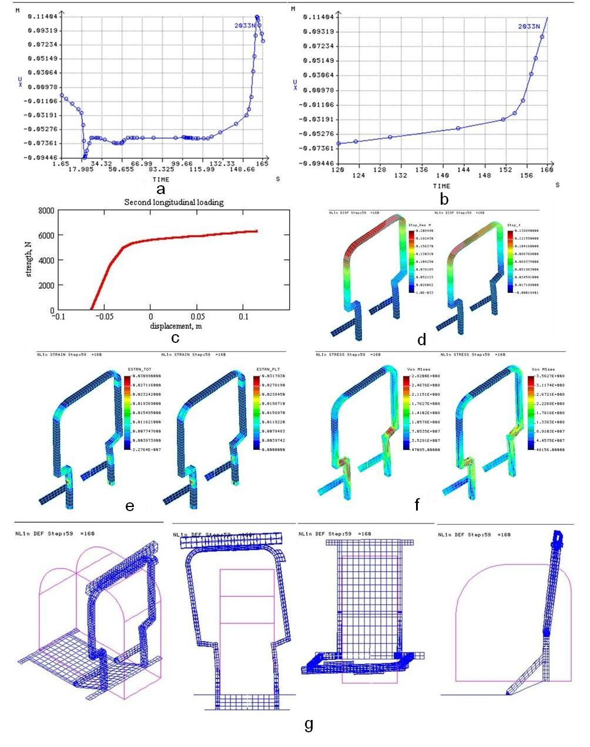
Figure 4 The second longitudinal loading: the displacement on the strength direction of the node 2033, on the entire duration of the test (a) and strictly for longitudinal loading (b); the strength – displacement diagram on the test (c); the displacement distribution on the pattern (d) at the final of the test, resultant (left),on the strength direction (right); strain distribution at the final of the test, (e), total (left), plastic (right); stress distribution at the final of the test (f), nodal (left), elemental (right); the deformed shape of the protective structure at the final of the test (g).

