The 2nd International Conference
″Computational Mechanics
and
Virtual Engineering″
COMEC 2007
11 – 13 OCTOBER 2007, Brasov, Romania

VELOCITY FIELD ANALYSIS AROUND VERTICAL AXIS WIND TURBINE (VAWT)

Mircea IVANOIU¹, Yves CHAMPAGNE²
¹ Universitatea TRANSILVANIA Brasov, Catedra de Termodinamica si Mecanica Fluidelor, Brasov, ROMANIA, ivanhoe@unitbv.ro
² INSA Lyon, Département Génie Mécanique Construction, Villeurbanne, FRANCE, champagne@insa-lyon.fr

Abstract: The paper uses an American model for air flow in vertical ax wind turbines, model conceived by Sandia Laboratories, Albuquerque, New Mexico, in order to emphasize the impact of airfoil profile characteristics as well as wake flow velocity on turbine performance. Program data were processed in order to visualize the theoretic flow downwards rotor, allowing to be seen the evolution from permanent to non- permanent vortex field. A sound determination of speed field is essential for an accurate description of a fluid- blade interaction, in any point of rotating circle.
Keywords: vertical axis wind turbine, wake, vortex field, velocity field, numerical flow simulation.

1. INTRODUCTION

During the energy crises from the last third of the previous century the energy field researchers were focused on deployment of wind turbine projects with an optimal efficiency-cost ratio. Based on semi-empirical experience from the first half of the century, new theoretical and experimental studies were performed, being formulated new aerodynamic models, most of them consistently supported by IT evolution. A comprehensive model was elaborated by J.H. STRICKLAND [6] which creates a preliminary model, improving the theory of R. J. Templin NRC Ottawa, Canada [7] and finally formulates a 2D [5] and 3D vortex model.

2. THEORETHICAL FUNDAMENTS

2.1 Stream tube theory.

Sandia Laboratories Albuquerque, NM improves the theory of J.R. Templin, NRC Ottawa [7] replacing the single streamtube generated by turbine cross-section with multiple streamtube, obviously more appropriate for non-uniformity of velocity field in this section [6]. The model was also used with good results by the team lead by Otto de Vries [8] NRL, Holland.
The model quality in assessing Darrieus wind turbine efficiency, for solidity 27 is noticed in fig. 1, where the theoretic power coefficient curves are compared to experimental data provided from a turbine operating to m/s.
The similarity to the experimental date brought by the model of multiple stream tube is evident.

  - Vortex theory for vertical axis wind turbine
The theory represents a phase almost simultaneously developed by worldwide laboratories: Holme [1], Larsen F.C.[2], Sharpe [4] initially in (2D) formulation and aerodynamic steadiness.
A 2D approach of the problem is very convenient to vertical ax turbine and straight blades [9], as there is a no velocity distribution in terrestrial boundary layer and the fluid movement is reproducing identically in parallel horizontal planes.

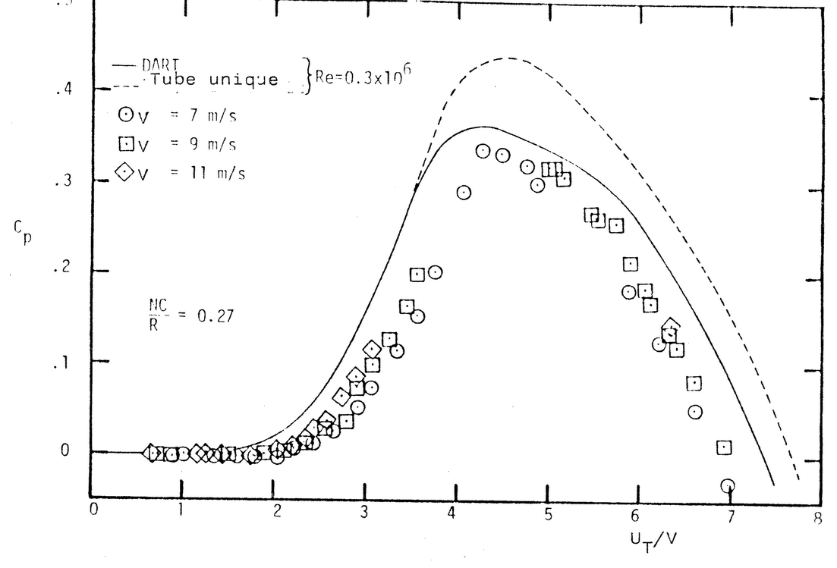
Figure 1 - Curves C_{p}= f (λ) plotted using single streamtube model (R. J. Templin) and multiple streamtube model (DART) and experimental points at different wind speeds for a Darrieus turbine with (N_{C}/R) = 0.27

The theory imposes the division of the blade in a certain number of segments along the span (vertically) and each segment is considered as a vortex detaches point.
Vortex fields determine velocity field, respectively, their components in incident flow plane. After determination of velocity field, the profile lift and drag are obtained starting from profile characteristics.
The basic equations are Thomson – Lagrange (plane flow, potential force field, perfect fluid)
(1)
from which it is developed the detached field theory and Biot-Savart law for induced velocity produced by a vortex in P point,
(2)
or considering the notations from fig.2
where is the direction unit (3)
Using Kutta - Joukowski theory, vorticity is connected to lift.
(4)

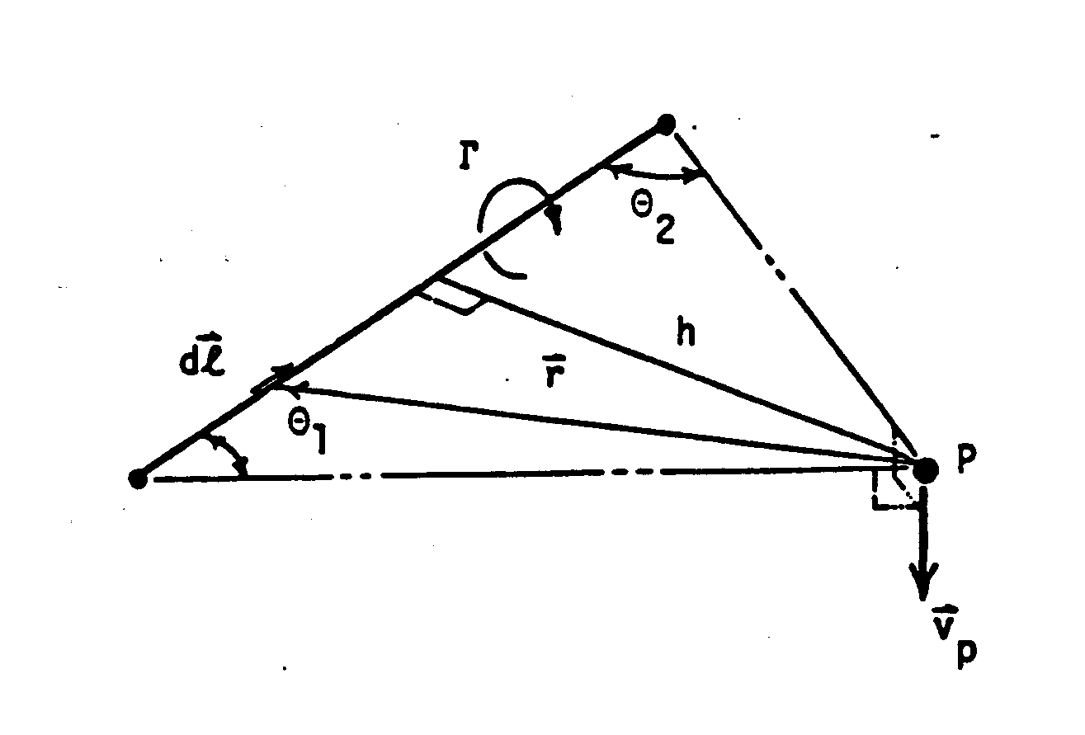
Figure 2 - Scheme of determination induced velocity by a vortex filament

and (5)
resulting (6)

As the induced velocities of all plane vortices are known the vector of local relative velocity is relatively easy to compute, having rotation velocity and blade orientation.
As it is known in different positions from rotational circle the bound vorticity are different so the detach vortex will be equal and of opposite sense with
(7)
Behind rotor it will be formed a mobile grid useful for the determination of vortex components in grid points.
As the vortex filament is infinite
and Biot – Savart law yields
in i, j point (8)
i = number of the blade segment yielding vortex
j = in time vortex location
For avoiding singularities in flow plane, fatal in computing, within the vortex nucleus determined by h_{C} radius, tangent velocity is constant and equals v_{C}. [see relation 5]
(9) Resulting from equations (5) and (6), bound vorticity depends on lift (expressed by C_{L}), which is
dominantly determined by angle of attack and local relative velocity.
The profile was attached with a coordinate system (fig 3.), velocity and angle of attack are finally the following:
(10)
(11)
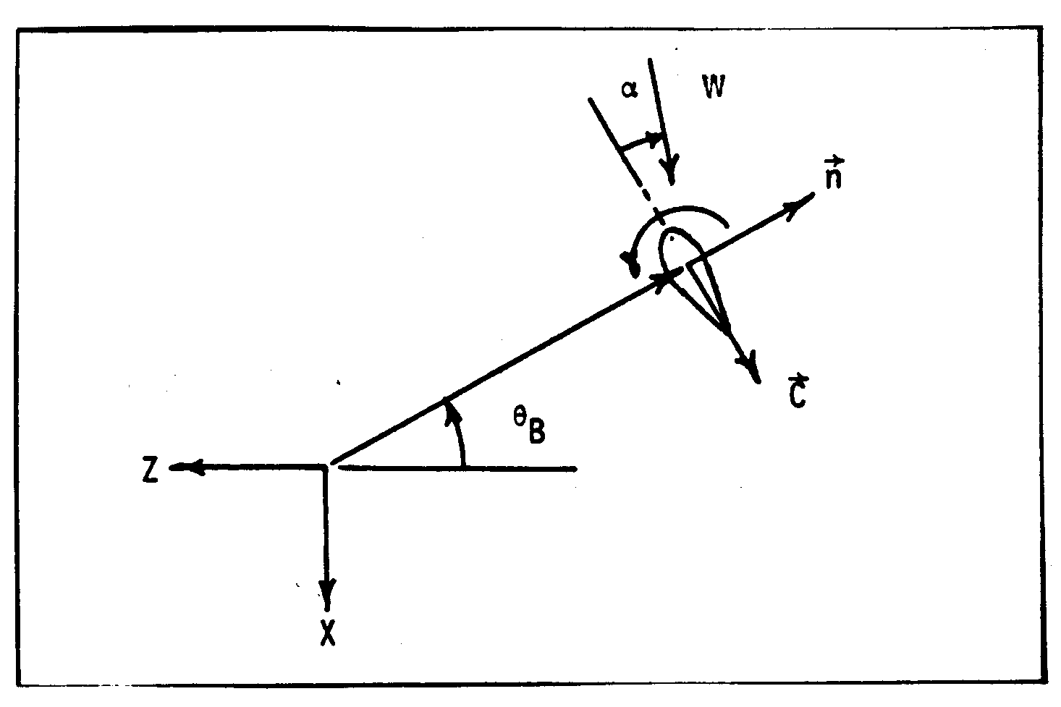
Figure 3 - VAWT blade and incident flow

The further calculation and energy performance have known expressions by all literature. Some observations are required for grid type, taking into account that velocities generate a plane gliding in Δt time which can be illustrated with Δx, Δy. Vorticity, in no dimensional expression, becomes:
(12)
(13)
Strickland [5] suggests a grid deformation at a certain time step using two integral explicit relations, but practical considerations determined by calculation complications favored the chose of a fixed grid (fig.4.)
The point values are determined using linear or polynomial interpolation. It was reduced the controlled surface and also the computed points. Using the specific form of continuity equation in plane flow:
(14)
it is introduced a direct relation between and , which shortens computing operations.

3. THE STRUCTURE OF COMPUTING PROGRAM

VAWT – V2D.FOR
It represents the transposing in Fortran 77 of Strickland program conceived by Sandia Laboratories, authors interventions being performed in aerodynamic software and input –output data files.

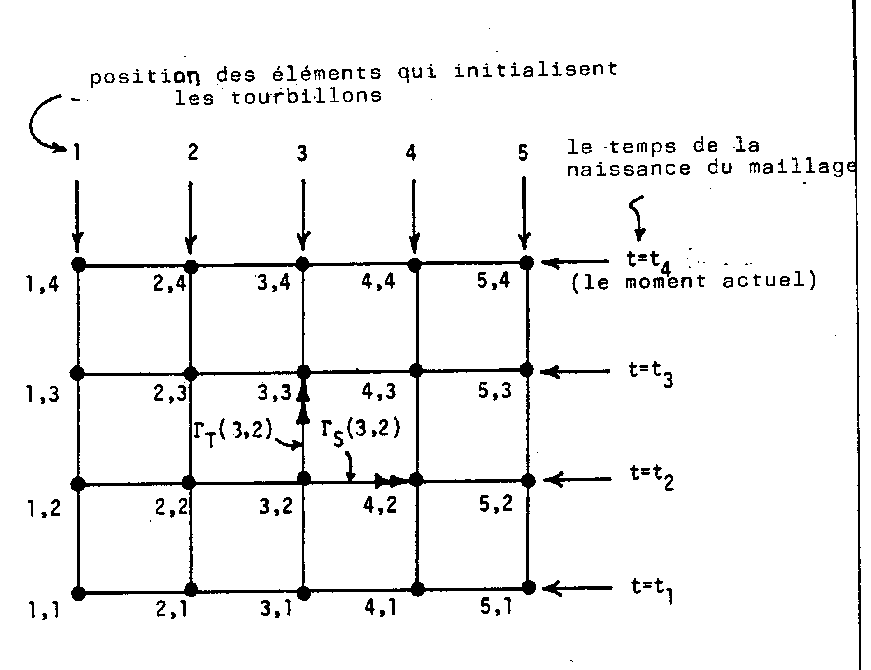
Figure 4 – Latice temporarly developed

The program consists of main module and 14 specific modules dealing with specific chapter such as,
BIVEL – calculates blade induced velocities
BVORT – calculates the bound vorticity
WIVEL – calculates wake induced velocities (downwards rotor)
SHEDVR – calculates vortex strenghts
CONLP – convects wake lattice points
INTERP – interpolates velocities between wake grid points
ALDNT – calculates airfoil, lift, drag, normal and tangential force coefficients
PERF – calculates performance parameters
etc.
Knowing the intimate software structure allows to intervention within main program or subprograms instructions, but external input data are sufficient for significant computing and graphics.
Input data, in packages:
a) GTURB – data on turbine geometry
NB – number of rotor blades
CR – chord to radius ratio c/R
UT – tip to wind speed ratio, respectively
XIP – blade mounting point to chord ratio, measured from leading edge, implicit 0,25
TCR – airfoil thickness to chord ratio
b) CPROF – data on profile
NTBL – number of data points in airfoil (angles of attack) for which there are determined aerodynamic coefficients
RE – airfoil chord Reynolds number for data table
ASTAL – static stall angle of airfoil
c) PROAERO – profile aerodynamic coefficients C_{L}, C_{D} table (NTBL table line) with
TA (I) airfoil angles of attack in degrees
TCL (I) CL airfoil lift coefficients
TCD (I) CD airfoil drag coefficients
The other input data represent control numbers for output data recording or listing (INDIC, PROFVIT).
Input data relatively accessible and useful in different analysis are as follows:
NR – number of rotor revolutions; here it may be studied convergence, meaning a permanent vortex field
NTI – number of time increments per rotor revolution (a way of increasing computing accuracy)
IFW – number of fixed wake grid points in the X direction
KFW – number of fixed wake grid points in the Z direction
XFW, ZFW – array of coordinates points using BLOCKDATA in accordance with scheme (fig 4 )
Output data, blocks
Excepting an input data package which allow listing and check there are other three data blocks which record and type data divided on three interest fields:
ETATPROF – contains geometric data for every blade, at every position fixed on revolution circle
THETA () – rotor or blade element azimuthal angle
ALPHA – blade element angle of attack
FN, FT – normal and tangential force coefficients
w_{X}, w_{Z} – components of relative velocity w
and instantaneous values of torque and power coefficients
EVDART 2 – contains main free vortex nucleus detached and corresponding velocity components in these points
DISVITS – file containing velocity components in preset wake sections
THETA – total revolution angle from starting rotation
X, Z – coordinates of wake points
VX, VZ – velocity components from wake points, meaning
- Graphics, interpretations, conclusions

All the graphics used DOS versions of GRAPHER (2D) and SURFER (3D, version TOPO) programs.
The figure 5 represents the passing through non-permanent operation mode of a wind turbine having straight blades. Stabilization of the operation mode regarding energy optimization (C_{P} value) is produced faster for low specific velocities λ= 2.5 ; 3.5, and for n=8 revolutions for λ=4.5.
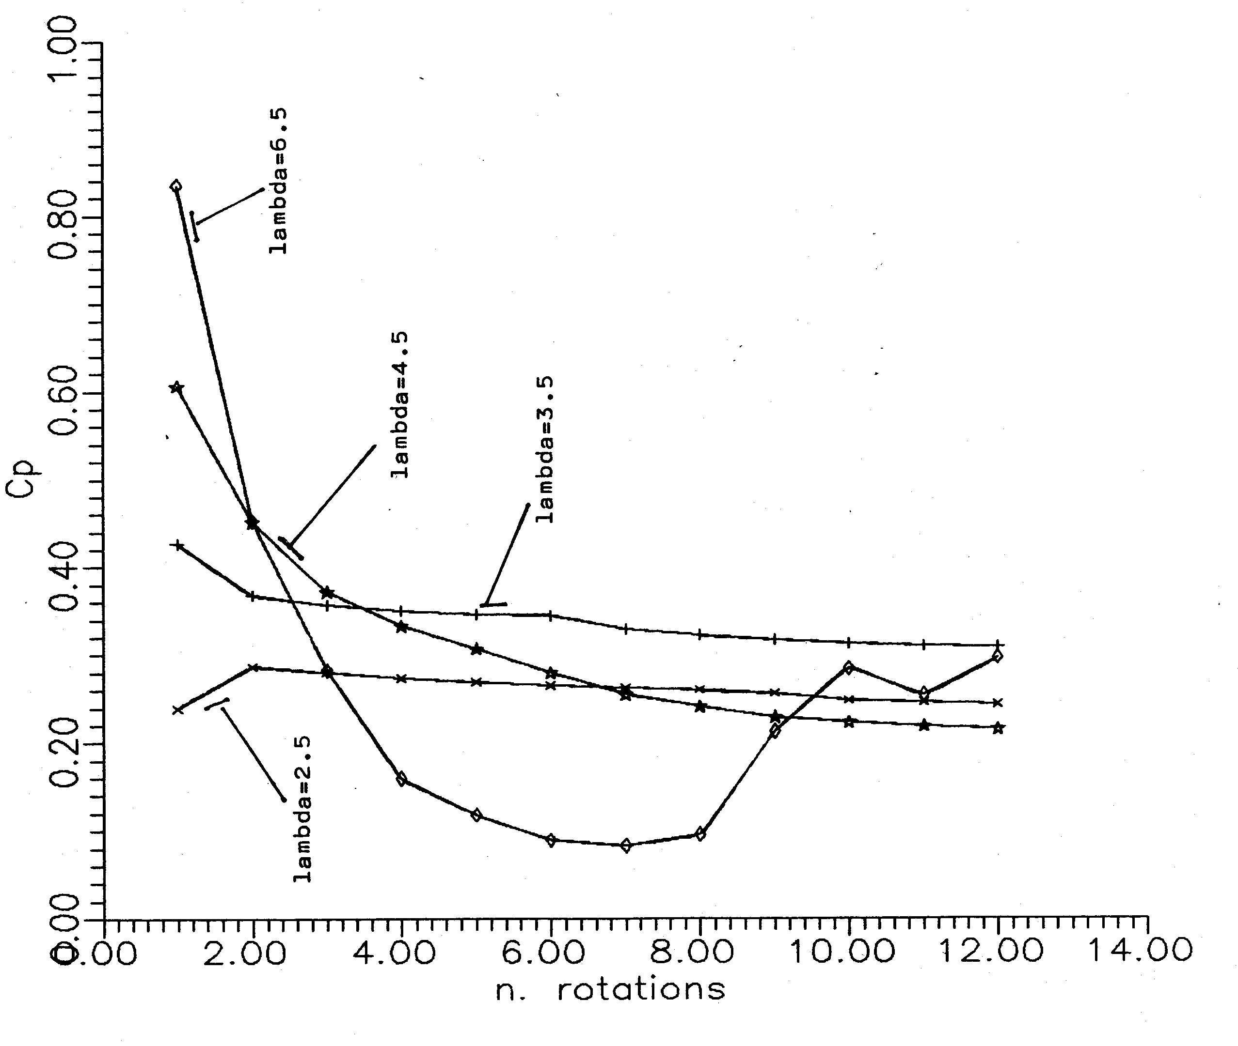
Figure 5 - Evolution before reaching permanent flow for the vertical ax rotor with
straight blades at different operation modes (using vortex model Strickland)

For λ=6.5 C_{P} decreases for getting stable and then, after 9-10 revolutions, it jumps to another operation mode and remains oscillate.
The last two image packages [fig 6,7,8 and fig 9,10,11 ] describe exclusively what is happening in wake up to 7R distance of turbine ax.
The field indicators were Δv_{X} and Δv_{Z}, variations of velocity components along and normal on flow direction.
In order to emphasize what changes appear in wake at operation mode variation, it was represented the wake for λ= 2.5, at 1220°. The vortex nuclei are difficult to be recovered, but they can be more easily located on v_{Z} component images (normal on flow direction) in concentric deployment area. For λ=5.5, at almost 4 revolutions in this mode (1220°) the vortex wake did not cover all observed surface, the number of identifiable vortices is still low.
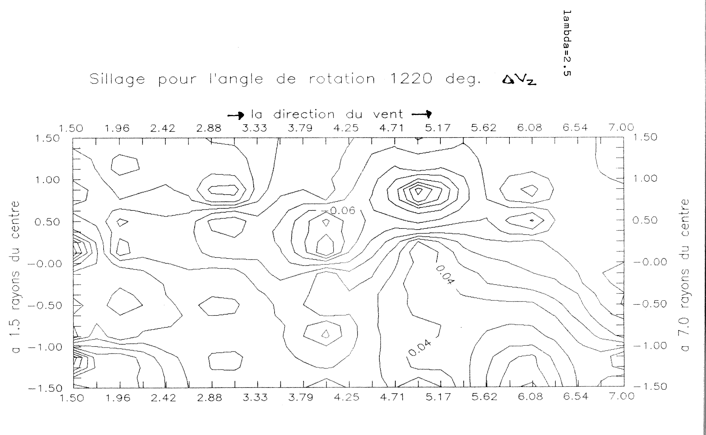

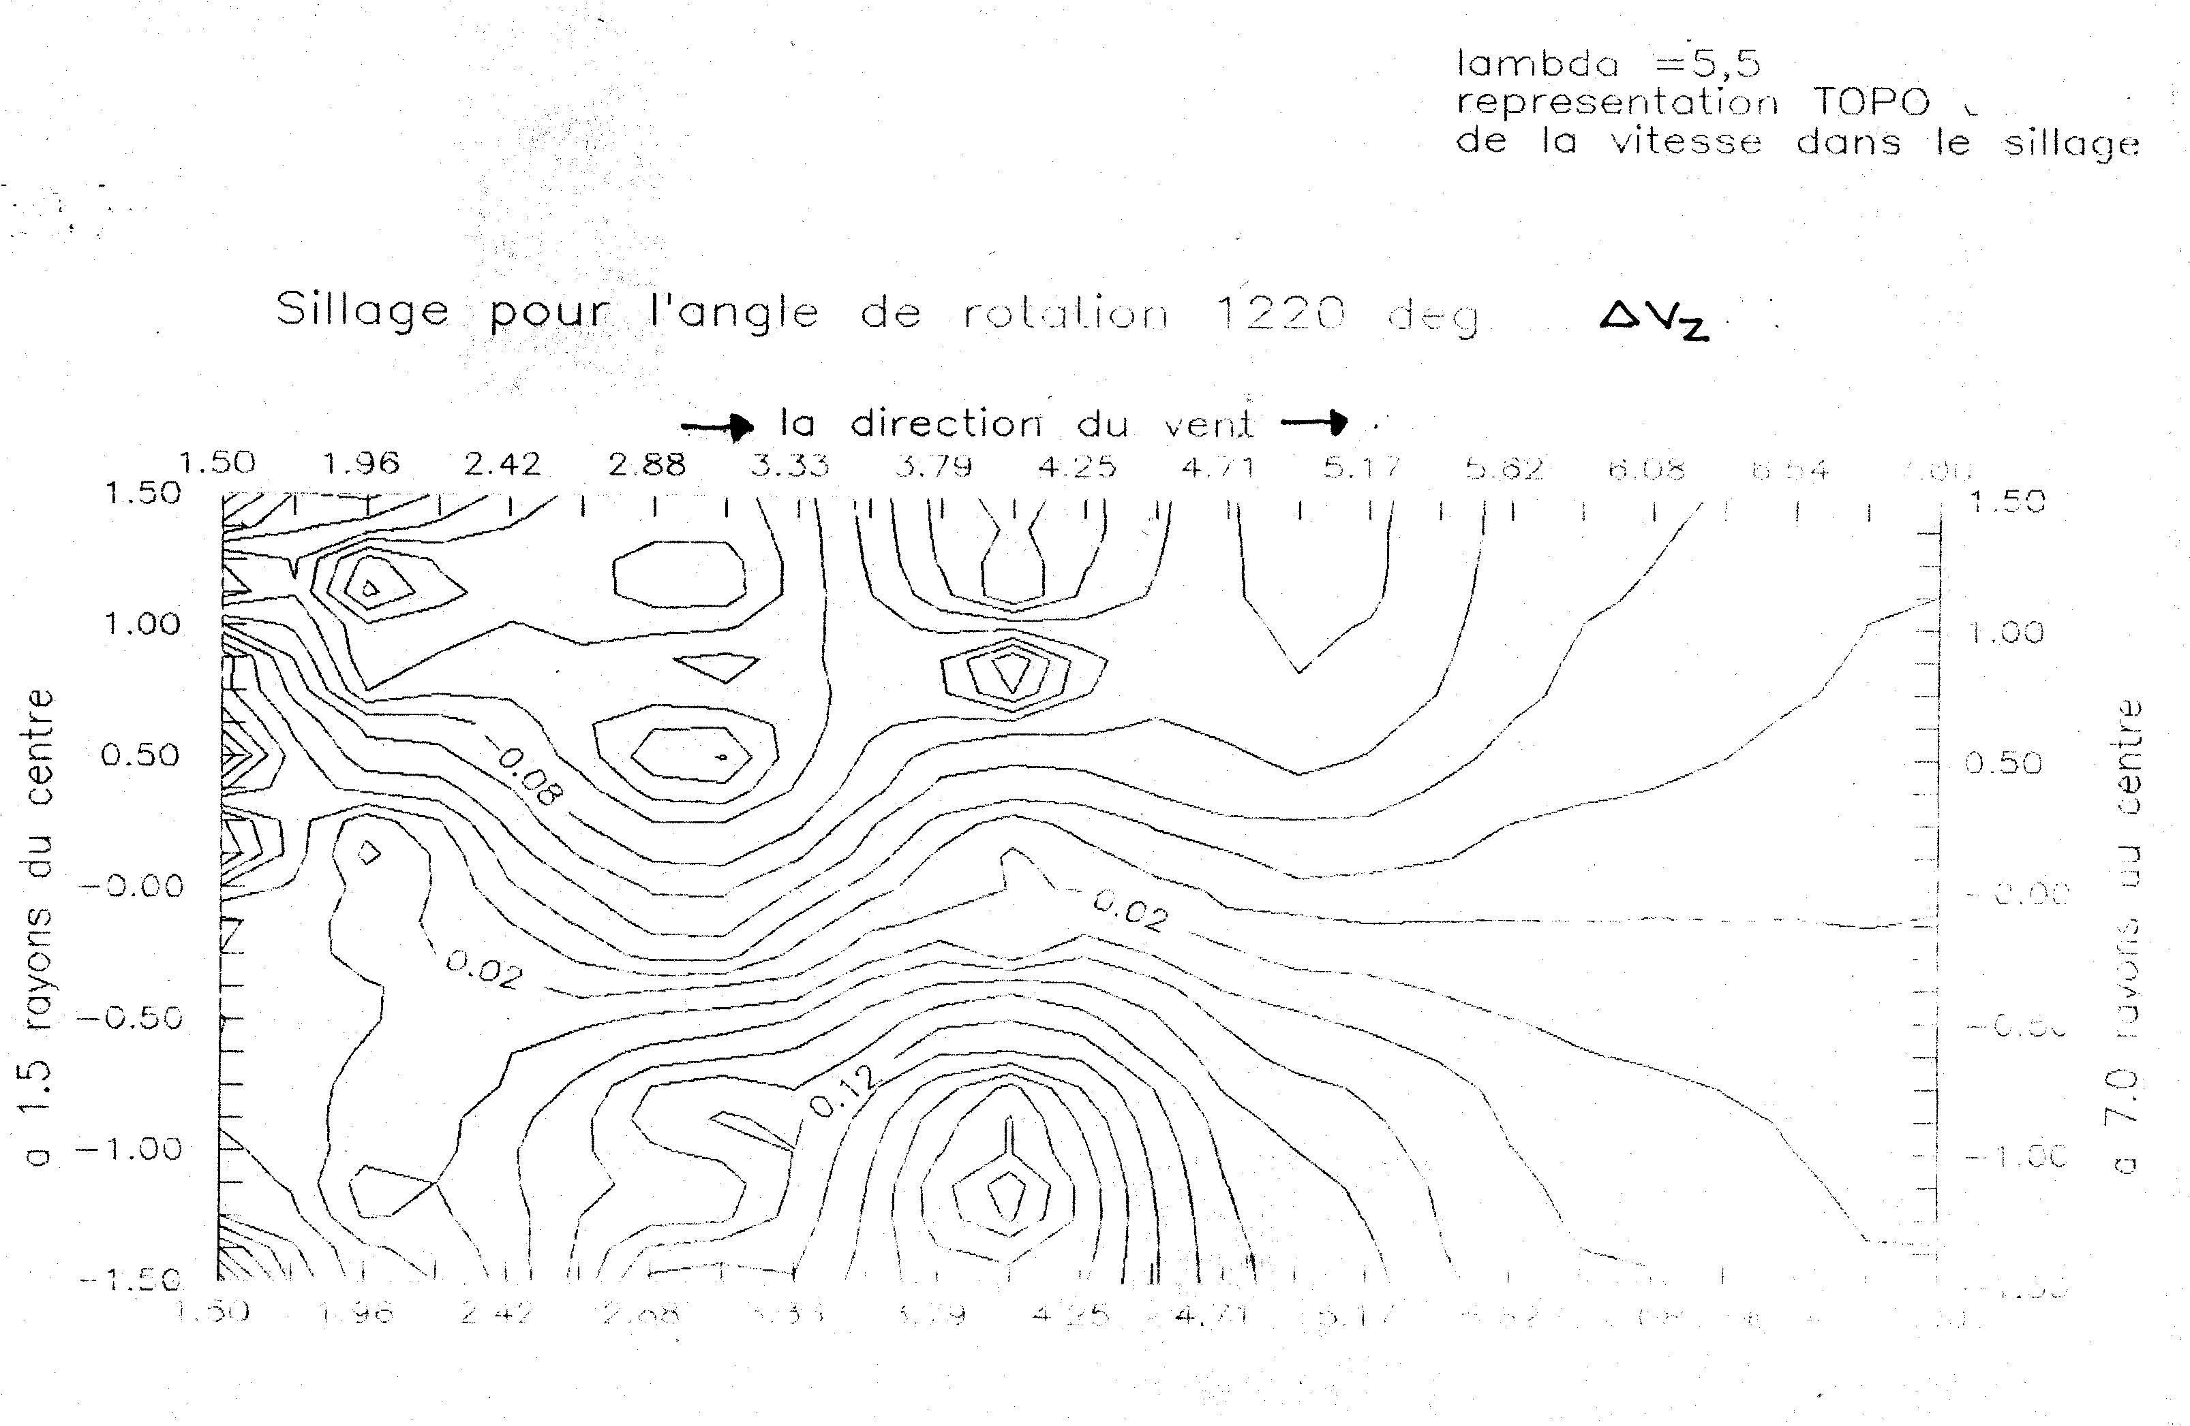

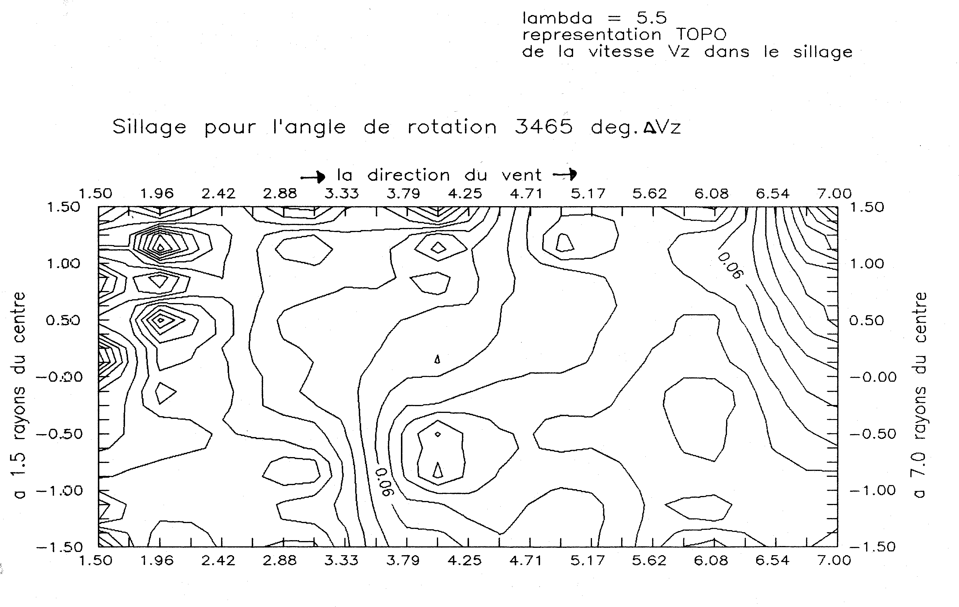
Figure 6,7,8 - Images of constant Δv_{z} lines in VAWT wake in different
operation modes and moments from starting rotation

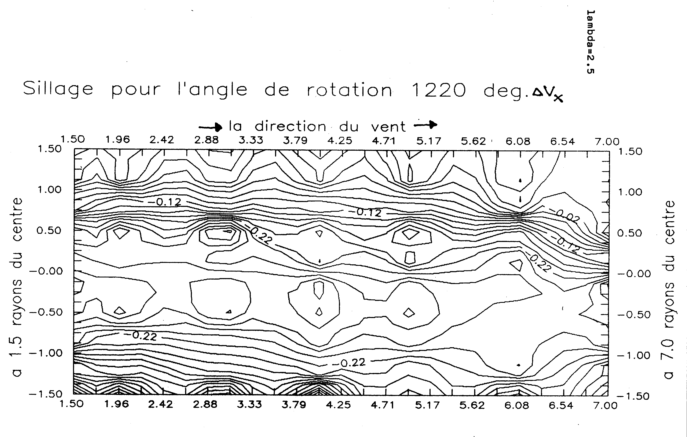
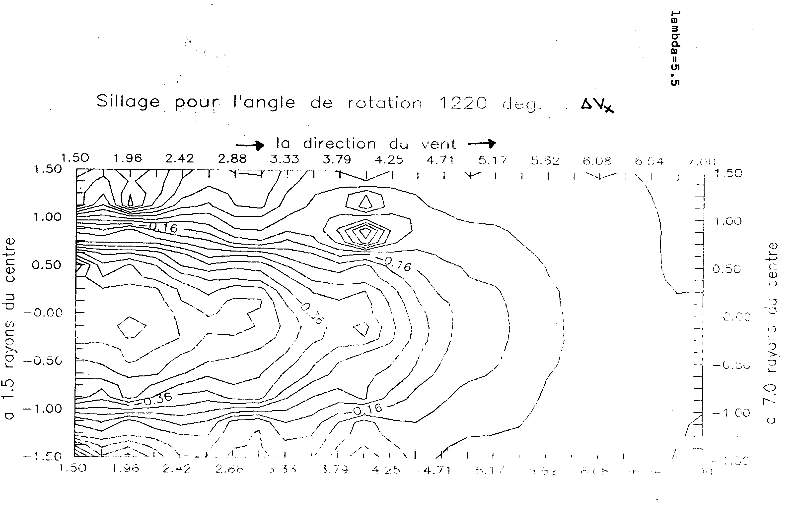
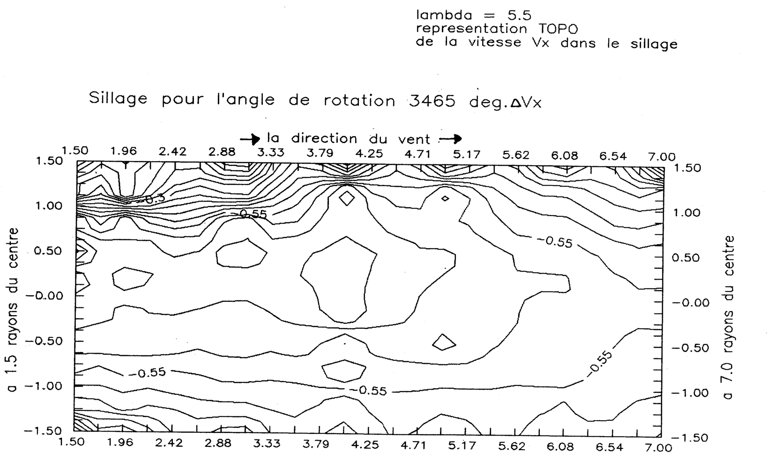
Figure 9, 10,11 - Images of constant Δv_{x} lines in VAWT wake in different
operation modes and moments from starting rotation

After almost 10 revolutions (3465°) at the same operation mode m, some of the vortices left flowing ax and observed surface is crossed by diagonal currents with blocking passage areas and flow inversions. Here it can be noticed a close similarity with vortex representation from H. Matsumiya [3] article. (fig 12)
Finally it may be concluded that the model and program represent an important didactic and scientific instrument for the simulation of VAWT operation. It can be improved especially in data input and processing modules. It is also imposed to enlarge the downward field, at least up to . It can be used for the study of the impact on energy performance of the turbine design and functional parameters, especially to analyze sensitivity to profile changes.
The thorough description of the field downwards semi-rotor will allow an accurate analysis of the interaction with the fluid around all revolution circle.

Acknowledgements -The authors wish to thank to Prof. E. Rieutord and Prof. R. Morel, for the special conditions assured during paper elaboration (software, laboratory equipment, consulting), in Fluid Mechanics Department from Dept. Génie Mécanique Construction, INSA Lyon.

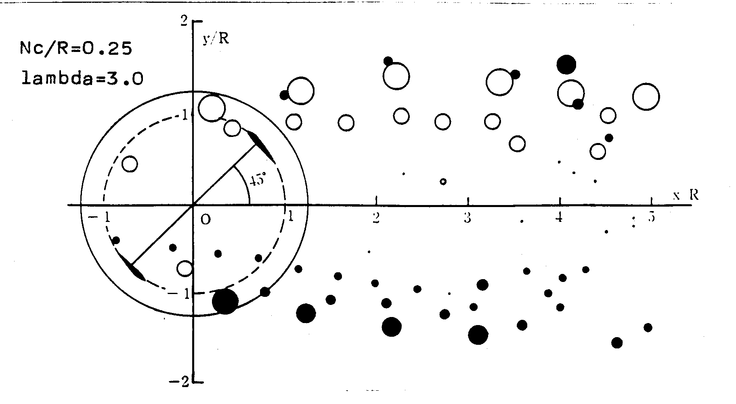
Figure 12 - Image of the wake detached vortex downwards VAWT,
virtual construction (Matsumiya [3])

REFERENCES

[1] Holmes, O. – A Contribution to the Aerodynamic Theory of the Vertical Axis Wind Turbine, Proceedings of the International Symposium on Wind Energy Systems, St. John´s College, Cambridge, England, sept.1976
[2] Larsen, H.C. – Summary of a Vortex Theory for Cyclogiro, Proceedings of Second U.S. National Conference on Wind Engineering Research Colorado State University, pp V-81, 1-3 June 1975
[3] Matsumiya, Hikaru – Numerical Experiments on GIROMILL Rotors, Bulletin of Mechanical Engineering Laboratory no. 40/1984, Kaisui, Japon
[4] Sharpe, D.J. – A Vortex Flow Model for the Vertical Axis Wind Turbine, First BWEA Wind Energy Wokshop, Cranfield, April 1979
[5] Strickland, J.H.; Webster, B.T.; Nguyen, H. - A Vortex Model of the Darrieus Turbine: An Analytical and Experimental Study, SAND 79-7058, Sandia, Albuquerque, New Mexico
[6] Strickland, J.H. – The Darrieus Turbine: A Performance Prediction Model Using Multiple Streamtubes, SAND 75-0931, July 1975, Sandia Laboratories, Albuquerque, New Mexico
[7] Templin, R.J. – Aerodynamic Performance Theory for the National Research Council Vertical Axis Wind Turbine, LTR-LA-160, June 1974
[8] Vries, O.de – Rigid Rotor Computer Program for the Darrieus Wind Turbine Performance and Blade Loading, NLR TR 77031U, April 1977
[9] Paraschivoiu, Ion – Wind Turbine Design. With Emphasis on Darrieus Concept., Ecole Polytechnique de Montréal, 2002

