The 2nd International Conference
″Computational Mechanics
and
Virtual Engineering″
COMEC 2007
11 – 13 OCTOBER 2007, Brasov, Romania

PROIECTING OF CONCRETE ELEMENTS EXPOSED TO
CHEMICAL AGGRESSIVENESS AND REPAIRING
SOLUTION OF THE ADMAGES USING
POLYMERIC CONCRETE

Ing.prof.gr.I MIHAELA NITU
GRUP SCOLAR CONSTRUCTII “ANGHEL SALIGNY”
BD. N. GRIGORESCU 12, SECTOR 3, BUCURESTI

Abstract: The authors wish to bring a character of novelty through the choosen theme.
This is important for the engineering gfield, directly connected with the production market-some of concrete elements are exposed to chemical agents and our idea is intended to protect them.
The paper contains four chapters, refering to general terms and information looking the composition of concrete fighting with the chemical aggresion, as well as methods of repairing the demaged zones throught polymeric concrete; further, it presents practical solutions and, in the same time, theoretical diagrams, in the second chapter. The illustrated part of this researching work is constituted of maps, tables, visual drawings – for example, the water action on a building.
The water destroys the concrete, so primary, we establish the composition according to the SREN; the next step is a secondary protection with chemical materials and finally, if the concrete is highly demaged, we fill the corodated area with polymeric moisture.
A personal contribution is: at first compoling various publishings and the conceive diagrams and mathematical statistic; all these come to assure the efficiency for being compatible with environmment and humman body.
The paper refers at scientifical multiareas, crossing through disciplines, and it also contains instruments of evaluation like guides and standards and other books.
Much more, it is important for current intervention leading to the protection, security, and health in day to day work.

CHAPTER 1

GENERAL NOTIONS REFERS TO ACTION OF NATURAL AGRESSIVITTY ON THE CONCRETE

The destroy of the concrete is determinated from corosive actions like chemical, physical biochemical or combinate. The most frecvently is the chemical one; there are four processes of corosive [1 ].
*type I – distroying of cement stone through soft water or water with CO₂
*type II – agressiv agents are acid solution magnezium, fat and sugar.
*type III is determinate from sulphat and CaCl.
The concrete could be damaged from: [1 ].
- water with little hardness coused by rain, melding of snow, river as follow that Ca (OH)₂ goes out from cement stone. So, it is important to use a mixed cement with slag and trass.
- water with CO₂ produce a dissolving of calcium salt in cement stone (badly is the loosing of liant, proporties).
- water with sulphate; sulphates, there are to find in underground water or sea water (presence of them are to meet in any ground)
- Sea water; although the sea contains, many dangerous ions, the salt in sea water, is not so risky.
The chemical deterioration is caused specially from Mg(SO₂). Like aspect seems with an erosion or diminuation of constituents in mass. Also the bacterium could have an important role in distroiering of the concrete in Black Sea. The steel concret is more sensible that the simple concret because the cover over steel will be expansiv.
Very important for to resist by deteriorat ion is the dose of cement 350 kg cement/m3 for simple concrete and 450 kg cement/m³ for steel concrete and the cover is over 50 mm.
*Finally we adthat it’s exist another types of agressivitty produced by H₂S, ammoni salt, etc.
It is important to know the compozition andlevel of water in underground and the compozition of ground too, because the water could rise till the foundation.
The danger appear specially when the water contains C,S.

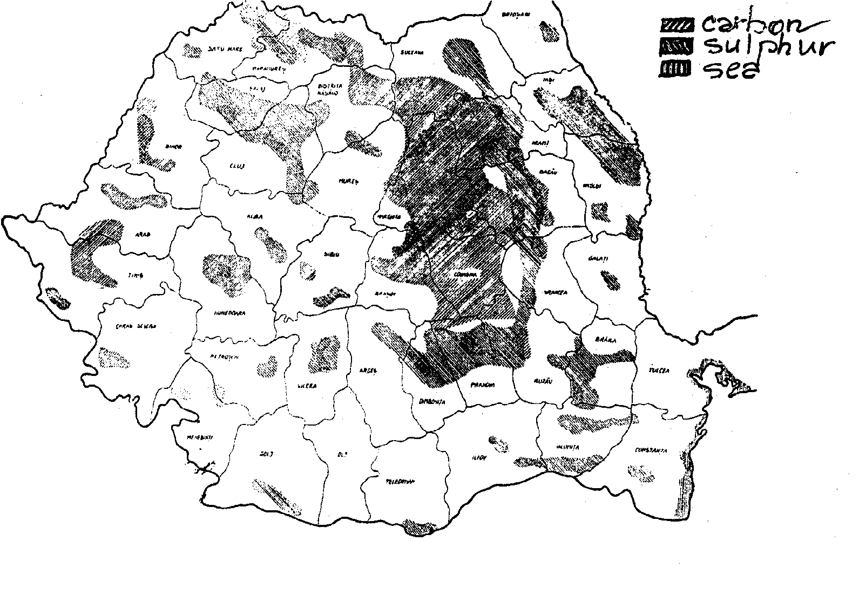

Figure 1: Zonarea dupa agresivitatea apei

CHAPTER 2
PROJECT AND CONCEPT CONDITION OF CONCRETE EXPOSED BY AGGRESSIVE SUROUNDING – PRIMARY PROTECTION

2.1 General aspects.

Definetely important to apreciate the aggressive atmosphere is to be included in the project them the following:
- type of aggressive agents
- the chemical substance concentration
- relative humidity of air
- the temperature of medium
These last are contained in technological and execution project for helping by documentation and studies.
On the surface of concrete elements could be formed condensation, salt dregs; the fight against them is made through increase the class of agressivitty with a step and application of a anticorrosiv protection.
The form of the element must be regulary, simple, plane, with roundly edges. To be ignore staying of condensation at join (join between element of structure or between element and instalation, or in perforation through element.
Presstressed concrete don’t be utilised in closed space with H2 [5], [6 ].
More and the most agressivity don’t permit utilising of girder (lattice work).
A little agressivity permit utilising of reinforced concrete element with granulit aggregat.
It must be protected too the anchor zone and the place where are fixed equipments.

2.2 Primary protection through conception the concrete, its constituents and its steel.

This chapter is built based on SREN 206-1 which defines at “class of exposure” [8 ].
The first letter X from exposure; the next it refers at corosive agent: C – Carbonation, D – Deicing salt, S – Sea water, F - Frost, A – Aggressive, M – Mechanical abrasion.
The planing of concret is function of chemical attack, so:
- water/cement
- resitance class
- cement dose
have values for various exposure closses.

Table 1: Valorile limita recomandata pentru compozitia si proprietatile betonului pentru clasele de expunere XF, XA si XM

Clasele de expunere
 | Atac infget-dezghet |  |  |  |  |  | Atac chimic |  |  | Atac mecanic
 | XF1 | XF2 |  | XF3 |  | XF4 | XA1 | XA2^{c} | XA3³ | XM1 | XM2 |  | XM3
Raport maxim apa-ciment | 0.50 | 0.55ª | 0.50 | 0.55ª | 0.50 | 0.50ª | 0.55 | 0.50 | 0.45 | 0.55 | 0.55 | 0.45 | 0.45
Clasa minima de rezistenta | C25/30 | C25/30 | C35/45 | C25/30 | C35/45 | C30/37 | C25/30 | C35/45 | C35/45 | C30/37 | C30/37 | C35/45 | C35/45
Dozaj minim de ciment (kg/m³) | 300 | 300 | 320 | 300 | 320 | 340 | 300 | 320 | 360 | 300 | 300 | 320 | 320
Continut minim de aer antrenat (%) | - | a | - | a | - | a | - | a | - | - | - | - | -
Alte conditii | Agregate rezistente la inghet-dezghet conform SR EN 12620 |  |  |  |  | d |  | Ciment rezistent la sulfati |  |  | Tratarea suprafetei btonului^{b}
^{a)}Continutul de aer antrenat se stabileste in functie de dimensiunea maxima a granulei in conformitate cu 5.4.3. Daca betonul nu contine aer antrenat cu intentie, atunci performanta betonului trebuie masurata conform unei metode de incercari adecvate, in comparatie cu un beton pentru care a fost stabilita rezistenta la inghet-dezghet pentru clasa de expunere corespunzatoare.
^{b)}B) De exemplu tratarea prin vacuumare
^{c)}Cand prezenta de SO²⁻₄ conduce la o clasa de expunere XA2 si XA3 este esential sa fie utilizat un ciment rezistent la sulfati. Daca cimentul este clasificat dupa rezistenta la sulfati, trebuie utilizate cimenturi cu o rezistenta moderata sau ridicata la sulfati pentru clasa de expunere XA2 (si clasa de expunere XA1 este aplicabila) si trebuie utilizat un ciment avand o rezistenta ridicata la sulfati pentru clasa de expunere XA3.
^{d}) In cazul expunerii in zonele marine se vor utiliza cimenturi rezistente la actiunea apei de mare.

Table 2: Valorile limita recomandate pentru compozitia si proprietatile betonului pentru clasele de expunere XO, XC, XD, si XS

 | Clasele de expunere
 | Nici un risc de coroziune sau atac chimic | Coroziune indusa prin carbonatare
 | XO^{a)} | XC1 | XC2 | XC3 | XC4 | XD1 | XD2 | XD3 | XS1 | XS2 | XS3
Raport maxim apa-ciment | - | 0.65 | 0.60 | 0.60 | 0.50 | 0.55 | 0.50 | 0.45 | 0.55 | 0.50 | 0.45
Clasa minima de rezistenta | C8/10 | C16/20 | C16/20 | C20/25 | C25/30 | C30/37 | C35/45 | C35/45 | C30/37 | C35/45 | C35/45
Dozaj minim de ciment (kg/m³) | - | 260 | 260 | 280 | 300 | 300 | 300 | 320^{b} | 320 | 300^{b} | 320^{b}
320Continut minim de aer antrenat (%) | - | - | - | - | - | - | - | - | - | - | -
Alte conditii | - | - | - | - | - | - | - | - | - | - | -
- | -
^{a)}Pentru beton fara armatura sau piese metalice inglobate
^{b)}La turnarea elementelor maive se recomanda cimenturile cu caldura redusa de hidratare. Pentru elemente masive (grosimea elementelor mai mare de 80 cm) trebuie sa se adopte un dozaj de ciment de 300 kg/m³

Our contribution consist in realising a diagram in which the resistance is depended on class of aggression and water/cement
Diagram:

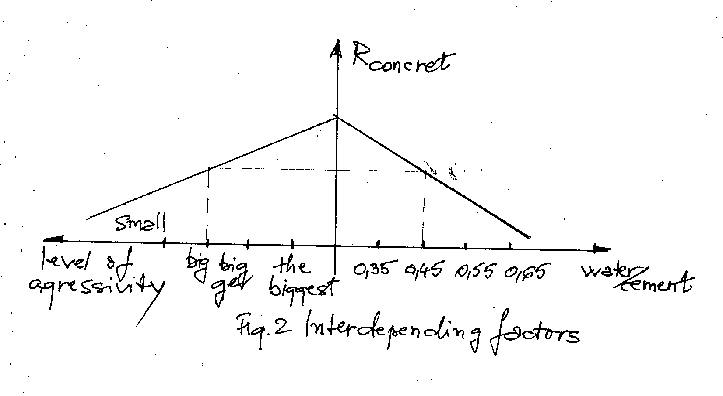

Figure 2: Interdepending factors

In Romania there are in the moment many types of cement; the choice is made in function of these factors:
- temperature when the concret is poured
- execution of the work
- dimension (highness, lenghth and width) of elements.
- working condition (cold weather, hot weather.
The same standard SREN 197-1 indicate some caracteristics of cements made in Romania and aptitude for utilising and shows where utilising goes not. [5 ], [6], [8 ].

Table 3: Caracteristici ale unor tipuri de cimenturi din Romania

Tip ciment | Sensibilitatea la frig | Degajare de caldura | Utilizare Preferentiala | Contraindicatii | Observtii particulare
1 | 2 | 3 | 4 | 5 | 6
CEM I 52,5R | Insensibil | Ridicata | Elemente monolite si prefabricate Betonare pe timp friguros | Betoane massive**  mortare,sape | Destinat in special elementelor prefabricate
CEM I 42,5R | Insensibil | Ridicata | Elemente monolite si prefabricate Betonare pe timp friguros | Betoane massive**  mortare,sape | Pe timp calduros trebuie luate masuri speciale
IA 52,5c | Insensibil | Ridicata | Elemente prefabricate
SR I | Insensibil | Redusa | Betoane rezistente la sulfati
CD 40 | Insensibil | Redusa | Betoane de drumuri
CEM II A-S  32,5 N sau R | Putin sensibil | Redusa | Beton, beton armat
CEM II A-S  42,5 N sau R | Putin sensibil | Medie | Beton, beton armat
H II AS | Putin sensibil | Redusa | Betoane masive
1 | 2 | 3 | 4 | 5 | 6
CEM II B  32,5 N sau R | Sensibil | Redusa | Beton, beton armat |  | Necesita o tratare prelungita
CEM II B  42,5 N sau R | sensibil | Redusa | Beton, beton armat |  | Necesita o tratare prelungita
CEM III A  32,5 N sau R | Foarte sensibil | Redusa | Beton, beton armat  Betonare pe timp calduros | Betonare pe tim friguros | Necesita o tratare prelungita
* *La turnarea elementelor masive (avand grosimea egala sau mai mare cu 80 cm) se recomanda utilizarea cimenturilor cu degajare redusa de caldura

Adding addmixture are necessary to be included for:
- more fluid/superfluid
- recicling the internal air
- reduce the water/reduce very much the water
- setting of cement this moments comes bately
- setting of cement this woment comes eaarlier
In Table 4 are given the types of concrete (bount with technologi cal and pouring conditions) in function of types of adding parts. [5 ], [6], [8 ]

Table 4: Aditivi

Nr.  Crt. | Tip beton, tehnologie si conditii de turnare | Aditiv recomandat | Observatii
1 | Betoane de rezistenta avand clasa cuprinsa intre C8/10 ]i C30/37 inclusiv | Plastifiant | Dupa caz: Superplastifiant
2 | Betoane supuse la inghet-dezghet repetat | Antrenor de aer
3 | Betoane cu permeabilitate redusa | Reducator de apa/plastifiant | Dupa caz:  - intens reducator de apa/superplastifiant  - impermeabilizator
4 | Betoane expuse in conditii de agresivitate intensa si foarte intensa | Reducator de apa/plastifiant | Dupa caz:  - intens reducator de apa/superplastifiant  - inhibitor d coroziune
5 | Betoane executate monolit avand clasa ≥C35/45 | Superplastifiant/intens reducator de apa
6 | Betoane fluide | superplastifiant
7 | Betoane masive  Betoane turnate prin tehnologii sspeciale (autocompactante) | (Plastifiant)  Superplastifiant+[ntarzietor de priza
8 | Betoane turnate pe timp calduros | Intarzietor de priza+superplastifiant (plastifiant)
9 | Betoane turnate pe timp friguros | Anti-[nghet+accelerator de priza
10 | Betoane cu rezistente mari la termene scurte | Acceleratori de intarire fara cloruri

For aggregate the dimension of grain is embraced between 16-63 mm for the class of concrete ≤C50/60 (For classes over C50/60 the content of fine parts are bigger) [8 ].
Steel must be cover with concrete more then in medium without agressivity (ourguid is the same standard).
Even the cover is not distroyed, the aggressive substances difuse through concrete till the steel.
The bigest danger is represented by Cl ions.
The corosion appears in many cases due to fault of execution
The protection against agressiv agents like H₂O, CO₂, H₂O+CO₂ in ground water is realised through growing up the compactness of concrete be growing up of the cover, limiting of the possibility of cracking (more steel), avoiding the joint rost created by casting.
An efficient proceeding is using by inhibitor of corosion like:
- chromat easily to soluble
- benzoate sodium
- borate
- nitrite sodiu [5 ], [6],

CHAPTER 3

SECONDARY PROTECTION

- Prepare of the surface to be ready for application of protection against corosivity it be carried that the surface of element, before solution beeing like under.
- continuos
- without declivities, segregation
- cleaning and roughness are made with mechanical means: sanding brushing
- dustcatching through blowing compressed air
- ungreasing solvent organic
- it’s important to assure the level of umidity for material and for the working volume this last to be closed.
- At once is to prove a little surface
- Standard gaugen (the specialists named staarring at its behaviour).
- In chaptel 2 it was treated the planing of concrete (its constituents) for resist at corrosion. If these rules are not respected, it will be applied a plstering (cement mortar) [3 ], [5 ], [6]
Before appling the material of protection sistem it’s to consider the following:
- class of agressivity (chaptel 2)
- thickness of the system (40…340)
- maximal open of crack (0,25 mm) it comes next the structure of the protection system.
- Amorce firsty coat (grund) – 1-2 layers
- Intermediary paint – 2-3 layers
- Finished layer and protection
As types of produces there are:
- pitch paint gudron
- Epoxi
- Enamel perclorvinil
- Polyurethane (pitch)
- Polyuretan (against ulsunny rays)
- Acryl (vinarom) [6]

CHAPTER 4

REPAIRING OF FAULTS WITH POLYMERIC CONCRETE

The old deteriorated concret represent the support layer
The existed part is processed to be fill it or over with polymeric concrete.
- The preparing of the support
- the contact surface must be rough adhesion and composed by plane surfaces, preferation ally perpendicular
- in existed concret are made cogging or connection bars.
- It will be applied amorce on the existed concret.
- The reinforcement in existed concret will be cleaned (faraway the rust).
- applyng of the polymeric concret
- the thickness of the new annex is minimum 20 mm; if it is necessary the included steel is were with stitch 25…40 mm.
- it will be assemble an water-tight coffrage
- by mixing ofconcrete it will be used the mixer
- compactness is by external vibration on the coffrage
- no special treatment after pouring only maintain the temperature 10…30⁰ of the sorounding medium
- the prescription of composition of polymeric concrete is given in table below [5,6]

Table 5: Producatori si standarde

Nr.  Crt. | Denumirea material | Producator | Norma de calitate
0 | 1 | 2 | 3
1 | Agregate calcaroase | Exploatarea miniera Orsova | STAS 5090
2 | Agregate cuartoase | Exploatarea miniera Orsova | STAS 8517
3 | Agregate silicioase | Exploatarea miniera Orsova | STAS 1667
4 | Alorex 102 (CR+CI) | Anticorozivul SA | N.T.I.5661/87
5 | Alorex VSA (CR+CI) | Anticorozivul SA | N.T.I.5250/82
6 | Asmoplex L₁ | METCHIM Galati | N.T.I. 03/95
7 | Asmoplex L₁ | METCHIM Galati | N.T.I. 03/95
8 | Diluant epoxidic | Anticorosivul SA | STF 3081/93
9 | Electrografit | Anticorosivul SA | STAS 4667
10 | Faina cuart | Exploatarea miniera Orsova | STAS 11095
11 | Furfurol-acetona (ORAMIN) | Anticorosivul SA | STF 10641
12 | Gudron acid tip G | SIDEX – Galati | N.T.I.

Tabl 6: Compozitii pentru betoane polimerice

Tipul de beton  Materialul | BE/C 7/70 | BE/C 7/80
Tipul de beton  Materialul | Parti in greutate
- Alorex 102 | 100 | 100
- In 222 (intaritor) | 50 | 50
- Faina de cuart | 110 | 75
- Agregate sortul 0,5… 1 mm | 150 | 100
1…2 mm | 225 | 150
2…4 mm | 150 | 100
4…7 mm | 340 | 225

- it comes bellow a statistical figure own –made.

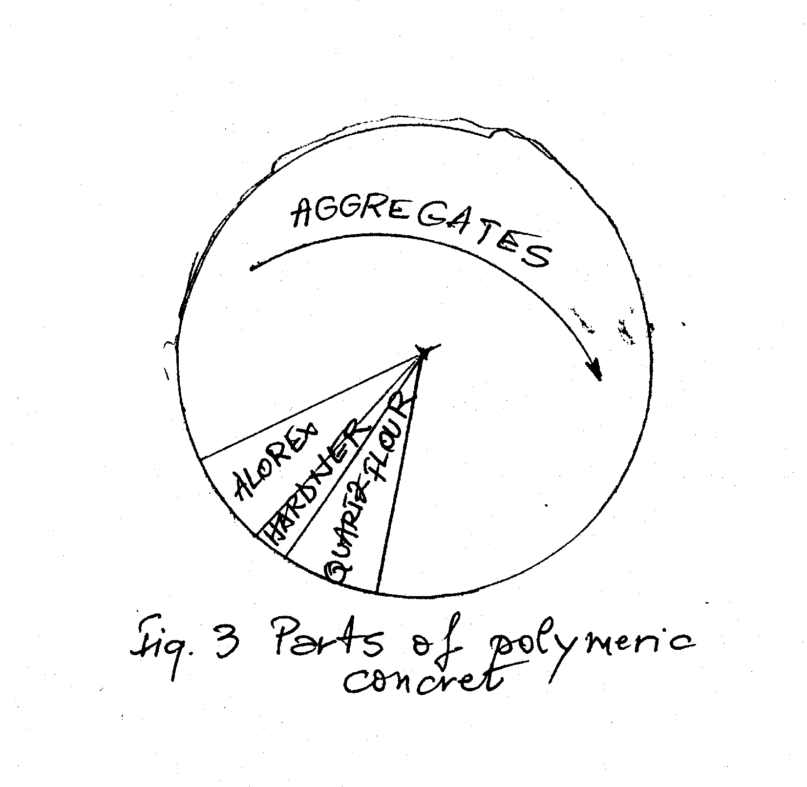
Figure 3: Parts of polymeric concret

- taking of evidence and ready made of specimen (measuring the dimension keeping in determinated condition, testing and interpretation of the results).
Refering at experiments, it will be obtained the physical and mechanical charcteristics (density strength of compression knsile strength, modulus of elasticity aand another characteristics (contruction, plastic deformation).
Not only the experimental dates, but the visual examination it important too.
- Adding to the quality control it is to say that an esential problem consist in adhesion at support – layer.
Finally at reception, the dimensional deviations must be conform with the project.
[3 ] [5 ] [6] [8 ]

BIBLIOGRAPHY

[1 ] Natural aggresivity on the romanian surface – A. Vasiliu, E.Popescu, C.Solacolu, D. Teodorescu
[2 ] Construction and Techology of works R. Constantinescu, C. Pavel, M. Voiculescu, Didactical and Pedagogical Publishing Housse 1974.
[3 ] Normbook PC 1/1-93 – Degradation and anticorosiv protection of concret and reinforcement
[4 ] Construction – Pestisan Didactical and Padagocical Publishing House 1995
[5 ] Normbook GP – 033 – 98, Polymeric concrete utilised by reinforcement concret with degradation caused by corosion.
[6 ] Normbook C170-87 – revision in SR 13510/2006
[7 ] Review AROTEM 1/2007 – writing methodology
[8 ] SREN 206-1 , SR 13510/2006
[9] “Construction materials” Book for Industrial Highschool Didactical Publishing 1989, V. Maciuca

ADUCEM PE ACEASTA CALE MULTUMIRI I.N.C.E.R.C. BUCURESTI
PENTRU MATERIALELE PUSE LA DISPOZITIE SI
PENTRU TOT SPRIJINUL ACORDAT

