The 2nd International Conference
″Computational Mechanics
and
Virtual Engineering″
COMEC 2007
11 – 23 OCTOBER 2007, Brasov, Romania

BIOMECHANICAL BEHAVIOR OF THE HUMAN LUMBAR SPINE

Dan Ioan Stoia, Mirela Toth-Taşcău, Cosmina Vigaru,
Politehnica University of Timisoara, ROMANIA, ionut@cmpicsu.upt.ro, mirela@cmpicsu.upt.ro, cosmina@cmpicsu.upt.ro

Abstract: The paper purpose is to find a correlation between the lumbar spine movement and the intervertebral disc pressures. The fundamental of the paper involves the functional anatomy of the spine and the mechanics of the spine structure. In order to draw a pertinent conclusion, a number of 20 healthy subjects riding a medical bike in different conditions were tested. The recording results involve the angular amplitudes of the lumbar segment in flexion, rotation and lateral movement. Combining the experiment’s results and the simplified model of the spine, the reaction forces acting on the lumbar spine were calculated.
Keywords: spine, flexion movement, reaction forces, lumbar segment, equilibrium equations

1. INTRODUCTION

The human spine is a very complex structure composed by: 33-34 bone elements called vertebras, 344 joint surfaces, 24 intervertebral discs and 365 ligaments with 730 insertion points. Due to the large number of joint facets existing in a vertebra, the whole spine system has many capabilities of the movement. From the anatomical point of view, the human spine can be divided in three segments: lumbar segment (the segment bounded with the pelvis), thoracic segment and cervical segment (which sustain the head). Because it sustains the body trunk, the lumbar segment supports the highest loads during the daily activities. There are many experimental and theoretical ways to investigate the mobility of the spine [1].
One way is based on cell analysis of movement. The existing cells for movement analysis allow to investigate different body segments during normal or specific activities. In order to investigate the biomechanical behavior of the human lumbar spine, a Zebris CMS-HS system was used. The physical principle of the investigation method is based on emission and reception of ultrasounds. The system provides the angular amplitudes of the lumbar segment in all the anatomic planes (coronal, sagittal and transverse). The recorded angles refer to flexion, rotation and lateral movements. 40 years old men provided the anthropometric dimensions of the body segments. The theoretical studies are based on the general mechanical principles.

2. EXPERIMENTAL STUDY

In order to investigate the spine movement, 20 healthy subjects having the same age (40 years old) and comparable heights were tested riding a medical bike. Each of the subjects was recorded in 5 different conditions. The test conditions consist of modifying the bike seat position, along Z axis, from the lowest level to the top. The riding velocity was imposed at the same value for each subject, in order to obtain easier analysis of the data records. The sketch of bike and the diagram of the variation of the seat height by the seat level are presented in the figure1. The first step in the measurement technique with the Zebris system was to attach the sensors to the body [4]. In this case, the two sets of lumbar sensors were attached to the lumbar segment, one at the lowest part (corresponding to the fifth lumbar vertebra) and the other one surrounding the first lumbar vertebra. The system is capable to record all the movements of the lumbar segment: flexion-extension, lateral bending, rotation, pelvis tilt and total trunk inclination.

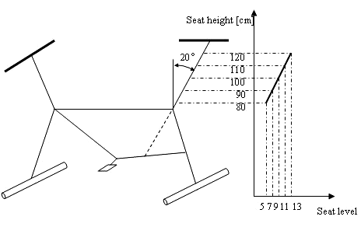
Figure 1: Measurement positions of the bike seat

The test starts with the bike seat in the lowest position and ends in the highest position of the seat. During the test, the Zebris system records the angular amplitudes. Following the same recording method for all the investigated persons, a large database was established. After the analysis of the all the recording data, a representative subject was selected. In the paper are presented the recording data for this subject called from now on “patient x” in two cases: in the first position of the bike seat (figure 2), and in the last position (figure 3).

Figure 2: Angular amplitudes for Patient x with the bike seat in the lowest position | Figure 3: Angular amplitudes for Patient x with the bike seat in the highest position

From the long time interval of the exercise a lap of 10 seconds of movement that can be considered representative for the whole movement cycle, has been chosen. Comparing the figures 2 and 3 it’s clearly to see the differences between the angular amplitudes in both cases. In the case of highest seat level, the amplitudes of the angles are greater because of the additional movements executed by the subject. The additional movements are necessaries to compensate the lack of limbs length. So, an optimal level of the seat height, corresponding to an optimal physical effort, can be established.
The lateral bending, flexion-extension and rotation manifest a periodical variation with respect to time (figure 3) during the test intervals. The pelvic and total trunk movements manifest an apparently chaotic movement, very much influenced by the subject additional movements: head, hands and shoulders movements. Because the highest angular interval corresponding to a periodical movement was recorded in the case of lateral bending, this movement was taken into consideration for the calculus. The range of the lateral movement is situated between +2 and -6 degrees. This non-symmetrical variation against zero line shows that the “Patient x” bends the lumbar spine more on the left side (the negative values correspond to the left side movement) and less on right side. In order to establish the pressure appearing in the L5-S1 intervertebral disc, the absolute value of the highest amplitude was used. This maximal value corresponds to the bending on the left side of the spine.

3. THEORETICAL STUDY

In the second part of the study, simplified mechanical models of the spine and pelvis according to the anatomical topology were established. Both external and internal forces acting on the lumbar segment have been applied accordingly with figure 4. The forces act due to the own individual segments weights, and muscles actions. In order to simplify the biomechanical behavior study, several considerations have been made. First, the anatomic segments (spine and pelvis) were modeled as two articulated mechanical plates (figure 5). The reaction force generated by the great psoas muscle, was considered to act at the top of the lumbar segment, on the first vertebra (L1). The psoas muscle is responsible for straitening the lumbar segment after a lateral flexion. In a free movement, the values of this force vary all the time proportional with the curvature angle against vertical spine line. In the present study, the value of the muscle force was taken from the literature, keeping the same test conditions (curvature angle and body weight) [2]. Taking into account the bone density and muscle mass, the own weight of the segments was approximated. The values of the gravity forces, muscle forces, anthropometric dimensions and curvature/insertion angles are presented in the table 1.

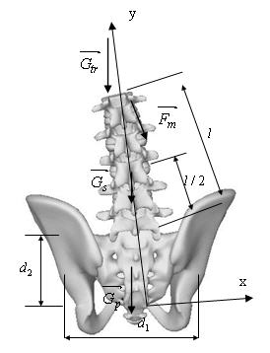 | 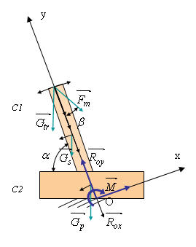
Figure 4: Forces acting on the anatomical model of the lumbar-sacral segment | Figure 5: Simplified model of the lumbar-sacral segment

Table 1: Parameters of the study
Parameter | Description | Value
α | maximum absolute value of the lumbar spine lateral bending | 5,5 deg
β | insertion angle of the great psoas | 23 deg
l | length of the lumbar segment | 25 cm
d₁ | width of the pelvis | 30 cm
d₂ | height of the pelvis | 20 cm
h | height of the pelvis along y axis: $h=\frac{d_{2}}{\text{sin}(\text{90}−α)}$ | ≈20 cm
F_{m} | value of the psoas muscle during contraction | 100 N
G_{tr} | total weight of the trunk | 470 N
G_{s} | own weight of the lumbar segment | 10 N
G_{p} | weight of the pelvis | 120 N

In order to calculate the reaction forces at the sacral level, the rigidity method of static equilibrium study was used.
Equilibrium equations of the simplified model based on the rigidity method [3] are:
(1)
(2)
By projecting the vectorial equilibrium equations on the reference system axes, the following scalar equations were obtained:
(3)
Solving these static equilibrium equations, the reaction force values were obtained.
(4)
Using the separation method of static equilibrium study of a mechanical structure was possible to calculate the reactions between lumbar L5 and sacral S1 vertebras. The two anatomical segments were considered as rigid articulated bodies (figure 6 and 7).

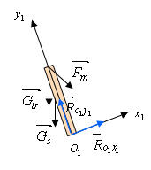 | 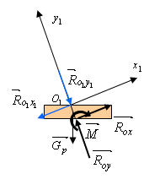
Figure 6: C1 body - lumbar segment | Figure 7: C2 body - the pelvis

The equilibrium equations for both isolated bodies are:
(5)
By projecting the vectorial equilibrium equations on the reference system axes for the pelvis segment, the following scalar equations were obtained:
(6)
The reaction force ${\vec{R}}_{0}$ acting on the point O was calculated using the rigidity method (equation (4). Solving these static equilibrium equations, the reaction force values were obtained.

4. CONCLUSIONS

In the presented study, the biomechanical behavior of the human lumbar spine was studied in two ways: experimental and theoretical. For the experimental study, the subjects were tested riding a medical bike in different conditions. The purpose was to find out the additional movements of the spine assessed by the unsuited position of the bike seat. The angular amplitudes of the lumbar spine during the movement were successfully recorded using an ultrasound measurement technique. The lateral bending of the lumbar spine appears like a periodical movement with maximum amplitude of 5.5 deg. The maximal angle value obtained from experimental study belongs to the anatomical limit of movement. Using the maximum angular value recorded in lateral bending, the pressure acting on the disc can be calculated. In order to calculate this pressure, the value of the reaction force acting as a compression force on the L5-S1 disc, can be used from the theoretical study ($R_{\text{01}}$- equation (7)). Thus, the results of the study can be used to evaluate both the value interval of the pressure acting on the last lumbar disc and its maximum value.

REFERENCES

- MIDDLEDITCH A.: Functional Anatomy of the Spine, Second Edition, Elsevier, UK, 2005
- KURTZ S.M., EDIDIN A.A.: Spine Technology Handbook, Academic Press, UK, 2006
- DRAGULESCU D.: Modelarea in biomecanica, Editura Didactica si Pedagogica, Bucuresti, 2005
- *Zebris CMS-HS: Operating Instructions.

