 | The 2nd International Conference  ″Computational Mechanics  and  Virtual Engineering″  COMEC 2007  11 – 13 OCTOBER 2007, Brasov, Romania

THEORETICAL ASPECTS ABOUT BIOMECHANICS OF LOWER LIMB DURING NORMAL CYCLE GAIT

C. RADU¹, I.C. ROŞCA¹
¹ Transylvania University, Brasov, ROMANIA, ciprian1_radu@yahoo.com
¹ Transylvania University, Brasov, ROMANIA, ilcrosca@unitbv.ro

Abstract: This paper presents some theoretical considerations about biomechanics of the lower limb during normal cycle gait. These considerations will be used later on to determine the internal reaction forces, which act into the ankle and knee joints by using the inverse dynamic method.
Keywords: biomechanics, foot, forces reduction method, inverse dynamics, modeling

1. INTRODUCTION TO NORMAL CYCLE GAIT

The gait cycle is the period of time between any two identical events in the walking cycle. Any event could be selected as the onset of the gait cycle because the various events follow each other continuously and smoothly. Initial contact, however, generally has been selected as the starting and completing event. By contrast, the gait stride is the distance from initial contact of one foot to the following initial contact of the same foot.
Each gait cycle is divided into two periods, stance and swing (figure 1). A full gait cycle is described as the undertaking of both stance and swing phases by one limb [1].

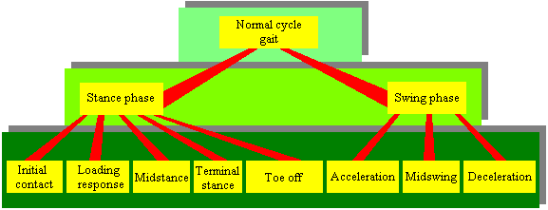
Figure 1: Gait cycle divided into two periods and eight phases

Stance is the time when the foot is in contact with the ground, constituting 62 percent of the gait cycle (figure 3). This phase is broken down into five distinct phases [1][3]:
- Initial contact – is the moment when the hip is flexed, knee is extended, ankle is dorsiflexed to neutral and foot just touches the floor. The hip is flexed, the knee is extended, and the ankle is dorsiflexed to neutral (figure 2, a);
- Loading response - begins with full floor contact and involves a brief period of double limb support. As the body weight is transferred onto the forward limb, knee is flexed for shock absorption (figure 2, b).
- Midstance – is the first half of single limb support. It finishes when body weight is aligned over the forefoot (figure 2, c);
- Terminal stance - the body moves ahead of the limb and weight is transferred onto the forefoot (figure 2, d).
- Toe off - finishes the stance phase and appears when the foot lives the ground (figure 2, e).
Swing denotes the time when the foot is in the air, constituting the remaining 38 percent of the gait cycle (figure 3). The swing phase begins when the foot is lifted from the floor until the heel is placed down. This phase is broken down into three distinct phases [1][3]:
- Acceleration - the objective of this stage is to clear foot off the floor and advance it. It ends when swinging foot lies opposite the stance foot. It is achieved by hip and knee and ankle flexion;
- Midswing - in this phase foot is advanced and ends when tibia lies vertical;
- Deceleration - during this phase leg moves ahead of the thigh and ends when foot strikes the ground.

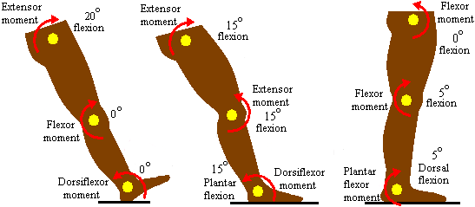
a) b) c)

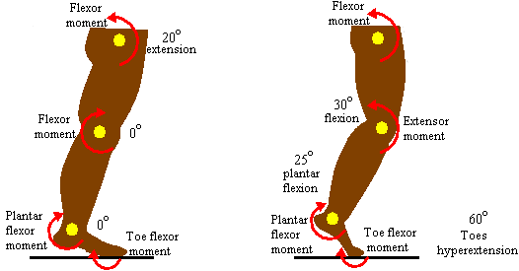
- e)
Figure 2: Biomechanics of stance phases during normal cycle gait: a) initial contact; b) loading response; c) midstance; d) final stance; e) toe off [4].

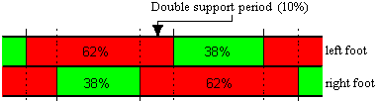
Figure 3: Percentage quantity of stance period and swing period from gait cycle [1]
2. INVERSE DYNAMIC METHOD USED FOR BIOMECHANICAL MODELING OF THE LOWER LIMB

With 206 bones and over 400 muscles involved in movement, the human body is too complex to be modeled directly. It is therefore necessary to produce a simplified model of the body, by reducing the number of movable parts and grouping muscles together. Various levels of model exist in biomechanics, we shall use one of the simplest, a ‘link-segment’ model. This represents the body as a series of straight segments of known physical properties, joined by simple point links [2].
In order for accurate calculations to be performed using the model it must be tailored to represent the individual. This is done by attributing the physical characteristics of the subjects’ limbs (mass, moment of inertia, length etc.) to the segments of the model.
The ultimate aim of biomechanical analysis is to know what the muscles are doing: the timing of their contractions, the amount of force generated (or moment of force about a joint), and the power of the contraction - whether it is concentric or eccentric [5].
These quantities can be derived from the kinematics using the laws of physics, specifically the Newton – Euler equations:
$F=m⋅a$, (1)
$M=I⋅α$, (2)
where: F – force [N],
m – mass [kg],
a – linear acceleration [m/s²]
M – momentum [Nm],
I – mass moment of inertia [kg⋅m²],
α - angular acceleration [rad/s²].

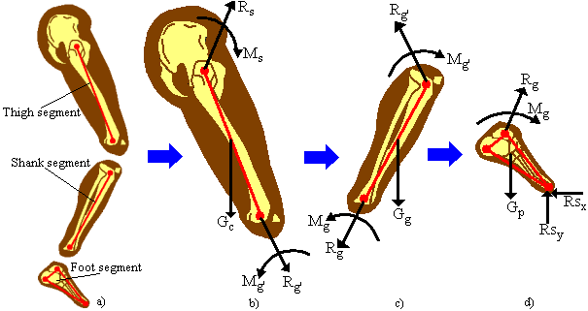
Figure 4: Lower limb modeling using inverse dynamic method: a) lower limb divided into three segments: tight segment, shank segment and foot segment; b) free body diagram of tight segment; c) free body diagram of shank segment; d) free body diagram of foot segment, where: Rs – hip reaction force [N]; Ms – net muscular moment from hip [Nm]; Gc – thigh’s weight force [N]; Rg′ - knee reaction force [N]; Mg′ - net muscular moment from knee [Nm]; Gg – shank’s weight force [N]; Rg – ankle reaction force [N]; Mg - net muscular moment from ankle [Nm]; Gp – foot weight force [N]; Rs_{x,y} – ground reaction forces on the ox, oy directions [4].

These equations describe the behavior of a mathematical model of the limb called a link-segment model, and the process used to derive the joint moments at each joint is known as inverse dynamics, so-called because we work back from the kinematics to derive the kinetics responsible for the motion (figure 4).
This is easily done when the motion is open-chain, with no resistance to motion at the terminal segment, since all the kinematic variables are known from motion analysis (in this case Rs_{x} and Rs_{y} of the first segment in the chain, the foot, are both zero). When there is contact of the limb with another object, such as the ground, or a cycle pedal, the forces between the limb and the obstructing object in this closed-chain must be measured. This is usually arranged by the technique of strain gauging, such as used in a force platform used to measure the ground reaction force during walking and running [5].
There are two kinds of forces acting in the lower limb: internal forces (muscle forces, joint contact forces, forces due to gravity and inertia) and the external forces such as the ground reaction force (figure 3) [2].
To simplify the analysis of the forces acting within the body, the following assumptions and simplifications have to be incorporated within the model. These assumptions are [4][5]:
- the human body is divided in kinematic chain;
- these kinematic chains are divided in segments;
- each segment is rigid and it has a fixed mass located as a point mass at its center of mass (which will be the center of gravity in the vertical direction);
- the location of each segment's center of mass remains fixed during the movement;
- the mass moment of inertia of each segment about its mass center (or about either proximal or distal joints) is constant during the movement;
- the length of each segment remains constant during the movement;
- the friction force in the joint is null;
- the velocity of the biomechanical system is constant on the movement period.
In order to determine the internal reaction forces it is necessary to know the anthropometrical data of human subject and the ground reaction forces. In the table 1 are written the anthropometrical data of the most important body segments for human subjects older then 14 years. The ground reaction forces are determined using a force plate.

Table 1: Anthropometrical data of the most important body segments for human subjects older then 14 years, where: L – segment’s length [m]; c – length scaling coefficient; body’s total height [m]; m – segment’s mass [kg]; M – total body’s mass [kg]; I – segment’s inertial moment [kg⋅m²] [4].
Body’s segment | Length  L [m]  L = c⋅H | Mass  m [kg]  m = %⋅M | Centre of mass position from distal point  %⋅L | Inertial moment  %I [kg⋅m²]
Head | 0.126 | 7.8 | 50 | 49.5
Trunk | 0.312 | 49.7 | 50 | 50.3
Arm | 0.188 | 2.8 | 56.4 | 32.2
Forearm | 0.146 | 1.6 | 55 | 30.3
Hand | 0.108 | 0.6 | 50 | 39.7
Thigh | 0.265 | 10 | 59.05 | 32.3
Shank | 0.251 | 4.65 | 56.05 | 30.2
Foot | 0.152 | 1.45 | 50.85 | 47.5

3. CONCLUSIONS

These theoretical considerations, about biomechanics of the lower limb during normal cycle gait, will be used later, in the next scientific papers to determine the ankle and knee joints internal reaction forces.

REFERENCES

- Radu C.: Some Theoretical Aspects About Normal Cycle Gait, TMT, Hammamet, Tunisia 2007.
- Radu C., Cismaru M.: Determination of Ankle Joint Reaction Forces Using Inverse Dynamic Method, Comefim 8, Cluj-Napoca, Romania, 2006.
- Radu C., Baritz I.M.: Determination of Normal Cycle Gait Parameters, IMT Oradea, University of Oradea, Romania, 2007.
- Radu C.: Improvements Apported to the Biomechanical Systems Modeling, Second Report of the PhD. Thesis: Improvements Apported to the Prosthetic Elements by Rapid Prototyping, Brasov, April 2005.
- Winter D.A.: The Biomechanics and Motor Control of Human Gait: Normal, Elderly and Pathological, University of Waterloo press, Ontario, (1991).

