The 2nd International Conference
″Computational Mechanics
and
Virtual Engineering″
COMEC 2007
11 – 13 OCTOBER 2007, Brasov, Romania

MACHINES FOR CROPING BULBS-ROOTS REGARDING THE HARVESTING OF POTATOES

A. Ciaca¹
¹ Transilvania University, Brasov, ROMANIA, ancaciaca@unitbv.ro

Abstract These machines execute diging and teasing stratum of earth, where the potatoes are, separating them from earth, stones, stolons, creeping strems, and store them into a car, or between the rows of plants.
Keywords: potatos;stalks;tubers.

INTRODUCTION

In the process of harvesting the potatoes, the following conditions must be fulfilled: stalks removing machines must work simultaneous by (concomitant) 4-6 rows (lines); the stalk chopping has to be over 80% under 10 cm length; removing the stalks has to be done without uncovering the superficial tubers; the tubers removed from the sail have to be minimum 97%; those covered by ground to be less than 2% and those damaged by the machine to be less than 2% in divised tehnology and 3,5% in monophasic technology; the impurities left in tubers mass to be 6%.
Harvesting potatoes machines can be divided into:
- machines for removing the stalks;
- machines for taking out the tubers;
- machines for taking out and picking the tubers;
- combine for harvesting the potatoes.

MACHINES FOR REMOVING THE STALKS

The green mass (stalks and weeds) in the potatoes crops, in harvesting time, is from 4 to 40 t/ha but if the quantity is over 10 t/ha the harvesting can be done only after the removal of the stalks otherwise the dislocating, sheding and cleaving parts can be blocked.
Removing the stalks can be done chemical or mechanical. The chemical removal has the following advantages: - assure the total and rapid (2-4 days)destroy of the vegetation;
- determine the growing of the tubers in a short time,so it reduces the harvest period;
- relif the working conditions for the dislocation and cleaning the tubers
Disadvantages are: - the pollution of the environment;
- the high cast of the chemical substances.
Mechanical removal of the stalks can be done through chapping ar pulling up. Removal through pulling up has the same effects as the chemical distayal but until now there are no devices to execute satisfactory such work.
The existing machines for chapping the stalks remove the vegetation only 60-80%. Unpicked remain stalks and weeds 3-6 cm high and 14-40% unchapped stalks. Chapping the stalks can be done with the combines for harvesting the fodder plants or with special machines.
Special machines are: 1.) with orizontal rotor or
2.) with disk with vertical axle
At the machines with otizontal rotor the working elements are the bitting bars made by steel, after made flat at the active end or knives, joint to the main shaft.

Figure 1: MTV-4 machines

1- draw bar
2- rotor
3- case
4- bars
5- hydraulic cylinder
6- protection
7- wheels
The machine has a working broad of 2,8 m and carry out 8-10 ha/sch. The machine with disk with vertical axle has an horizontal disk on which are fastened simple ring-shaped chains. The speed of the chains during the work is 50-60m/s.

MACHINES FOR PICKING THE TUBERS

Machines for picking tubers dig the soil in which are the tubers, spread it, partially separate the tubers from soil and stalks and put the tubers on the surface of the soil.
Machines for dislocation of the tubers are divided, after the separation part, in 1.) machines with rotor with farks; 2.) machines with shedding grate.


Figure 2: The scheme of the machine for dislocation of the tubers with rotor with farks

1- dislocation part
2- the forks of the rotor
3- the copy wheel
4- the grate.
The soil dislocated by the share 1is moved by the forks 2 and is thrown laterally where it meet the grate with rods 4. The capacity of machine is of 2 ha/sch. These machines with rotor with forks are built for harvesting a single row of potatoes.
Next is the scheme of a machine with rolling grates.

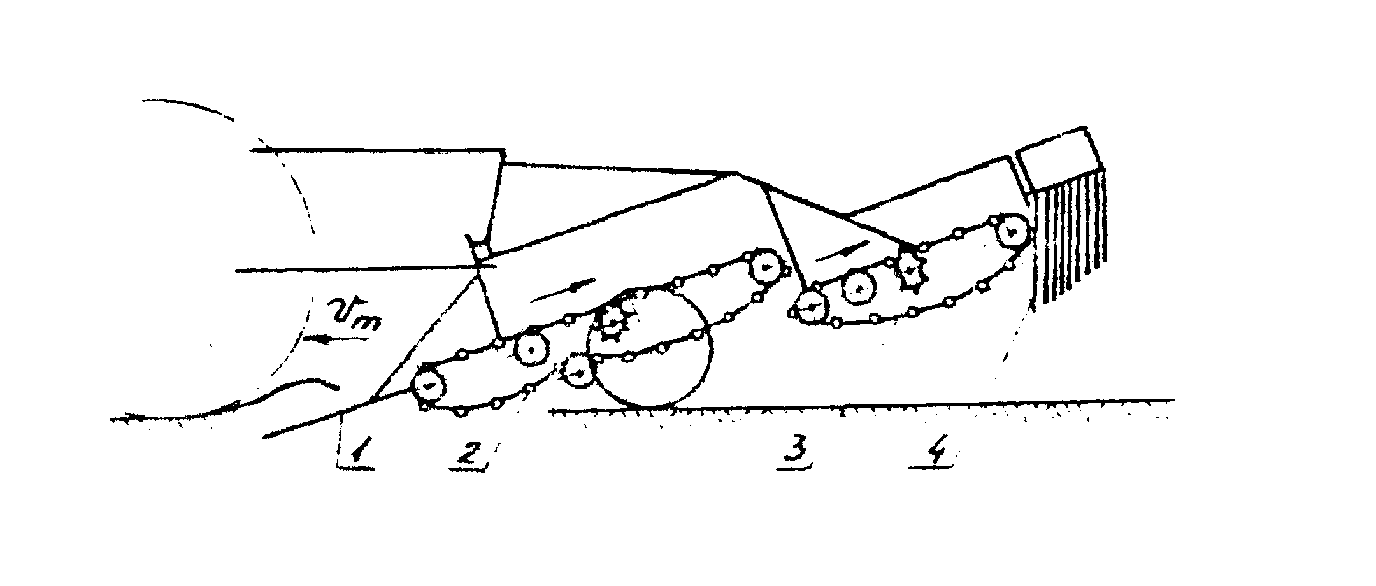
Figure 3: The scheme of the machine for picking up potatoes with shedding grates
1- shares
2;3- rolling grates
4-the grate for downloading the material on the soil in a row.
These machines are built generally for harvesting 2 rows at a time.
The capacity of work is 0,3-0,5 ha/h.

MACHINES FOR PULLING OUT AND COLLECT POTATOES

These machines execute diging and teasing stratum of earth, where the potatoes are, separating potatoes from erth, stones, stolons, creeping stems and store them into a car, or between the rows of plants.

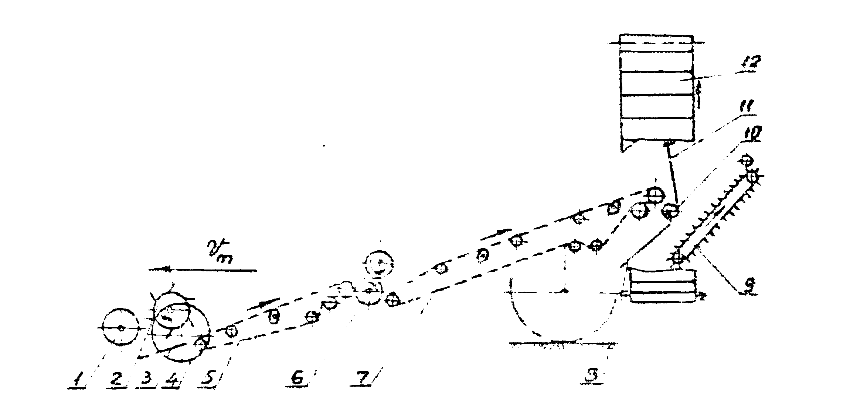
Figure 4: The scheme of the machines for pulling out and collect potatoes

1- cylinder
2- rotor blade
3- dislocation parts
4- disk knives
5;7- separation grates
6- pneumatic roll
8- stalk downloading grate
9- conveyor
10- roll
11- stzlk (stop) keeper
12- elevator
These machines are built for cropping from 2 or 3 rows of potatoes.
From this group belongs E-684, which is cropping (harvesting) 3 rows potatoes, situated from 0,7 to 0,75 m.The speed of this machine is 6 km/h, and is cropping aprox. 5 ha/sch.

THE HARVESTING POTATOES MACHINES

These machines execute diging and teasing stratum of earth, where the potatoes are, separating them from earth, stones, stolons, creeping strems, and store them into a car, or between the rows of plants.
The harvesting potatoes machines diferes by the tehnological flux structure, by organological scheme and by construction of interval components.
In the next figure is presented the scheme of a harvesting potatoes machine made by the next working components.
1- disks for cutting vegetation (stalks)
2- spurs for removing the weeds
3- rollers
4- disk knives
5- dislocation shares
6- rolling grates
7- pneumatic roll
9- ceiving conveyor with rods
10- finger elevator
11- hammers
12- dollies/stops
13- elevator drum
14- conveyor for downloading the stones
15- cross conveyor with rods
16- separating conveyor with elastic fingers
17;19-rods conveyors for manual separation
18-stocking rolls
20-elevator
21-stones collector

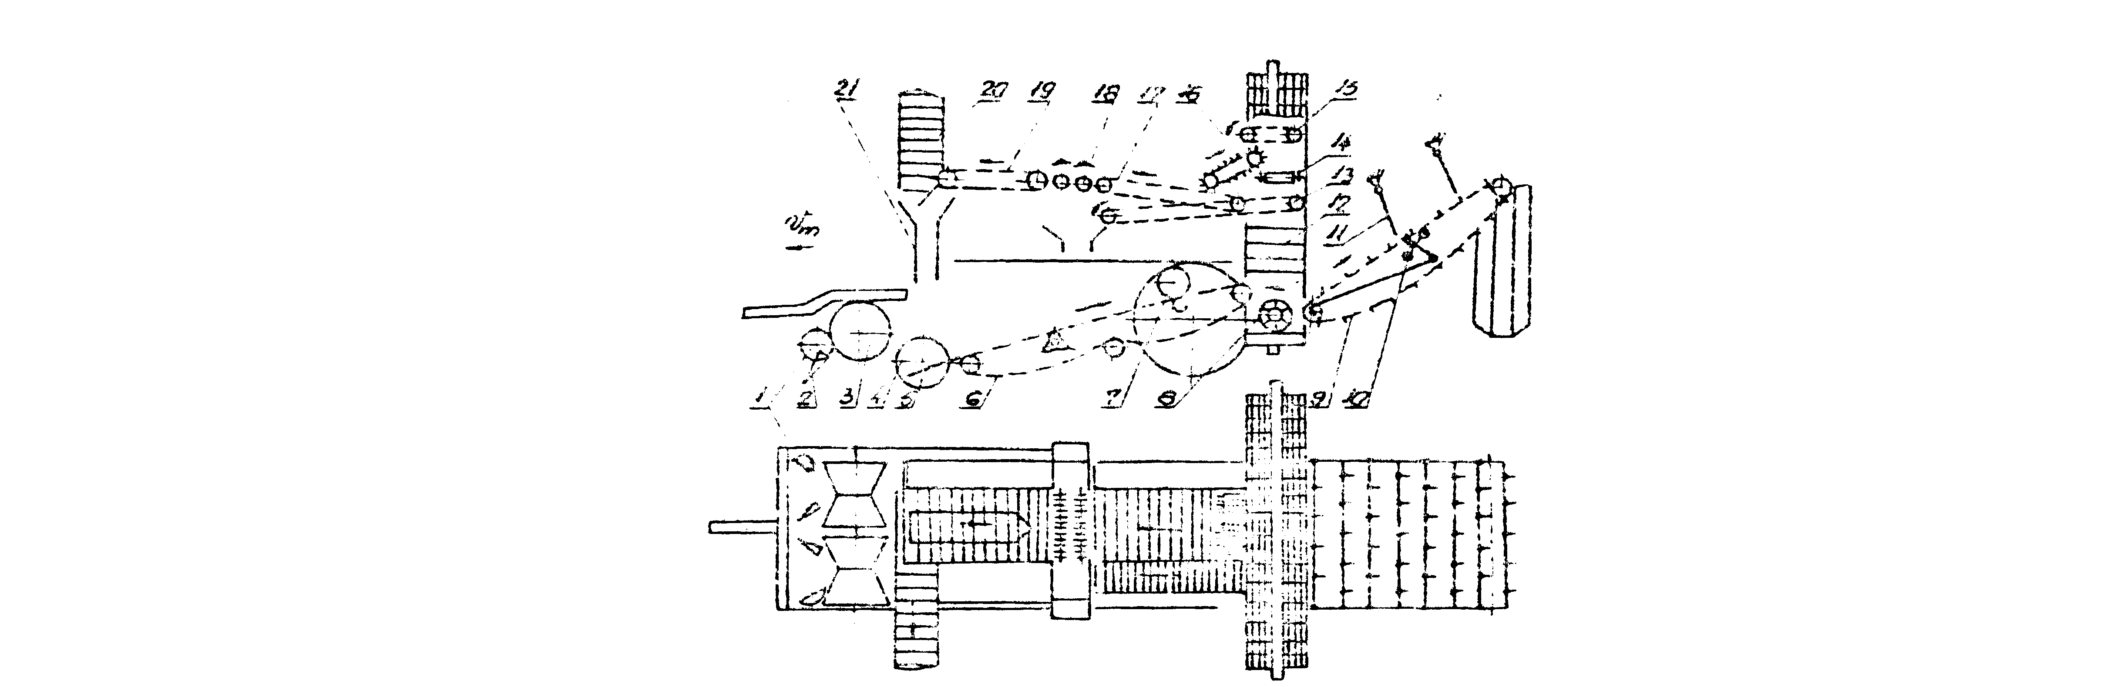
Figure 5: The scheme of the harvesting potatoes machines

REFERENCES

[1] Scripnic,V;Babiciu,P; Machines agriculture; Bucharest, Publishing house Ceres, 1979;
[2] Nicolaiasa,V;Danica,I; Process of wrking and machines agriculture of harvest, Publishing house A 92, Iasi-1995;
[3] Caproiu,ST. si contributor; Machines agriculture of working soil,sowing and upkeep growing, Publishing house Didactic and Pedagogic,1982.

