The 40th International Conference on
Mechanics of Solids, Acoustics and Vibrations &
The 6th International Conference on
“Advanced Composite Materials Engineering”
ICMSAV2016& COMAT2016
Brasov, ROMANIA, 24-25 November 2016

THERMAL CONDUCTIVITY OF HYBRID CF/FF
EPOXY BASED COMPOSITE MATERIALS

Dana Luca Motoc¹, Santiago Ferrándiz Bou², Rafael BALART²
¹ Transilvania University of Brasov, Brasov, ROMANIA, danaluca@unitbv.ro
² Polytechnic University of Valencia, Valencia, SPAIN, sferrand@mcm.upv.es, rbalart@mcm.upv.es

Abstract: The paper aims to present the synergistic effects resulted from the hybridization process of flax and carbon fibers laminates based on a DGEBF polymer resin, stacked as symmetrically and asymmetrically architectures. One of the thermo-physical properties of hybrid composite architectures, namely thermal conductivity, was measured through the specimens’ thickness and debated against reference sample entirely based on flax reinforcements. Differences among the values will be regarded as positive/negative hybrid effects and further debated to account the reinforcement volume fraction, sequencing, number of layers and manufacturing issues.
Keywords: carbon fiber, flax fiber, epoxy, composite, thermal conductivity

1. INTRODUCTION

Concerns for the natural resources preservations enabled paradigm changes toward materials development and technology approaches with an exponential tendency directed toward “all green” combinations. These were supplemented by actions and regulations targeted to raise public awareness or enforce penalties and inappropriate demeanor. Consequently, jointly these have recast the natural reinforcements as promising constituents for the development of both high-performance composites and sustainable eco-friendly based materials at the top of the competitive industry. The reason for this trend is the market oriented strategies of the major players in the composite materials' arena that are facing increasingly high manufacturing costs and the lack of viable solutions with respect to the recycle/reuse phase in the life cycle analysis of their benchmark products.
A literature survey allows a comprehensive insight into the world of natural derived constitutive composites and related material properties, irrespective of the polymer resin synthesis or manufacturing technologies employed, through some outstanding review papers of Jawaid and Khalil or Faruk et al. in answering the question rise independently by Wambua or Joshi and their co-authors: “Are natural fiber composites superior to glass fiber reinforced composites?".
Any debate in favor of the material performances of synthetic/synthetic or natural/synthetic combinations is beyond the scope of this paper. However, the synergetic effects may always be considered as the subject of further approaches. Comparisons can be carried out proving several matching conditions, including: fiber content, sequence stacking, number of layers, manufacturing technology, resin type, etc.
Thermal conductivity of hybrid composite architectures out of particle/particle, particle/fiber and fiber/fiber combinations are relatively comprehensively tackled with literature by several research groups due to the application potential identified during their studies .
The herein paper aims to present a mixed theoretical/experimental approach on through-thickness conductivities of several hybrid epoxy polymer reinforced composites out of natural and synthetic constitutive and debate on the synergetic effects due to hybridization by closer monitoring the positive/negative variations with respect to the reference composite architecture.

2. THEORETICAL BACKGROUNDS

Rules of mixture (i.e. RoM) and the hybrid mixture (i.e. RoHM) were used to predict the effective stiffness of individual substrates, i.e. FF reinforced composites as well as combined FF/CF architectures, respectively.
Expressions were stated in terms of the volume faction of the composite constituents to facilitate further use even the weight fraction of the individual reinforcements and matrices were deployed:

- RoM with natural-fiber reinforced composites

$k_{\text{nfc}}=k_{\text{nf}}V_{\text{nf}}+k_{m}\left(1−V_{\text{nf}}\right)$ (1)

- RoM with synthetic-fiber reinforced composites

$k_{\text{sfc}}=k_{\text{sf}}V_{\text{sf}}+k_{m}\left(1−V_{\text{sf}}\right)$ (2)

- RoHM with natural/synthetic hybrid composites
$k_{c}=k_{\text{nfc}}V_{\text{cnf}}+k_{\text{csf}}V_{\text{sfc}}$ (3)

Deviation from the RoHM predictions of the experimentally retrieved values will underline the hybrid effect, which can be ranked as positive or negative . This hybrid effect highlights the synergistic based changes in the thermo-physical property under discussion due to the various combinations of natural and synthetic fibers.
In the above expressions letters and indices state as following: k for thermal conductivity, in W/mK, V for constitutive volume fraction, nfc for natural reinforcement composite, nf for the natural reinforcement, sfc for the synthetic fiber composite, sf for the synthetic reinforcement, c for the final hybrid architecture and m for the polymer matrix, respectively.

3. EXPERIMENTAL ISSUES

3.1. Material selection

Untreated flax (n. FF) and plain 1/1 weave carbon-fiber (n. CF) fabrics were used as reinforcements for the present hybrid composite architectures. All reinforcements can be ranked as having a balanced distribution along the fabric’s warp and weft directions. A commercial DGEBF epoxy resin was cured with its delivered hardener under a ratio of 100 to 45 parts by weight of each constituent. The resin was chosen due to its wide availability and adequacy; including its high thermoforming stable laminate manufacturing. Table 1 summarizes individual material data of the present reinforcements and epoxy based matrix, respectively.

Table 1: Material data on reinforcements and polymer resin
Synthetic and natural reinforcements |  |  | Polymer resin
 | Carbon fiber  (KDK 8003) | Flax fiber |  | DGEBF epoxy resin  (Epikote™ 04434)
Fabric areal weight (g/m²) | 200 ± 10 | 175 ± 10 | Glass transition temperature (°C) | up to 200 (by TMA)
Fabric thickness (mm) | 0.30 ± 0.05 | 0.40 ± 0.05 | Viscosity @ 25°C (mPa·s) | 800 ± 150
Young modulus (GPa) | 241 | 60 | Density @ 20°C (g/cm³) | 1.14 ± 0.02
Commercial trade name | SIGRATEX® | - | Curing agent | Epikure™ 04434
Supplier | SGL Technologies GmbH | Leinenweberei Hoffmann GmbH | Supplier | Momentive

3.2 Hybrid composite manufacturing

The hybrid architectures were produced by stacking combinations of selected natural/synthetic reinforcements by layering after delivering them as pre-impregnated sheets. The prepregs were manufactured in situ followed by deployment of a temperature-controlled oven was used to compress and fully cure the composite plates at different constant temperatures, distinctively for each resin, at 50 kN for one hour.
ISO 15034:1999 standardized procedures were used to determine the resin flow while ISO 15040:1999 was used to evaluate the gel time for each resin system, individually. With respect to the stacking sequence, in the case of the hybrid architectures, the higher strength material (i.e. CF) was layered as the outermost, external and external/middle layers. Flax fibers were layered in between due to their poor material properties comparatively with the CF reinforcements.
3.3 Material characterization

Thermal conductivities of specimens were retrieved by aid of LFA 447 NanoFlash™ device (Netzsch GmbH, D), within 25 °C – 125 °C temperature range according with the ISO 22007-4:2008 standard procedures. Samples were covered back and forth with a thin layer of graphite to enhance their emission/absorption properties. Thermal conductivity data can be referred as through-thickness values and represents the mean of recorded values out of five single shots on each point considered. The standard deviation of the five shots was less than 1.5%.

4. RESULTS AND DISCUSSION

In Figure 1 was plotted the experimental results gathered for the hybrid composite samples under investigation. As it can be seen, in all cases, there is a linear trend in the variation revealing an increase of the through-thickness thermal conductivities along with expanding temperature. The reader should recall the fact that through-thickness thermal conductivities represent the lowest values comparatively to their counterparts retrieved from in plane measurements. In addition, small values on through-thickness thermal conductivities limit heat dissipation from the composite panels and thus restricting their application potential.

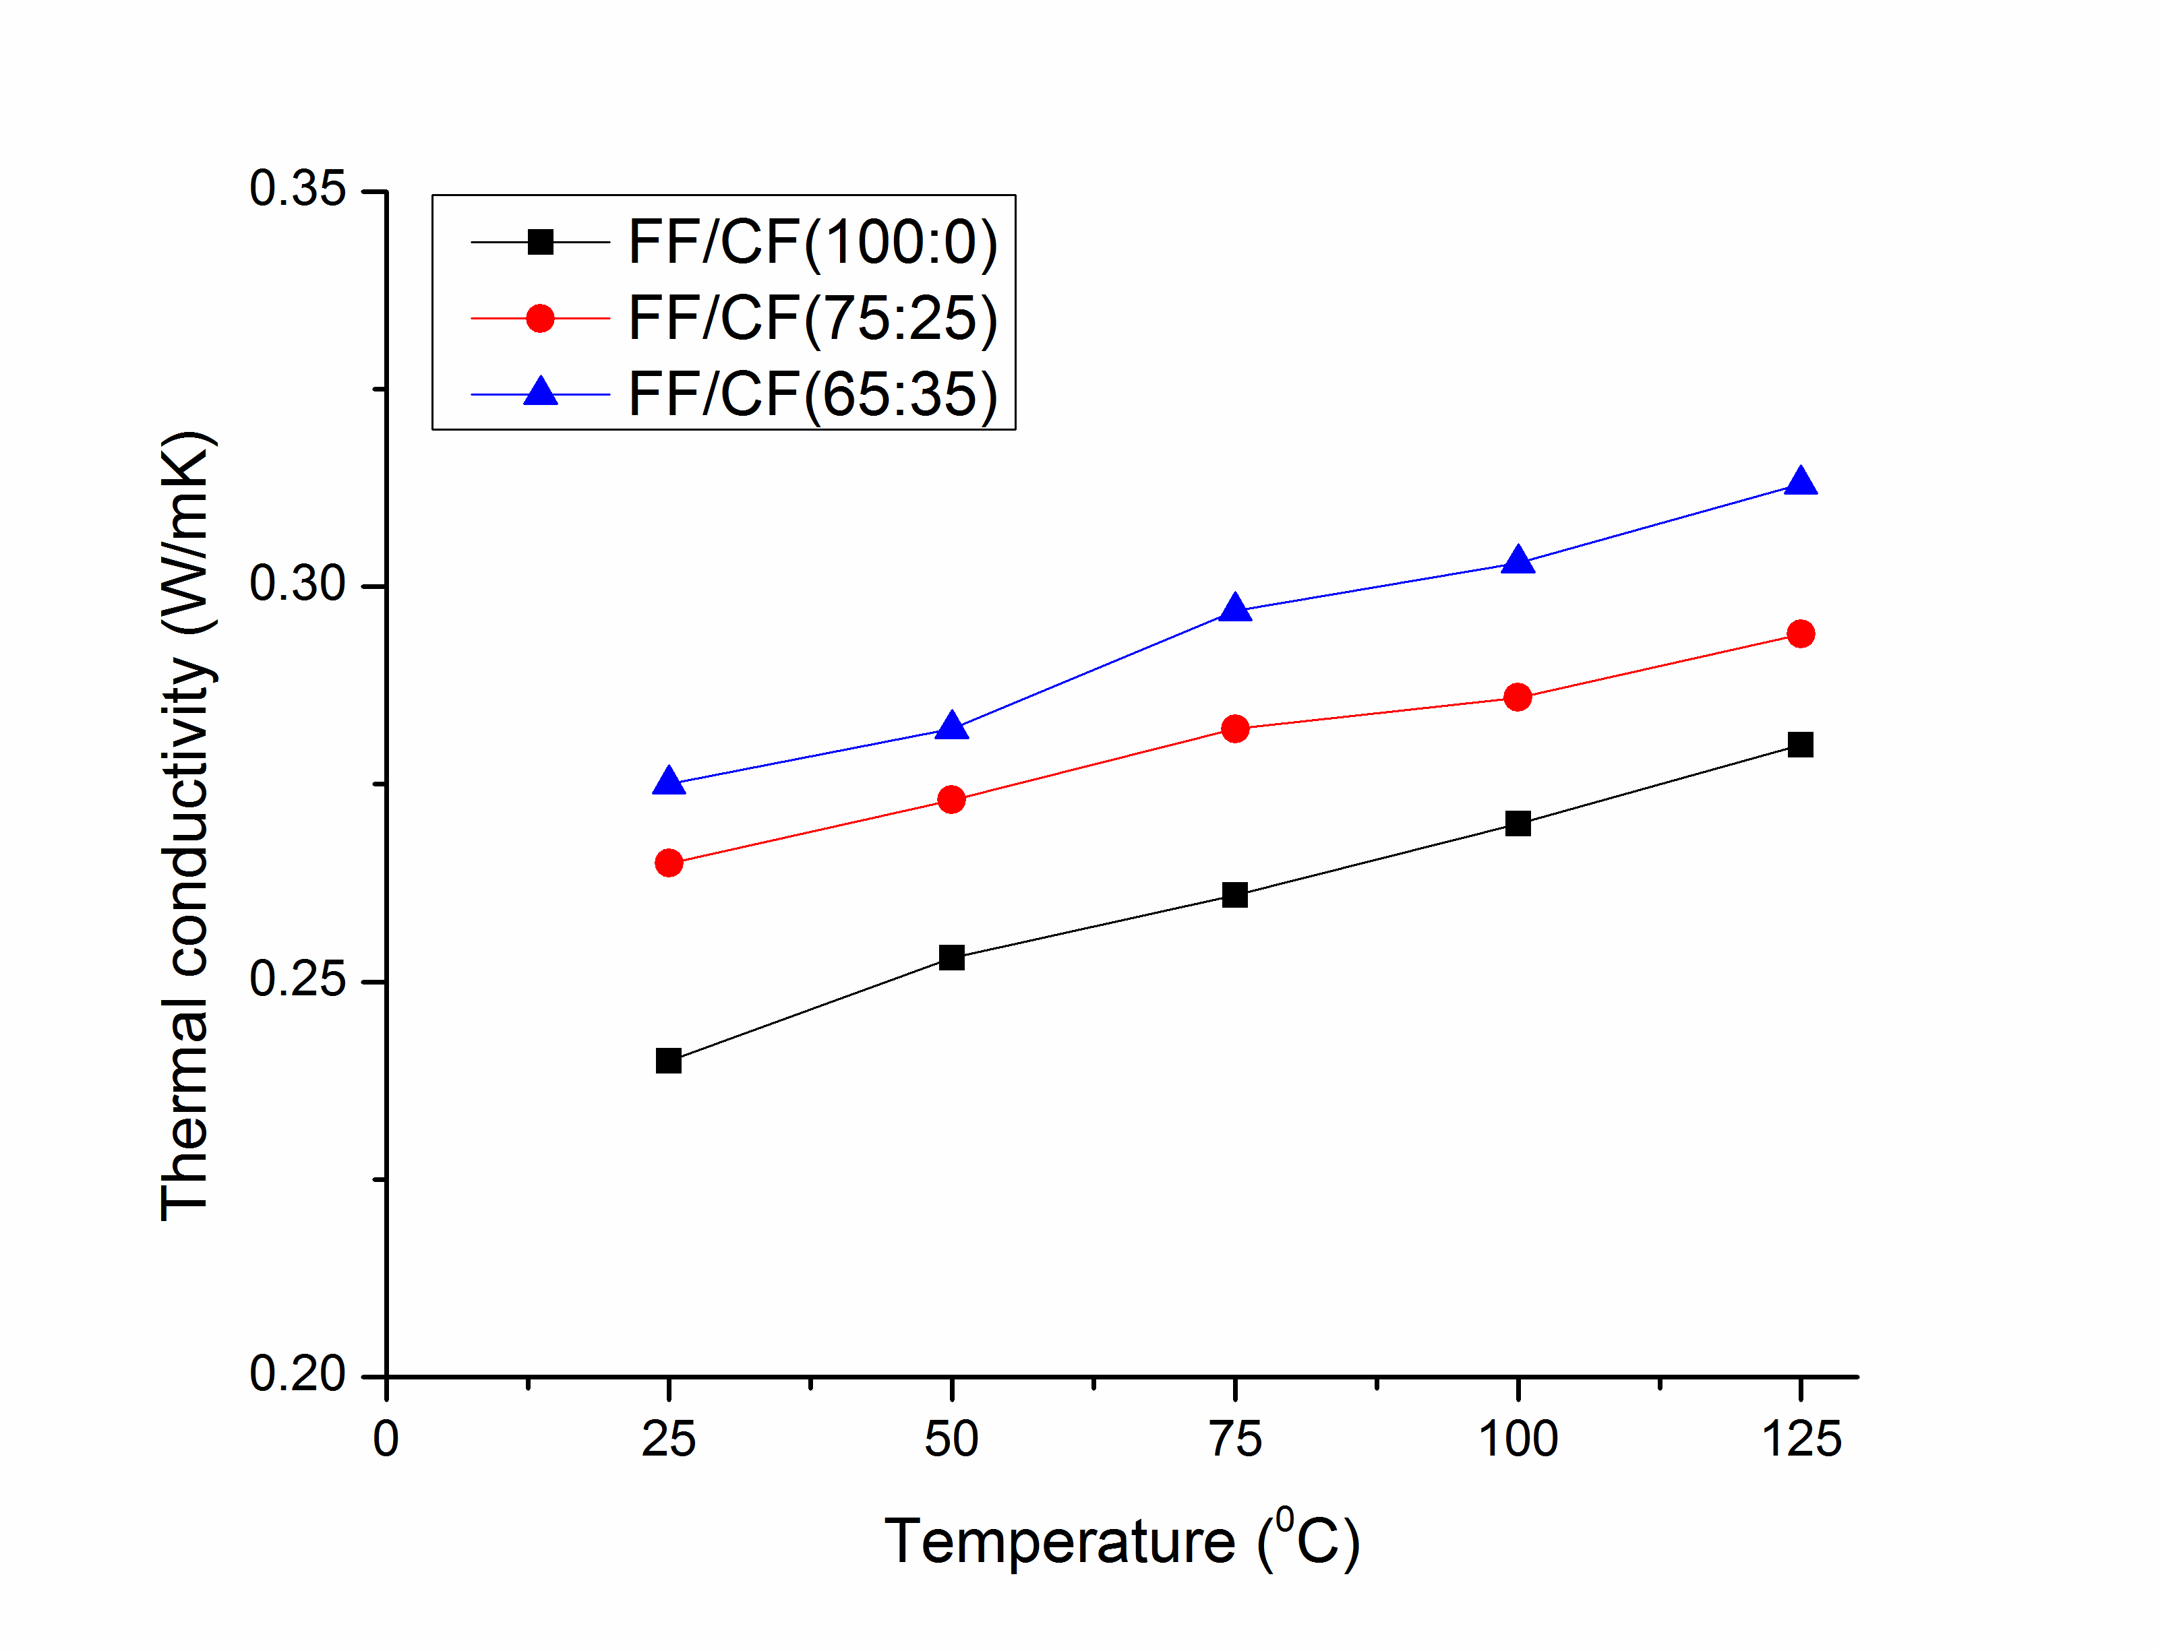
Figure 1: Thermal conductivity of DGEBF based hybrid composites

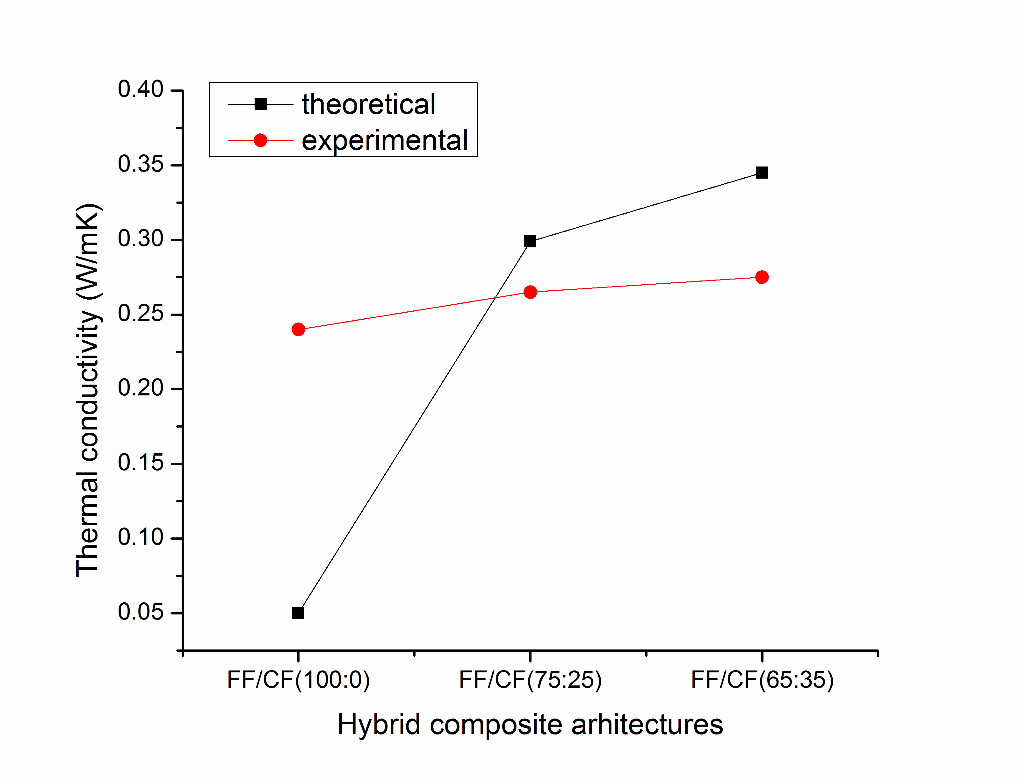
Figure 2: Theoretical vs. experimental values of DGEBF based hybrid composites

In Figure 2 is being represented the theoretical predicted (using expressions (1) to (3)) vs. experimentally retrieved values on thermal conductivities at room temperature. As it can be seen, the hybrid effects are positive, quantified to 13% and 25% as relative error, respectively, whereas the FF reinforced composite plate referential provide a negative trend about more than 75% between the values. These values must be hindered generally as indications on the heat dissipation behavior of hybrid composite architectures under debate and tackled to aid the synergy due to sequencing and individual reinforcement selection. A thermal conductivity enhancement factor (i.e. TCEF) can be defined as relative error between the retrieved hybrid specimens’ and DGEBF epoxy resin thermal conductivities to further enabling materials characterization. In Figure 3 were plotted the corresponding percentages, showing an increasing tendency in terms of efficiency due to hybridization and deployment of more CF layers within the hybrid polymer architecture.
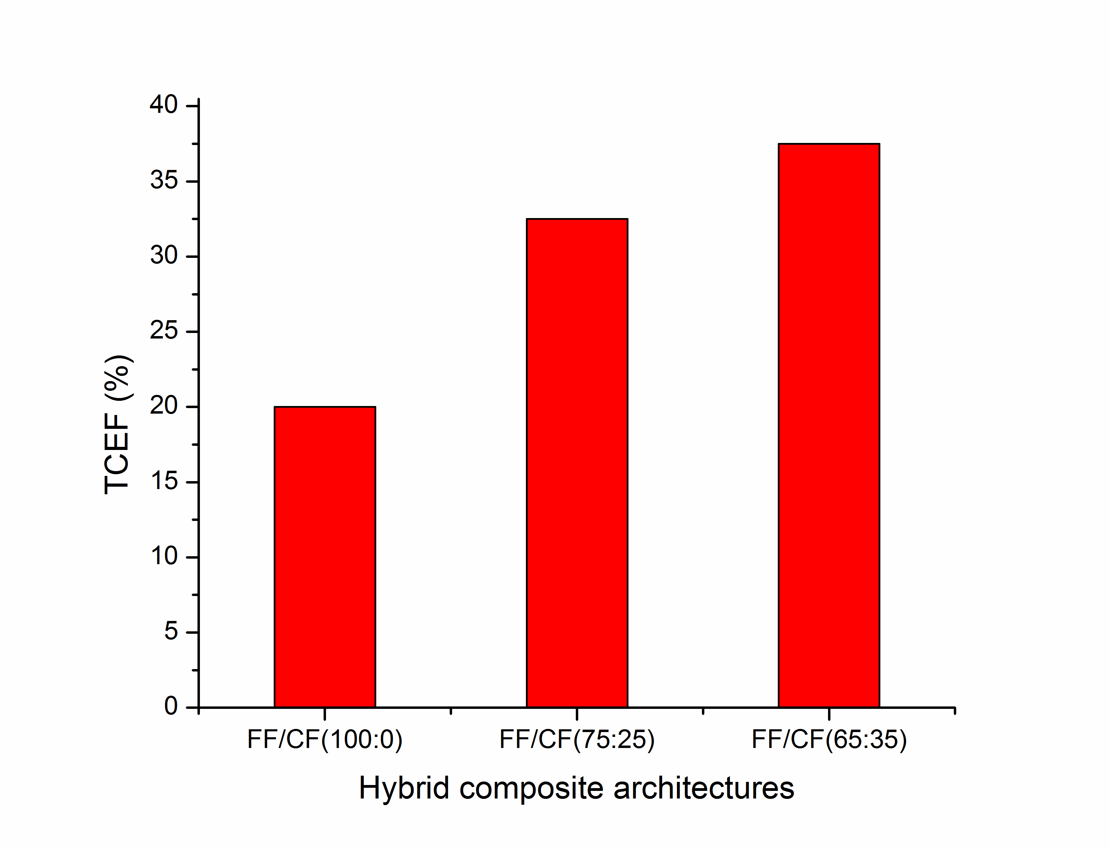
Figure 3: Thermal conductivity enhancement factor

5. CONCLUSIONS

Effective thermal conductivity in hybrid composite materials reveals an increasing tendency with temperature rise and is strongly influenced by the intrinsic reinforcements’ capability of dissipating heat, number of thermally conductive layers and their sequencing stacking. An enhancement factor related to the effective thermal conductivities of hybrid DGEBF polymer based specimens reveal the same increasing tendency with the increase of CF reinforcement layers embedded within the final architecture. In addition, the polymer matrix may enable improvements in the overall thermal conduction response of the composite architectures, especially due to deployment of an optimized curing cycle, fiber/matrix interface adhesion enhancements procedures prior laminates manufacturing or conductive fillers embedding (e.g. carbon nanotubes).

REFERENCES

- Jawaid M, Abdul Khalil HPS. Cellulosic/synthetic fibre reinforced polymer hybrid composites: A review. Carbohydrate Polymers. 2011;86(1):1-18.
- Faruk O, Bledzki AK, Fink H-P, Sain M. Biocomposites reinforced with natural fibers: 2000–2010. Progress in Polymer Science. 2012;37(11):1552-96.
- Wambua P, Ivens J, Verpoest I. Natural fibres: can they replace glass in fibre reinforced plastics? Composites Science and Technology. 2003;63(9):1259-64.
- Joshi SV, Drzal LT, Mohanty AK, Arora S. Are natural fiber composites environmentally superior to glass fiber reinforced composites? Composites Part A: Applied Science and Manufacturing. 2004;35(3):371-6.
- Kulkarni MR, Brady RP. A model of global thermal conductivity in laminated carbon/carbon composites. Composites Science and Technology. 1997;57(3):277-85.
- Lee DJ, Oh H, Song YS, Youn JR. Analysis of effective elastic modulus for multiphased hybrid composites. Composites Science and Technology. 2012;72(2):278-83.
- Wang S, Qiu J. Enhancing thermal conductivity of glass fiber/polymer composites through carbon nanotubes incorporation. Composites Part B: Engineering. 2010;41(7):533-6.
- Schuster J, Heider D, Sharp K, Glowania M. Thermal conductivities of three-dimensionally woven fabric composites. Composites Science and Technology. 2008;68(9):2085-91.
- Marom G, Fischer S, Tuler FR, Wagner HD. Hybrid effects in composites: conditions for positive or negative effects versus rule-of-mixtures behaviour. J Mater Sci. 1978;13(7):1419-26.

