OPTIMAL Airfoils With Continuous Curvature at supersonic SPEEDS
BULLETIN OF THE TRANSILVANIA UNIVERSITY OF BRAŞOV

- BERBENTE* S. DĂNĂILĂ*

Abstract: The profile of minimum drag depends on the particular auxiliary structural condition that is imposed on the airfoil geometry [1]. By using a third degree approximation [4], with respect to the flow deviation, some analytical formulas for the optimal maximum thickness position were obtained for symmetrical airfoils at zero lift in inviscid flow. A structural (area or volume) criterion was also used pointing out a better behaviour of continuous curvature [2] airfoil as compared with the rhomboidal one.

Keywords: airfoil, minimum drag, structural criterion, optimization

1. Introduction

In a previous paper, [2], a class of analytically generated aerodynamic profiles with continuous curvature on both upper and lower sides was introduced. Knowing the influence of the pressure gradient on the boundary layer flow and, on the other hand, the influence of the airfoil shape on the pressure gradient distribution, maintaining the curvature continuity is important. The method was based on polynomial spline functions, with a degree of continuity up to second order derivative inclusively. A large amount of numerical results, generated by the FLUENT 6 code, was done to reveal the effect of continuity of curvature radius. Once the curvature continuity is secured new improvements can be achieved. As Chapman [1] pointed out the profile of minimum drag depends, among the other things, on the particular auxiliary condition that is imposed on the airfoil geometry. For example, the analysis presented in our paper shows that, if one requires the optimum profile to satisfy as auxiliary condition a given thickness ratio, the double-edge (rhomboidal) profile represents the optimal airfoil. However, this particular auxiliary condition is not the only practical case where an airfoil must satisfy structural requirements, such as a given area moment of inertia, or a given section modulus. A practical criterion of optimization consists also of imposing a minimum drag coefficient at a given lift required by specified flight conditions. By using a third degree approximation [4] with respect to the flow deviation some analytical formulas for the optimal maximum thickness position were obtained for symmetrical airfoils at zero lift in inviscid flow. A structural (area or volume) criterion was also used pointing out a better behaviour of continuous curvature airfoil as compared with the rhomboidal one in viscid (real) flow. The study of supersonic profiles and the attempt to optimize the airfoils shape in order to reduce the drag is a very actual problem of aerodynamics. Many classical [1,8,9,4,5] and more recent [10,6] papers are dedicated to this purpose. In the present paper we try to carry out a study on the influence of curvature radius continuity on the aerodynamic characteristics of supersonic airfoil. To obtain a shape with a continuity degree up to second derivative, we introduce an analytical method based on the polynomial spline functions of third degree. Following the Ferri [9] experimental results, a finite thickness of trailing edge was included for further studies. The result is a class of airfoil geometry controlled by certain parameters, witch can be arranged in order to minimize the aerodynamic drag or imposing auxiliary conditions.

2. Airfoil geometry

The airfoil shape is generated by polynomial spline functions of third degree connected in four points. Lets be$x_{i}$, $i=0,…,4$, a set of points on the profile chord, where $x_{0}=0$ and $x_{4}=c=1$ are the leading edge and the trailing edge, respectively; $x_{1}$ and $x_{3}$ are the inflection points and $x_{2}=k$ is the maximum thickness point (Fig.1).

Fig. 1. Airfoil geometry

Supposing a symmetrical airfoil, only the upper surface will be considerate. Lets be$y_{i}$, $i=0,…,4$ the corresponding airfoil ordinates. So, we have:
$x_{0}=0, y_{0}=0$,$x_{2}=k, y_{2}=ε$, $x_{4}=c=1, y_{4}=H$. | (1)
A continuous shape up to second order derivative can be obtained by polynomial spline function of at least third degree. Denoting by $p_{3i}(x)$ the restriction of the polynomial spline function on the interval [$x_{i},x_{i+1}$], we have [3]:
$p_{3i}(x)=y_{i}+m_{i}(x−x_{i})+b_{i}(x−x_{i})^{2}+a_{i}(x−x_{i})^{3}$, $x∈[x_{i},x_{i+1}]$, $i=0,…,3$, | (2)
where $m_{i}$, $a_{i}$, $b_{i}$, $i=0,…,3$ are, up to now, unspecified coefficients. The $m_{i}$ coefficients represent the contour slopes and the $b_{i}$’s are proportional to the radius of curvature.
The continuity conditions up to second order derivatives, inclusively, yield the following relations [3]:
$a_{i}h_{i}^{3}=h_{i}(m_{i}+m_{i+1})−2(y_{i+1}−y_{i})$, $b_{i}h_{i}^{2}=3(y_{i+1}−y_{i})−h_{i}(m_{i+1}+2m_{i}),$ | (3)
where $h_{i}=x_{i+1}−x_{i}$, $i=0,…,3$.
Slopes $m_{i}$ are the solution of the system of equations [3]:
$ρ_{i}m_{i−1}+2m_{i}+λ_{i}m_{i+1}=d_{i}$, $i=1,…,3$, | (4a)
$ρ_{i}=\frac{h_{i}}{h_{i−1}+h_{i}}$, $λ_{i}=\frac{h_{i−1}}{h_{i−1}+h_{i}}$, $d_{i}=3\left(\frac{λ_{i}}{h_{i}}(y_{i+1}−y_{i})+\frac{ρ_{i}}{h_{i−1}}(y_{i}−y_{i−1})\right)$, $h_{i}≠0$. | (4b)
Usually, the coordinates ($x_{i},y_{i}$), $i=0,…,4$, together with the slopes the leading and trailing edges ($m_{0}$ and $m_{4}$, respectively) are given and the problem is entirely determined (all coefficients $m_{i}$, $a_{i}$, $b_{i}$, $i=0,…,3$, are known). However, in the present analysis, we are interested to keep as parameters, for example, the inflection point positions, $x_{1}$, $x_{3}$, and the maximum thickness position, $k$. Also, we’ll assume as given leading and trailing edge slopes and the thickness at trailing edge:
$m_{0}=M_{0}$, $m_{4}=M_{4}$, $y_{4}=H$. | (5)
According to the definition of inflections and maximums, we have:
$y_{1}^{''}=0$, $y_{2}^{'}=0$, $y_{3}^{''}=0$. | (6)
Imposing conditions (6) for the polynomials (2), one yields:
$b_{1}=0$, $m_{2}=0$, $b_{3}=0$. | (7)
On the other hand, the maximum thickness, $y_{2}=ε$, has to be given; consequently five parameters: $x_{1}$, $y_{1}$, $x_{2}$, $x_{3}$, $y_{3}$, remain to be determined from three equations (7). Therefore, two parameters are independent. Among the possible choices are the pairs: a) ($x_{1}$,$x_{2}$), positions of the first inflection and the maximum thickness points; b) ($x_{1}$,$x_{3}$), positions of inflection points; c) ($y_{1}$, $y_{3}$) with $y_{1}<ε$, $y_{3}<ε$, the airfoil thicknesses at the inflection points, etc. In the follows we will consider the couple ($x_{1}$,$x_{2}$) as done.
Taking into account conditions (5), (6), (7) and the system (4) we obtain:
$a_{0}=\frac{1}{6x_{1}^{2}}\frac{−3ε+M_{0}(2k+x_{1})}{k}$, $b_{0}=−\frac{1}{2x_{1}}\frac{−3ε+M_{0}(2k+x_{1})}{k}$, | (8a)
$a_{1}=−\frac{1}{6(k−x_{1})^{2}}\frac{3ε−M_{0}x_{1}}{k}$, $m_{1}=\frac{1}{2}\frac{3ε−M_{0}x_{1}}{k}$, | (8b)
$a_{2}=\frac{1}{3(x_{3}−k)^{2}}\frac{3(H−ε)+M_{4}(x_{3}−1)}{k−1}$,$b_{2}=−\frac{1}{2(x_{3}−k)}\frac{3(H−ε)+M_{4}(x_{3}−1)}{k−1}$, | (8c)
$a_{3}=\frac{1}{6(1−x_{3})^{2}}\frac{3(H−ε)+M_{4}(2k+x_{3}−3)}{k−1}$, $m_{3}=−\frac{1}{2}\frac{3(H−ε)−M_{4}(1−x_{3})}{k−1}$, |  |  |  | (8d)
$y_{1}=\frac{x_{1}}{3}\frac{3ε−M_{0}(x_{1}−k)}{k}$, $x_{3}=k\frac{3ε(x_{1}−1)+M_{4}(x_{1}−k)+M_{0}x_{1}(1−k)+3H(k−x_{1})}{3ε(k−1)+M_{0}x_{1}(1−k)+M_{4}k(x_{1}−k)}$, |  | (8e)
$$y_{3}=−\frac{1}{3}\frac{3ε(1−x_{3})+3h(x_{3}−k)−2M_{4}(1−x_{3})(x_{3}−k)}{k−1}$$ |  |  | (8f)
In this way the airfoil shape with continuous curvature is entirely determined. However, additional conditions can be added to in order to estimate the other unspecified parameters. For example, the leading edge slope can be calculated from the condition to minimize the airfoil forward area (area upstream to maximum thickness position). So, the forward area is:
$$A_{f}=\int_{0}^{k}{y(x)dx}=\frac{1}{5k}(6ε^{2}−2M_{0}x_{1}+{\text{kM}}_{0}^{2}x_{1})$$ | (9)
and the solution of equation $∂{A_{f}}/∂M_{0}=0$ is
$M_{0}=\frac{ε}{k}$, | (10)
the same value as the leading edge slope of a double-edge (rhomboidal) airfoil.

3. Effect of curvature radius continuity

In order to study the effect of continuity of curvature radius, we assume as reference the airfoil shape generated by second-degree parabola arcs. Let’s be $p_{2i}(x)$ the restriction of the second order polynomial spline function on interval [$x_{i},x_{i+1}$]:
$p_{2,i}(x)=y_{i}+m_{i}(x−x_{i})+b_{i}(x−x_{i})^{2}$, $x∈[x_{i},x_{i+1}]$, $i=0,…,3$. | (11)
Imposing the continuity in values and slops on intermediate points, one yields:
$p_{2,i}(x_{i+1})=p_{2,i+1}(x_{i+1})$; $p_{2,i}^{'}(x_{i+1})=p_{2,i+1}^{'}(x_{i+1})$, | (12)
or:
$y_{i}+m_{i}(x_{i+1}−x_{i})+b_{i}(x_{i+1}−x_{i})^{2}=y_{i+1}$; $m_{i}+2b_{i}(x_{i+1}−x_{i})=m_{i+1}$ | (13)
Solving the above system of equations, we obtain:
$b_{i}=\frac{1}{2h_{i}}(m_{i+1}−m_{i})$, $m_{i+1}+m_{i}=\frac{1}{2h_{i}}(y_{i+1}−y_{i})$, | (14)
where$h_{i}=x_{i+1}−x_{i}$. Taking as parameters inflection points positions, $x_{1}$, $x_{3}$, and the maximum thickness position, $x_{2}=k$, for $m_{0}=M_{0}$, $m_{2}=0$, $m_{4}=M_{4}$ and $y_{4}=H$ we obtain:
$m_{1}=\frac{2ε−M_{0}x_{1}}{k}$; $m_{3}=−\frac{2(H−ε)−M_{4}(1−x_{3})}{k−1}$, | (15)
and the airfoil coordinates at inflections are:
$y_{1}=\frac{1}{2}x_{1}\frac{2ε+M_{0}(k−x_{1})}{k}$; $y_{3}=\frac{1}{2}\frac{2H(x_{3}−k)+2ε(1−x_{3})−M_{4}(x_{3}−k)(1−x_{3})}{1−k}$. | (16)
Finally, from first equation (14) one gets the coefficients:
$b_{0}=\frac{2ε−M_{0}(x_{1}+k)}{2{\text{kx}}_{1}}$; $b_{1}=\frac{M_{0}x_{1}−2ε}{2k(k−x_{1})}$; | (17a)
$b_{2}=\frac{2(H−ε)−M_{4}(1−x_{3})}{2(x_{3}−k)(k−1)}$;$b_{3}=−\frac{2(ε−H)+M_{4}(2−k−x_{3})}{2(x_{3}−1)(k−1)}$. | (17b)
Fig. 2 (upper side) plots the resulting airfoils for$2ε=0\text{.}1$, $x_{1}=0\text{.}\text{25}$, $k=0\text{.}5$, $M_{0}=−M_{4}=0\text{.}1$, $H=0$. The solid line corresponds to the airfoil generated by third degree polynomial spline function and dashed line represents the airfoil obtained by the second-degree polynomial connected arcs. On the same plot, on the lower side, to make visible differences between shapes, the transverse coordinate is multiplied by a factor of 10. The corresponding slope distribution is presented in Fig. 3. To compare airfoils generated by third degree polynomial spline (3DPS) with airfoils generated by second-degree polynomial spline functions (2DPS), a series of computational tests was carried out using FLUENT 6 code. For numerical experiments, the closed airfoils (H=0) with 10% thickness ratio ($2ε=0\text{.}1)$and sharp leading and trailing edges ($M_{0}=M_{4}=0$) were chosen.
Fig.2 Airfoils generated by polynomial spline functions
Other geometric elements involved in airfoils geometry were taken identically for both airfoils: $x_{1}=0\text{.}\text{25}$, $k=0\text{.}5$, $x_{3}=0\text{.}\text{75}$. In order to obtain accurate information regarding the influence of curvature continuity on the aerodynamic characteristics, the numerical results were obtained on the same computational mesh (only the solid surface was changed according to the airfoil shape).
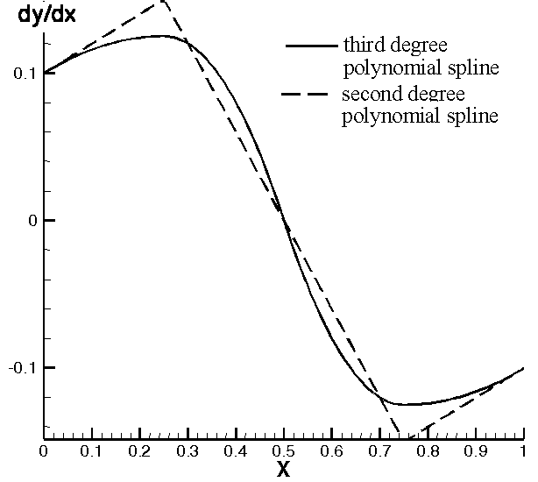
Fig. 3 Slope distribution
For numerical calculations, the structured computational grid is presented in Fig.4 (12350 cells, 24960 interfaces). A number of double sided refined 100 points, on the solid profile surface was employed (50 on the upper surface and 50 on the lower surface, respectively). The computational domain was extended about 15 chord lengths upstream and about 30 chord lengths downstream. On the vicinity of both, above and beneath the
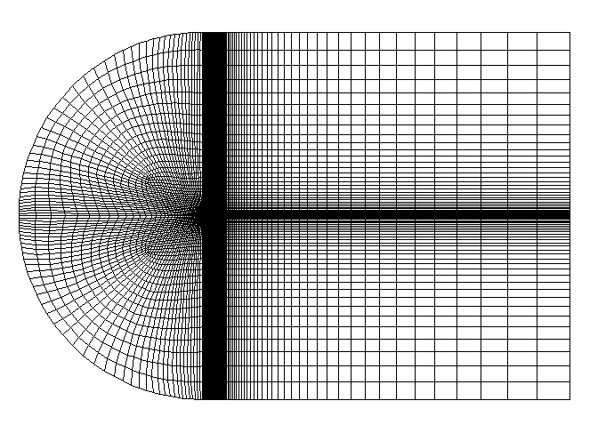
Fig.4. Computational grid

airfoil surfaces, boundary layer zones were included. For turbulent flow calculations, the standard $k−ε$ turbulence model was adopted, combined with wall function formulation of boundary conditions. Therefore, the distance to the wall of first row grid points was calibrated each time to obtain a value of about 40 for the dimensionless parameter $y^{+}$ [7].
Fig. 5 and 6 plot the pressure distribution and skin friction distributions at M∞ = 2, and $α=0$, respectively. The same plots at M∞ = 2 and $α={\text{10}}^{∘}$ are presented in fig. 7 and 8.
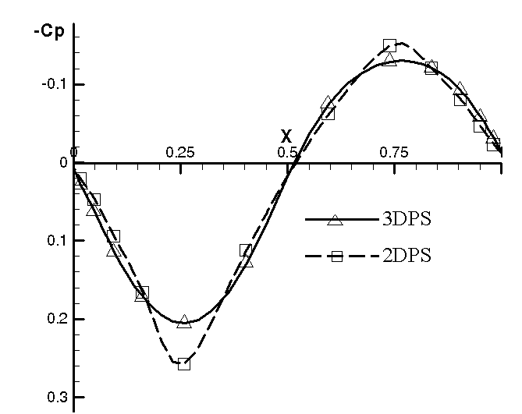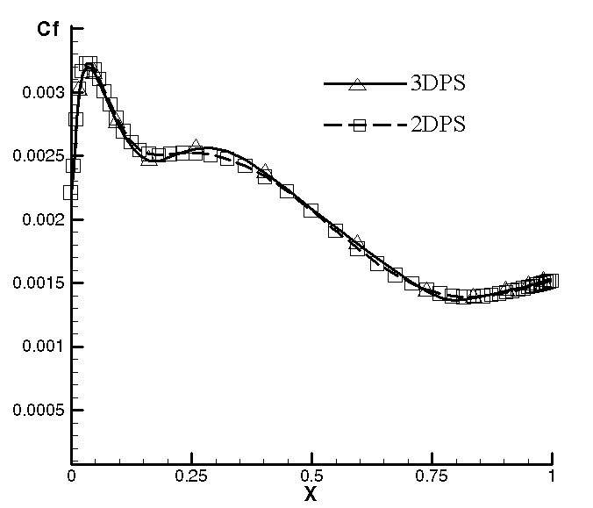

Fig.5. Pressure distribution Fig.6. Skin friction coefficient distribution

Fig.7. Pressure distribution Fig.8. Skin friction coefficient distribution

Table 1 presents the global aerodynamic coefficients as function of incidence at M∞ = 2. From the above data one can conclude the positive effect of the radius continuity on the drag coefficient, $C_{D}$, at low incidences (0°−2° ): a diminution of $C_{D}$ for 3DPS airfoil as compared to the 2DPS airfoil up to 9 % in the range of such small angles of attack corresponding to the cruise regimes for commercial airliners of large speeds.

Table 1
 | 3DPS airfoil |  |  | 2DPS airfoil
$α$[°] | $$C_{D}$$ | $$C_{L}$$ | $$C_{M}$$ | $$C_{D}$$ | $$C_{L}$$ | $$C_{M}$$
0 | 0.030861 | 0 | 0 | 0.033813 | 0 | 0
2 | 0.033616 | 0.082066 | 0.037259 | 0.036619 | 0.082101 | 0.037326
10 | 0.069648 | 0.392170 | 0.192930 | 0.069531 | 0.391221 | 0.194060
20 | 0.291470 | 0.929053 | 0.394450 | 0.289810 | 0.929158 | 0.394150

4. Optimization at zero lift. An inviscid analytical formulation

Taking as reference the far-field unperturbed upstream state, the pressure coefficient$C_{p}$ on the airfoil is:
$$C_{p}=\frac{2}{{γM}_{∞^{2}}}\left(\frac{p}{p_{∞}}−1\right)$$ | (18)
Denoting by indexes 1 and 2 the upper and the lower face, respectively, and assuming the unitary chord one obtain the following expressions for the aerodynamic coefficients [4,5]:
$C_{L}=\int_{0}^{\text{cos}α}{(C_{p2}−C_{p1})dx}$,$C_{D}=\int_{0}^{\text{cos}α}{(C_{p2}\text{tan}δ_{2}+C_{p1}\text{tan}δ_{1})dx}$, | (19a)
$$C_{M}=\int_{0}^{\text{cos}α}{(C_{p2}−C_{p1})(xdx+ydy)}$$ | (19b)

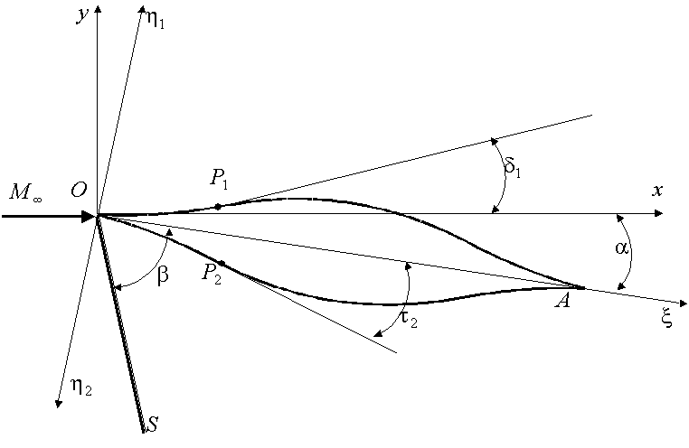
Fig. 9. Geometric elements.
where $C_{L}$, $C_{D}$ and $C_{M}$ are the lift, the drag and the moment relative to the leading edge coefficients, respectively; $δ$ is the tangent slope of the airfoil surface and $α$ the incidence, relative to the chord.
The main geometric notations are presented in Fig. 9. Lets be $Oξ$ the airfoil chord axis, and $O{\text{ξη}}_{1}$ and $O{\text{ξη}}_{2}$ the reference frames for the upper side and lower side, respectively. We can write the following relations between angles:
$δ_{1,2}=τ_{1,2}±α$, $\text{tan}τ_{1,2}=\frac{{dη}_{1,2}}{dξ}=η_{1,2}^{'}$ | (20)
and the geometric transformations are:
$x=ξ\text{cos}α±η_{1,2}\text{sin}α$, $dx=(\text{cos}α±η_{1,2}^{'}\text{sin}α)dξ$. | (21)
In the above relations, the first sign corresponds to the points on the upper face and the second sign to the points on the lower face.
The pressure coefficient on the airfoil surface can be expressed as:
$C_{p}≃A_{1}\text{tan}δ+A_{2}{\text{tan}}^{2}δ+A_{3}{\text{tan}}^{3}δ$, | (22)
where the coefficients $A_{i}, i=1,2,3$ are functions of $M_{∞}$ and the ratio of specific heats, $γ$.
For inviscid supersonic flow the coefficients $A_{i}$ can be derived using the exact oblique shock wave relations and the exact Prandtl-Mayer expansion relations [4,5]. Differences between various formulations appear especially for the coefficient$A_{3}$, due the irreversibility of transformations through shock wave. For example, Carafoli-Berbente approximation corresponds to:
$A_{1}=\frac{2}{B},$ $A_{2}=\frac{γ+1}{2}m^{2}$, $A_{3}={\left(\frac{γ+1}{4}\right)}^{2}\frac{m^{2}M_{∞}^{2}}{B}−\frac{1}{B}$, | (23)
where:
$B=\sqrt{M_{∞}^{2}−1}$, $m=\frac{1}{\text{cos}β}=\frac{M_{∞}}{\sqrt{M_{∞}^{2}−1}}$, | (24)
Classical Ackeret’s linear theory corresponds to $A_{1}=2/B,$ $A_{2}=A_{3}=0$.
In the particular case of zero incidences, equation (22) reduces to:
$C_{p}≃A_{1}η^{'}+A_{2}η^{}+A_{3}η^{}$. | (25)
For a symmetrical airfoil at zero incidences the drag coefficient is:
$C_{D0}=2\int_{0}^{1}{(A_{1}η^{}+A_{2}η^{}+A_{3}η^{})dξ}$. | (26)
Obviously, the minimum of $C_{D0}$ is reached for the linear function:
$η(ξ)=aξ+b$, | (27)
in the case when the minimization problem is continuous. In the case of piecewise continuity (polygonal airfoil), the minimum is reached taking into account the discontinuity locations.
Remark. For a symmetrical airfoil a zero lift coefficient condition is identically satisfied. It follows that our optimisation corresponds to zero lift as an additional condition.
In linear approximation, the drag coefficient at zero lift,${\text{Cx}}_{0}^{(1)}$, for the symmetric rhomboidal airfoil is:
$C_{D0\text{,min}}=C_{D0,r}^{(1)}=\frac{\text{16}ε^{2}}{B}$, | (28)
and for the closed airfoil generated by third order polynomial spline function (3DPS) with sharp edges yields:
$C_{D0,\text{3DPS}}^{(1)}=\frac{\text{24}ε^{2}}{5B}\frac{1}{k(k−1)}$, | (29)
independent to the inflections point locations. The minimum is obtained for $k=1/2$ and the minimum value of drag coefficient for 3DPS profile is:
$C_{D0,\text{3DPS,min}}^{(1)}=\frac{6}{5}C_{D0,r}^{(1)}$, | (30)
therefore an optimum value better than the double-arc airfoil ($4/3C_{D0,r}^{(1)}$).
Considering the nonlinear pressure coefficient (22) the drag coefficient (26) can be written as:
$C_{D0}=C_{D0}^{(1)}+C_{D0}^{(2)}+C_{D0}^{(3)}$, | (31)
where:
$C_{D0,\text{3DPS}}^{(1)}=N_{1}ε^{2}\frac{1}{k(1−k)}$, | (32a)
$C_{D0,\text{3DPS}}^{(2)}=N_{2}ε^{3}\frac{(1−2k)}{k^{2}(k−1)^{2}}$, | (32b)
$C_{D0,\text{3DPS}}^{(3)}=N_{3}ε^{4}\frac{1−3k+3k^{2}}{k^{3}(1−k)^{3}}$, | (32c)
The $N_{i}, i=1,2,3$ coefficients, for the 3DPS airfoil are:
$N_{1,\text{3DPS}}=\frac{\text{12}}{5}A_{1}$, | (33a)
$N_{2,\text{3DPS}}=\frac{\text{108}}{\text{35}}A_{2}$, | (33b)
$$N_{3,\text{3DPS}}=\frac{\text{144}}{\text{35}}A_{3}$$ | (33c)
and:
$N_{i,r}=2A_{i}, i=1,2,3$, | (34)
for the rhomboidal profile.
Cancelling the first derivative:
$\frac{{dC}_{D0}}{dk}=0$, | (35)
we obtain $k_{\text{opt}}$, the position of maximum thickness, k corresponding to the minimum value of drag coefficient. Yields the following implicit equation:
$ν_{\text{opt}}=\frac{2N_{2}(1+3ν_{\text{opt}}^{2})}{1−ν_{\text{opt}}^{2}}ε {\left[N_{1}+\frac{\text{24}N_{3}(1+ν_{\text{opt}}^{2})}{(1−ν_{\text{opt}}^{2})^{2}}ε^{2}\right]}^{−1}$, $k_{\text{opt}}=\frac{1+ν_{\text{opt}}}{2}$. | (36)
The numerical results for two values of Mach number ($M_{∞}=2$ and $M_{∞}=3$) and two values for the relative thickness ($ε=0\text{.}\text{05}$ and $ε=0\text{.}\text{06}$) are presented in Table 2.

Table 2
$$M_{∞}$$ | $$A_{1}$$ | $$A_{2}$$ | $$A_{3}$$ | $$ε$$ | $$k_{\text{opt}}$$ |  | $${\left({C_{D0}}/{ε^{2}}\right)}_{\text{opt}}$$
 |  |  |  |  | 3DPS | R | 3DPS | R
2 | 1.15470 | 1.6 | 0.531162 | 0.05 | 0.5981 | 0.5722 | 10.8004 | 9.0468
 |  |  |  | 0.06 | 0.6251 | 0.5904 | 10.6874 | 9.0302
3 | 0.70710 | 1.35 | 0.935144 | 0.05 | 0.6140 | 0.6031 | 6.5094 | 5.5983
 |  |  |  | 0.06 | 0.6861 | 0.6293 | 6.3649 | 5.4516

On the third approximation, the maximum thickness position is located downstream with 7-16% to realize the minimum drag. This displacement grows in respect to Mach number and in respect to relative thickness. The rhomboidal profile (R) still displays the minimum value of drag coefficient (up to17% smaller than the 3DPS profile).

5. Numerical solutions. Structural approximations

As Chapman [1] pointed out the profile of minimum drag depends, as well on the particular auxiliary conditions imposed on the airfoil geometry. For example, the analysis presented in the present section shows that, if one requires the optimum profile to satisfy as auxiliary condition a given thickness ratio, the double-edge (rhomboidal) profile represent the optimal airfoil. However, this particular auxiliary condition does not represent practical cases where an airfoil must satisfy certain structural requirements, such as a given area moment of inertia, or a given section modulus. If the airfoil is a solid-section structure and the moment of inertia is prescribed, then the particular auxiliary condition which $y(ξ)$ must satisfy in addition to minimize $C_{D}$ is that the integral I_{n} (see (37) ) be constant. The general form of the structural auxiliary condition can be expressed as:
$$I_{n}=\int_{0}^{1}{y^{n}}dξ=\text{const}\text{.}$$ | (37)
Some of the different structural requirements to which the general expression (37) corresponds are summarized in Table 3.

Table 3
n | Structural criteria
1 | Given torsion stiffness, or torsion strength, or volume of thin-skin structure
2 | Given bending stiffness of thin-skin structure
3 | Given bending stiffness or given torsion strength of solid section

In the present analysis we chose the case $n=1$. The aerodynamic characteristic of a 3DPS airfoil with $2ε=0\text{.}1$, $k=0\text{.}5$, $x_{1}=0\text{.}\text{25}$, $H=0$, $M_{1}=0\text{.}1$ (calculated from condition (10)) and $M_{4}=−M_{1}$, at $M_{∞}=2\text{.}5$are presented in Table 4, being calculated by FLUENT 6 code. Also, in the same table, the characteristics of the double-edge (rhomboidal) with the same value of $I_{1}=\int_{0}^{1}{y(ξ)dξ}$ = 2.56×10⁻² are presented.
Table 4
 | 3DPS airfoil |  |  | rhomboidal airfoil
$α$[°] | $$C_{D}$$ | $$C_{L}$$ | $$C_{M}$$ | $$C_{D}$$ | $$C_{L}$$ | $$C_{M}$$
0 | 0.023841 | 0 | 0 | 0.024625 | 0 | 0
10 | 0.079553 | 0.31671 | 0.14051 | 0.082162 | 0.31787 | 0.14100
20 | 0.155390 | 0.48377 | 0.22086 | 0.158516 | 0.48573 | 0.22104

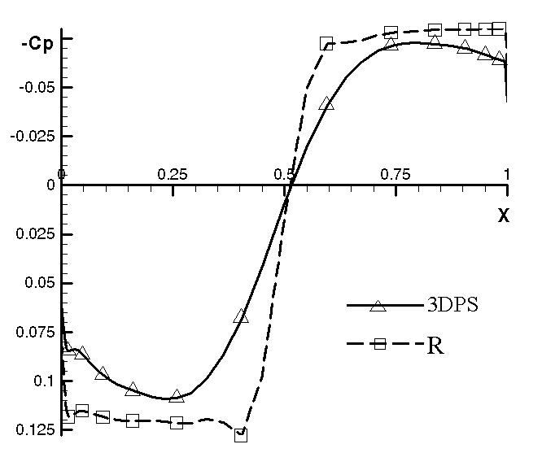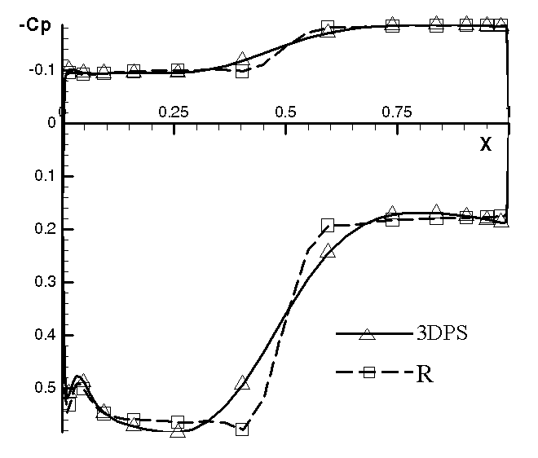
Fig 10. Pressure distribution$α=0^{∘}$ Fig 11. Pressure distribution $α={\text{15}}^{∘}$

Figs. 10 and 11 plot the pressure coefficient distributions for two values of angle of attack $α=0^{∘}$and$α={\text{15}}^{∘}$, respectively. The smooth variation of pressure on the 3DPS airfoil produces a lower value of the aerodynamic drag maintaining practically the same value of the airfoil lift. The drag reduction for incidences below ${\text{10}}^{∘}$ is about 3-4%.
Finally, we mention that the previously presented analytical approach predicts, for the same geometries and for the inviscid flow at zero incidence, $C_{D}=0\text{.}\text{021345}$ for the 3DPS airfoil and $C_{D}=0\text{.}\text{018805}$ for the rhomboidal airfoil, respectively. Comparing to the corresponding values presented in Table 4, we can conclude that the friction drag produced by the rhomboidal airfoil reached 23.6% and for the 3DPS airfoil only 10.5 % of total values.

6. Conclusions

The main effect of the continuity of curvature radius is the smooth variation of pressure gradient on the airfoil surface. This effect is benefic for the pressure drag and also for the boundary layer development. Compared with an airfoil without continuity on curvature radius, the drag reduction is about 9%, at moderate angle of attack.
In inviscid flow an analytical formulation in the third approximation points out that the 3DPS airfoil is inferior to the double-edge (rhomboidal) airfoil at zero lift (which represents the optimum shape), but is superior to double-arc airfoil; the maximum thickness position is located downstream with 7-16% to realize the minimum drag. This displacement grows in respect to Mach number and in respect to relative thickness. The rhomboidal profile displays the minimum value of drag coefficient (up to 17% smaller than the 3DPS profile) However in viscid (real) flow and imposing auxiliary structural condition, the characteristics of 3DPS airfoil are a little better as compared to the double edge airfoil.

References

1. Chapman D.R.: Airfoil profiles for minimum pressure drag at supersonic velocities. General analysis with application to linearized supersonic flow. In: NACA TR 1063, 1951.
2. Berbente, C., Dănăilă, S.: The Aerodynamic Characteristics of a Class of Airfoils with Continuous Curvature at Supersonic Flow (to appear).
3. Berbente, C., Mitran, S., Zancu, S.: Metode numerice. Bucureşti, Ed. Tehnică, 1997.
4. Carafoli, E., Berbente C.: Caracteristicile aerodinamice ale profilelor în regim supersonic-hipersonic, în cazul neglijării pierderilor de sarcină datorită undelor de şoc. In: SCMA, No.4, 1963.
5. Carafoli, E., Berbente C.: Determination of the Characteristics of Aerodynamic Profiles in Supersonic-Hypersonic Flow, Considering The pressure Losses Trough Shock Waves. In: Rev. Roum. Sci. Techn, Mec. Appl, Tom 5, 1964.
6. Chang I.C., Torres F., Tung C.: Geometric Analysis of Wing Sections. In: NASA TM 110346, 1995.
7. Dănăilă, S., Berbente, C. Metode numerice în dinamica fluidelor. Bucureşti, Ed. Academiei, 2003.
8. Drouge G.: Wing Section with Minimum Drag at Supersonic Speeds. In: Rep. No. 26, Aero. Res. Inst. of Sweden, 1949.
9. Ferri, A.: Experimental Results with Tested in the High Speed Tunnel at Guidonia. In: NACA 946, 1940.
10. Item, C. C.: Wing-section optimization for supersonic viscous flows. In: NASA-CR-199747, 1995.

Acknowledgement.

This paper has received the support of Romanian.Space Agency and of Ministry of Education and Research within the Project Nr.142 /2004-“Models and modern numerical and experimental solutions regarding the flows around aerodynamical configuratins of practical interest”.

Profile optime de curburǎ continuǎ la viteze supersonice

Rezumat: Profilele aerodinamice de rezistenţǎ la înaintare minimǎ depind de condiţii structurale suplimentare care sunt impuse asupra geometriei [1]. Pe baza unei aproximaţii de ordinul al treilea [4], în raport deviaţia curentului, s-au obţinut o serie de formule analitice pentru poziţia optimǎ a grosimii maxime a unui profil simetric la incidenţǎ nulǎ în mişcarea supersonicǎ a fluidului fǎrǎ viscozitate. De asemenea, o restricţie structuralǎ (de arie sau volum) a fost impusǎ pentru a scoate în evidenţǎ comportarea îmbunătăţitǎ a profilului de curburǎ continuǎ [2] prin comparaţie cu cel rombic.

Cuvinte cheie: profile, rezistenţǎ minimǎ, restricţii structurale, optimizare.

* Dept. of Aerospace Sciences Elie Carafoli, Politehnica University of Bucharest.

