The fricative viscid phenomenon to the laminar two-dimensional motion
BULLETIN OF THE TRANSILVANIA UNIVERSITY OF BRAŞOV

D. Scurtu*

Abstract: The work has as aim analyses the fricative efforts in the case fluid Newtonian motion in the auditing space limits between two plan surfaces. Fluid flow has the two-dimensional character. Defined the new concept in mechanic fluid as the friction line and fricative surface. The phenomena study has the application in hydrodynamic lubricated.

Keywords: laminar, viscosity, chafe, pressure.

1. Theoretical considerations
The work proposes a theoretical study of fricative phenomena viscosity film tenuous of fluid. The movement in tenuous fluid film encounter in some hydrodynamic cases. Such movement has laminar character because:
-Thickness film of fluid is very small
-The local speed w is small;
Is caned asserted from these consideration as the number Reynolds (Re) characterize the motion has the values the little maul than the critical value.
The vectorial equation that describes this fluid movement is the Navier-Stokes equation:
(1)
where: is masic force
is the fluid density
the pressure
the fluid local speed in motion
The fluid have a Newtonian character pursuant the tangential fricative viscid effort is given on the relation:
(2)
where: is the dynamic coefficient of viscosity
is a perpendicular direction on the speed direction
In consequence the determination tangential efforts of local viscosity, presupposes the determination from relation (1) of local speeds.
The equation (1) solution can be determinate in the following conjuncture:
-the movement has a two-dimensional character. Is unrolled in [x₁ O x_{2]} plan:
=$w_{1}(x_{1};x_{2};x_{3}){\vec{e}}_{1}+w_{2}(x_{1};x_{2};x_{3}){\vec{e}}_{2}$ | (3)
-the masic forces have a potential character rot $f\vec{m}=0$ $∀(x_{1};x_{2};x_{3})∈D$ were D is the fluid flux domain. Then exist a scalar function$Π(x_{1};x_{2};x_{3})$, this as:
$f\vec{m}=−\text{grad}Π$(x₁;x₂;x₃)
-the movement has a permanent character $\frac{∂\vec{w}}{∂t}=0$
In this condition the scalar equation witch results from (1) are:
(4)
If potential $π$ is constant in all points $(x_{1};x_{2};x_{3})∈D$ whereupon: in consequence equation (4) becomes:
$$\frac{1}{ρ}\frac{∂p}{∂x_{1}}−w_{1}\frac{∂w_{1}}{∂x_{1}}−w_{2}\frac{∂w_{1}}{∂x_{2}}+υ\left[\frac{∂^{2}w_{1}}{∂x_{1}^{2}}+\frac{∂^{2}w_{1}}{∂x_{2}^{2}}+\frac{∂^{2}w_{1}}{∂x_{3}^{2}}\right]=0$$ | (5)
Equation (5) solved for a domain D, of fluid, included between two plane surfaces and parallels $Σ_{A}$ and $Σ_{B}$ , rapport to a system of reference, figure 1.

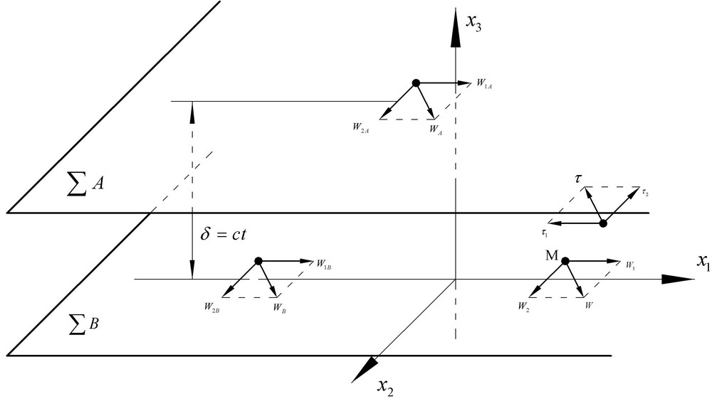
Fig.1
For resolve the system (5) witch in unknowns are the local speeds $w_{1}=w_{1}(x_{1};x_{2};x_{3})$ and $w_{2}=w_{2}(x_{1};x_{2};x_{3})$ are make next conjunctures concerning at variables speeds beyond the three axes:
$\frac{∂w_{1}}{∂x_{1}}→0$;$\frac{∂w_{1}}{∂x_{2}}→0$;$\frac{∂w_{2}}{∂x_{1}}→0$;$\frac{∂w_{2}}{∂x_{2}}→0$ | (6)
what attracts right consequence:
$\frac{∂^{2}w_{1}}{∂x_{1}^{2}}→0$;$\frac{∂^{2}w_{1}}{∂x_{2}^{2}}$$→0$;$\frac{∂^{2}w_{2}}{∂x_{1}^{2}}→0$;$\frac{∂^{2}w_{2}}{∂x_{2}^{2}}→0$ | (7)
With the (6) and (7) conjunctures the system (5) became:
$\frac{∂^{2}w_{1}}{∂x_{3}^{2}}=\frac{1}{η}$$\frac{∂p}{∂x_{1}}$ | (8)
$$\frac{∂^{2}w_{2}}{∂x_{3}^{2}}=\frac{1}{η}\frac{∂p}{∂x_{2}}$$ | (8)
The solutions for system (7) are:
$$w_{1}(x_{3})=\frac{1}{2η}\frac{∂p}{∂x_{1}}x_{3}^{2}+c_{1}x_{3}+c_{2}$$ | (9)
$$w_{2}(x_{3})=\frac{1}{2η}\frac{∂p}{∂x_{2}}x_{3}^{2}+c_{1}x_{3}+c_{4}$$ | (10)
where $c_{1}$ ; $c_{2}$ ; $c_{3}$ ; $c_{4}$ are the real integration constants witch are caused from limits condition of adhesive type.
For settlement constants $c_{1}$ and $c_{2}$ limit conditions are:
For:$x_{3}=0$,$w_{1}(x_{3})=w_{1}(0)=w_{1B}$ c${}_{2}$=$w_{1B}$
For: $c_{1}=−\frac{1}{2η}\frac{∂p}{∂x_{1}}δ+\frac{w_{1B}−w_{1A}}{δ}$
Results for $w_{1}(x_{3})$ the relation:
$$w_{1}(x_{3})=\frac{1}{2η}\frac{∂p}{∂x_{1}}(x_{3}^{2}−{δx}_{3})+\frac{w_{1A}−w_{1B}}{δ}x_{3}+w_{1B}$$ | (11)
To determine the constants and the limit conditions are:
For: .
For:
It results, for component of local velocity, the expression:
(12)
Comments: the velocity and have a parabolic distribution in rapport with variable, where The scalar value of the velocity is:
(13)
Once the local velocity is determined, the tangential strain of viscosity friction can be determined.
(14)
The relation (14) shows that in case of a bivariate motion are two strains :
Where
(15)
(16)
The relations (15) and (16) shows that in rapport with variable the two strains have a linear variation.
Each has two components. The first component witch is direct proportional with pressure gradient. The second component that depends on the fluid viscosity and it’s proportional with the velocity of the two surfaces.
With the relations (15) and (16) the expression of strain from relation becomes:
(17)
With tangential strains of friction given by the relations (17) it circumscribes a new expression in hydrokinetics, the friction line.
The friction line is defined like a curve in domain D, that admits in every point the vector as tangent given by the relation (19). If
The distance, infinity small, between two points from the friction line, we have the relation:
(18)
From the vectorial equation (18) it results the scalar equation of the friction line in plan:
(19)
or:
(20)
and are constants referring to the variables and , it obtains: with the conditions it obtains; or:
(21)
from where it results the equation of friction surface f(x₁, x₂):
(22)
with condition:
The most frequent situation in practice is the case when a surface is fixed and one is mobile. Cither the surface mobile, characterized by the velocity and the surface fixed. In this case relation (22) becomes:
(23)

2. Numeric application

We search the determination of friction surface form in two variants: ,diagram 1 and ,diagram 2
Those variants are graphic represented in diagrams 1 and 2. For
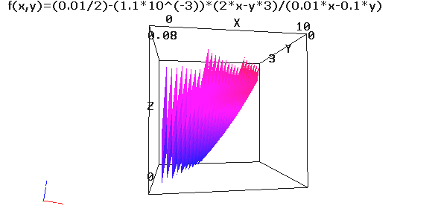
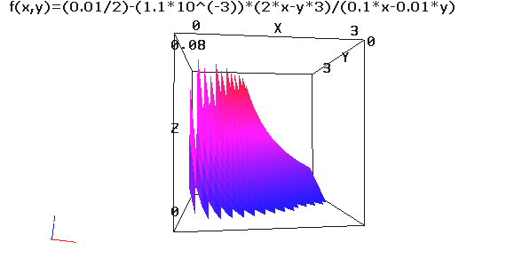
Diagram 1 Diagram 2
and, x=

3. Conclusions

The relation (22) represents the equation of a friction surfaces surface.
- The friction surface depends on:
- The distance between the two surfaces ;
- The fluid viscosity ;
- The two surfaces velocity ;
- The coordinates and from the fluid motion plan;
- The pressure gradients after the two directions
- The pressure gradient (diagram 1)
- Along with the increase of variable the friction surface increases ;
- Along with the increase of variable the friction surface increases ;
- The friction surface is strained towards the increasing values of variable ;
- The pressure gradient (diagram 2)
- The friction line increases along the increase of variable ;
- The friction line decreases along the increase of variable ;
- The friction surface is strained towards the small values of variable ;
Conclusively, to have as the small friction surface is necessary that the pressure gradient along direction to be bigger than the pressure gradient along direction.

Bibliography:

- R. Comolet , Dinamique des fluides visqueux ; vol. II Masson et c^{ie} Paris 1961
- Zidaru , Miscari potentiale si hidrodinamica retelelor de profil : E.D.P. Bucuresti 1981
- V. Pimsner , C. Borbente s.a. Procese in masini termice cu palete E.T. Bucuresti 1986
- J . Florea , V. Panaitescu s.a. Mecanica fluidelor probleme E.D.P. Bucuresti 1976

Fenomenul de frecare viscoasa intr-o miscare laminara bidimensionala

Reazumat:Lucrarea are in vedere stabilirea eforturilor de frecare viscoasa in curgerea bidimensionala, plecind de la legile de variatie a vitezelor pe directiile de miscare Se defineste vectorul efort de frecare si cu componentele scalare ale acestuia se introduce notiunea de linie de frecare, respective suprafata de frecare. Cercetarea are aplicatii in teoria hidrodinamica a lubrificatiei.

Cuvinte cheie: laminar, viscozitate, efort, presiune.

* Technical University “Gh.Asachi” Iasi, Fluid Mechanical Department, scurtud@yahoo.com

